What is memory management in java And how it is handled?

* Memory management in Java is primarily handled through **automatic garbage collection**, which helps in reclaiming the memory by destroying unused objects.  
  **Heap**: Stores objects and class instances. This is the main area managed by the garbage collector.
* **Stack**: Stores method call frames, local variables, and references to objects in the heap.
* **Method Area (MetaSpace in Java 8+)**: Stores class metadata, static variables, and method definitions.
* **Program Counter (PC) Register**: Keeps track of the current instruction being executed.
* **Native Method Stack**: Used for native (non-Java) method calls.  
    
    
  **How you debug outOfMemory error ?**To debug OutOfMemoryError in Java, first I identify the type of memory error (Heap, Metaspace, Stack, Direct Memory, etc.).  
  Then I enable heap dump on OOM, analyze it using tools like Eclipse MAT or VisualVM to identify memory leaks or large object retention.  
  Based on analysis, I fix the root cause such as unclosed resources, large collections, improper caching, thread leaks, or configuration issues.  
  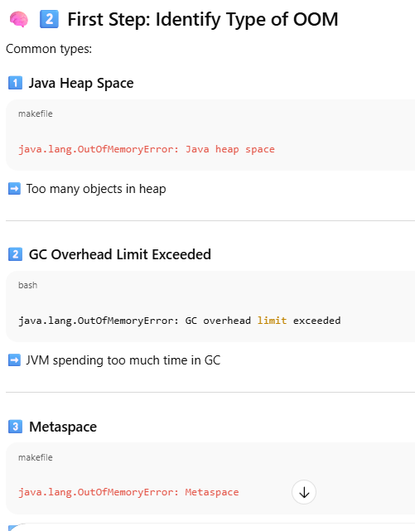  
    
  Q. Explain each best practice to avoid memory leak in java with example of code now.  
    
  **1. Avoid Unintentional Object References (especially in Collections)**
* **Problem**: Objects stored in collections (like List, Map) are not garbage collected if not removed.
* **Best Practice**: Remove unused objects from collections.

-------------------------------------------------------------------------

Map<string, object> cache = new HashMap<>();

public void addToCache(String key, Object value) {

    cache.put(key, value);

}

public void clearCache(String key) {

    cache.remove(key); // Prevents memory leak

}

**[2]Use Weak References for Caches**

**Problem**: Strong references in caches prevent GC.

**Best Practice**: Use WeakHashMap or WeakReference  
  
**What is a Strong Reference?**

In Java, **strong references** are the default type of reference. If an object is strongly referenced, the **Garbage Collector (GC)** will **never** remove it from memory as long as the reference exists.

**🔍 What is a Weak Reference?**

A **weak reference** allows the GC to collect the object **even if it is still referenced**, as long as it's only weakly referenced. This is useful for **caching**, where you don’t want the cache to prevent memory cleanup.

**WeakHashMap vs HashMap**

* HashMap uses **strong references** for keys and values.
* WeakHashMap uses **weak references** for **keys**. If a key is no longer used elsewhere, it can be garbage collected, and the entry is removed from the map.

import java.util.HashMap;

import java.util.WeakHashMap;

public class CacheExample {

    public static void main(String[] args) {

        // Strong reference example

        HashMap<object, string> strongMap = new HashMap<>();

        Object strongKey = new Object();

        strongMap.put(strongKey, "Strong Reference");

        // Weak reference example

        WeakHashMap<object, string> weakMap = new WeakHashMap<>();

        Object weakKey = new Object();

        weakMap.put(weakKey, "Weak Reference");

        // Remove strong references

        strongKey = null;

        weakKey = null;

        // Suggest GC

        System.gc();

        // Wait a bit for GC to run

        try { Thread.sleep(1000); } catch (InterruptedException e) {}

        System.out.println("StrongMap: " + strongMap);

        System.out.println("WeakMap: " + weakMap);

    }

}  
  
ouptput :  
StrongMap: {java.lang.Object@1b6d3586=Strong Reference}

WeakMap: {}

* The strongMap still holds the object.
* The weakMap entry is **gone** because the key was weakly referenced and GC collected it

**When to Use WeakHashMap or WeakReference?**

* **Caches**: You want to store data temporarily and allow GC to clean it up when memory is low.
* **Listeners or Callbacks**: Avoid memory leaks by not preventing GC of unused objects.

--------------------------------------------------------------------------------------------------------  
[3] **Close Resources Properly**

**Problem**: Open streams/sockets hold memory.

**Best Practice**: Use try-with-resources.

try (BufferedReader reader = new BufferedReader(new FileReader("file.txt"))) {

    String line = reader.readLine();

} // reader is auto-closed  
  
[4] **Avoid Static References to Large Objects**

**Problem**: Static fields live for the lifetime of the app.

**Best Practice**: Don’t store large objects statically.

// Bad

public static List bigList = new ArrayList<>();

// Better

public List getList() {

    return new ArrayList<>();

}  
  
[5] **Use Profiling Tools**

**Best Practice**: Use tools like **VisualVM**, **JProfiler**, or **Eclipse MAT** to detect memory leaks.

[6] **Be Careful with Inner Classes**

**Problem**: Non-static inner classes hold reference to outer class.

**Best Practice**: Use static inner classes when possible.

// Bad

class Outer {

    class Inner {

        // Holds reference to Outer

    }

}

// Good

class Outer {

    static class Inner {

        // No reference to Outer

    }

}

How do we implement security in spring boot application?

Implementing **security in a Spring Boot application** typically involves using **Spring Security**, a powerful and customizable authentication and access-control framework  
  
**Key Components of Spring Security**

1. **Authentication** – Verifying who the user is.
2. **Authorization** – Determining what the user is allowed to do.
3. **Password Encoding** – Storing passwords securely.
4. **Role-Based Access Control (RBAC)** – Restricting access based on user roles.
5. **JWT (JSON Web Token)** – For stateless authentication in REST APIs.  
     
   In Java (and specifically in Spring Boot), a **stateless REST API** means that the server does **not store any client session information** between requests. Each request from the client must contain **all the information** needed for the server to process it.  
     
   Basic Http Status Code :  
   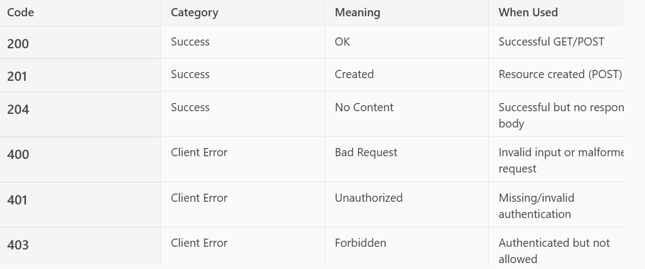  
   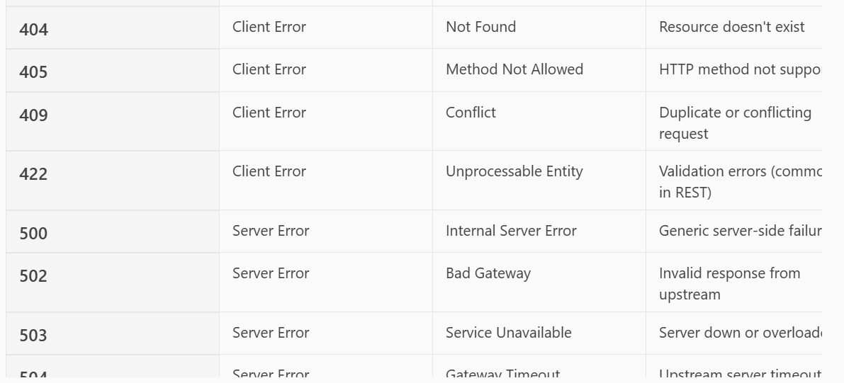

**In this the error and codes are thrown by the server side like 404 for not found and 405 method not allowed both are thrown by servers**.

**Basic Steps to Implement Security**

**1. Add Spring Security Dependency**

In pom.xml:  
  
<dependency>

<groupId>org.springframework.boot</groupId>

<artifactId>spring-boot-starter-security</artifactId>

</dependency>  
---------------------------------------------------------------------------  
2.**Create a Security Configuration Class**

@EnableWebSecurity

public class SecurityConfig extends WebSecurityConfigurerAdapter {

@Override

    protected void configure(HttpSecurity http) throws Exception {

        http

            .authorizeRequests()

            .antMatchers("/public/**").permitAll() // No auth needed

            .antMatchers("/admin/**").hasRole("ADMIN") // Role-based access

            .anyRequest().authenticated()

            .and()

            .httpBasic(); // or .formLogin() for web apps

    }  
@Override

    protected void configure(AuthenticationManagerBuilder auth) throws Exception {

        auth.inMemoryAuthentication()

            .withUser("user").password(passwordEncoder().encode("password")).roles("USER")

            .and()

            .withUser("admin").password(passwordEncoder().encode("admin")).roles("ADMIN");

    }

    @Bean

    public PasswordEncoder passwordEncoder() {

        return new BCryptPasswordEncoder();

    }

* }  
    
  Explanation of Code:  
  **[1]@EnableWebSecurity:** Enables Spring Security’s web security support.
* **WebSecurityConfigurerAdapter:** A base class that allows you to customize Spring Security by overriding methods like configure(HttpSecurity) and configure(AuthenticationManagerBuilder).  
    
  In Spring Security 6+, WebSecurityConfigurerAdapter is deprecated. You should use SecurityFilterChain beans instead.
* **http.authorizeRequests():** Starts defining access rules for HTTP endpoints.
* **.antMatchers("/public/**").permitAll**(): Allows unrestricted access to any endpoint under /public/.
* **.antMatchers("/admin/**").hasRole("ADMIN"):** Restricts access to /admin/** endpoints to users with the ADMIN role.
* .**anyRequest().authenticated():** All other endpoints require authentication.
* **.httpBasic():** Enables basic authentication (username/password via HTTP headers). You could replace this with .formLogin() for form-based login in web apps.
* **auth.inMemoryAuthentication():** Defines users in memory (not from a database).
* **.withUser("user")...roles("USER"):** Adds a user with username "user", password "password" (encoded), and role "USER".
* **.withUser("admin")...roles("ADMIN"):** Adds an admin user with role "ADMIN".
* @Bean: Registers this method as a Spring bean.
* BCryptPasswordEncoder: A secure password hashing algorithm used to encode passwords.

Spring Security requires passwords to be encoded. This bean ensures that the passwords used in inMemoryAuthentication() are properly hashed.

**What Does inMemoryAuthentication() Mean?**

It tells Spring Security to **store user credentials in memory** (RAM) while the application is running. This is useful for:

* **Testing or prototyping** applications
* **Simple apps** that don’t need persistent user storage
* Avoiding the need for a database or external identity provide
* **How It Works**
* Creates a user named "user" with a password and role "USER"
* Stores this user in an internal memory structure (like a map or list)
* Uses this data to authenticate incoming requests

---------------------------------------------------------------------------------  
[3]**Use JWT for REST APIs (Optional but Recommended)**

* Generate JWT on login.
* Validate JWT on each request.
* Use filters to intercept and validate tokens.

**🛡️ Additional Security Features**

* **CSRF Protection** (enabled by default for web apps).
* **CORS Configuration** for cross-origin requests.
* **OAuth2/OpenID Connect** for third-party login (Google, GitHub, etc.).
* **Method-Level Security** using @PreAuthorize, @Secured.

Here’s a simple example of **method-level security** in a Spring Boot application using @PreAuthorize and @Secured.  
[1]Adding dependency in pom.xml

<dependency>

    <groupId>org.springframework.boot</groupId>

    <artifactId>spring-boot-starter-security</artifactId>

</dependency>

**Step 2: Enable Method Security**

In your main application class or a configuration class, add:

@EnableMethodSecurity  // For Spring Security 6+

@Configuration

public class SecurityConfig {

    // You can define custom security rules here if needed

}

[3] **step 3: Use Security Annotations on Methods**

You can now annotate service or controller methods with:

**🔹 @PreAuthorize**

Checks before method execution.

@PreAuthorize("hasRole('ADMIN')")

public void deleteUser(Long userId) {

    // Only ADMIN can delete users

}

**@PostAuthorize**

Checks after method execution.

@PostAuthorize("returnObject.owner == authentication.name")

public Document getDocument(Long id) {

    // Only the owner can access the document

}

[5]**@Secured**

Simpler role-based access.

@Secured("ROLE_USER")

public void viewProfile() {

    // Only users with ROLE_USER can view

}

**Step 4: Configure Authentication**

You’ll need to configure users and roles either in-memory, via a database, or using an external provider (like OAuth2, LDAP, etc.).

@Bean

public UserDetailsService userDetailsService() {

    UserDetails user = User.withDefaultPasswordEncoder()

        .username("admin")

        .password("password")

        .roles("ADMIN")

        .build();

    return new InMemoryUserDetailsManager(user);

}

**how to implement jwt token security in spring boot application?**

To implement JWT (JSON Web Token) security in a Spring Boot application, you typically follow these steps:  
  
**Step 1: Add Dependencies**

* In your pom.xml (for Maven):(these does not come under spring boot starter security)  
    
  **Purpose**: Adds the **JJWT** library, which helps in creating and parsing JWT tokens.

<dependency>

    <groupId>io.jsonwebtoken</groupId>

    <artifactId>jjwt</artifactId>

    <version>0.9.1</version>

</dependency>

<dependency>

    <groupId>org.springframework.boot</groupId>

    <artifactId>spring-boot-starter-security</artifactId>

</dependency>

<dependency>

    <groupId>org.springframework.boot</groupId>

    <artifactId>spring-boot-starter-web</artifactId>

</dependency>

**Step 2: Create JWT Utility Class**

This class handles token creation and validation.

public class JwtUtil {

    private final String SECRET_KEY = "your_secret_key";

    public String generateToken(UserDetails userDetails) {

        return Jwts.builder()

            .setSubject(userDetails.getUsername())

            .setIssuedAt(new Date())

            .setExpiration(new Date(System.currentTimeMillis() + 1000 * 60 * 60 * 10)) // 10 hours

            .signWith(SignatureAlgorithm.HS256, SECRET_KEY)

            .compact();

    }

    public String extractUsername(String token) {

        return Jwts.parser()

            .setSigningKey(SECRET_KEY)

            .parseClaimsJws(token)

            .getBody()

            .getSubject();

    }

    public boolean validateToken(String token, UserDetails userDetails) {

        final String username = extractUsername(token);

        return (username.equals(userDetails.getUsername()) && !isTokenExpired(token));

    }

    private boolean isTokenExpired(String token) {

        Date expiration = Jwts.parser()

            .setSigningKey(SECRET_KEY)

            .parseClaimsJws(token)

            .getBody()

            .getExpiration();

        return expiration.before(new Date());

    }

* }  
    
    
  Explanation of code :  
  [1] private final String SECRET_KEY = "your_secret_key"; 🡪
* This is the **secret** used to sign the JWT. Keep this secure and never expose it publicly.  
  [2] generateToken() ->
* Jwts.builder(): Starts building a JWT.
* .setSubject(username): Sets the subject (usually the username).
* .setIssuedAt(new Date()): Sets the current time as the issue time.
* .setExpiration(...): Sets the token to expire in 10 hours.
* .signWith(...): Signs the token using HMAC SHA-256 and the secret key.
* .compact(): Finalizes and returns the token as a string.  
    
  [3] extractUsername() ->
* Parses the token using the secret key.
* Extracts the **subject** (username) from the token body.  
    
  [4] validateToken()->
* Checks if the username in the token matches the expected username.
* Also checks if the token is **not expired**.

[5] isTokenExpired

* Extracts the expiration date from the token.
* Compares it with the current date to check if it's expired.

✅ **Summary**: This utility class helps you:

* Create JWT tokens with a username and expiration.
* Extract the username from a token.
* Validate tokens by checking username and expiration.

**Step 3: Create JWT Filter**

Intercept requests and validate JWT.

public class JwtRequestFilter extends OncePerRequestFilter {

    @Autowired

    private JwtUtil jwtUtil;

    @Autowired

    private UserDetailsService userDetailsService;

    @Override

    protected void doFilterInternal(HttpServletRequest request, HttpServletResponse response, FilterChain chain)

        throws ServletException, IOException {

        final String authHeader = request.getHeader("Authorization");

        String username = null;

        String jwt = null;

        if (authHeader != null && authHeader.startsWith("Bearer ")) {

            jwt = authHeader.substring(7);

            username = jwtUtil.extractUsername(jwt);

        }

if (username != null && SecurityContextHolder.getContext().getAuthentication() == null) {

    var userDetails = userDetailsService.loadUserByUsername(username);

    if (jwtUtil.validateToken(jwt, userDetails.getUsername())) {

        var authToken = new UsernamePasswordAuthenticationToken(

                userDetails, null, userDetails.getAuthorities());

        authToken.setDetails(new WebAuthenticationDetailsSource().buildDetails(request));

        SecurityContextHolder.getContext().setAuthentication(authToken);

    }

}

        chain.doFilter(request, response);

    }

* }  
    
  Explanation of code :
* OncePerRequestFilter: Ensures the filter runs **once per request**.
* HttpServletRequest and HttpServletResponse: Represent the incoming request and outgoing response.
* SecurityContextHolder: Holds the security context (authentication info).
* UsernamePasswordAuthenticationToken: Represents the authenticated user.
* WebAuthenticationDetailsSource: Adds request-specific details to the authentication object.
* @Component: Makes this filter a Spring-managed bean.
* Code Explanation:  
  [1]@Autowired private JwtUtil jwtUtil; @Autowired private MyUserDetailsService:
* Injects the JwtUtil class to handle token parsing and validation.
* Injects MyUserDetailsService to load user details from the username in the token.

[2]doFilterInternal() 🡪

* This method is called for every request.
* FilterChain lets the request continue to the next filter or controller.
* [3]authHeader ->
* Gets the Authorization header.
* Checks if it starts with "Bearer " (standard JWT format).
* Extracts the token and gets the username from it.  
    
  [4] **Validate and Set Authentication**
* Checks if username is present and no authentication is already set.
* Loads user details from the database or hardcoded source.
* Validates the token.
* Creates an authentication token and sets it in the security context.

### [5] **Continue Filter Chain: chain.doFilter(request, response);**

* Passes the request to the next filter or controller.  
    
   **Summary**: This filter:
* Runs on every request.
* Extracts and validates JWT from the header.
* Sets the authenticated user in the Spring Security context.

**Step 4: Configure Security**

@Configuration

@EnableMethodSecurity

public class SecurityConfig {

    @Autowired

    private JwtRequestFilter jwtRequestFilter;

    @Bean

    public SecurityFilterChain filterChain(HttpSecurity http) throws Exception {

        http.csrf().disable()

            .authorizeHttpRequests(auth -> auth

                .requestMatchers("/authenticate").permitAll()

                .anyRequest().authenticated()

            )

            .sessionManagement(sess -> sess.sessionCreationPolicy(SessionCreationPolicy.STATELESS));

        http.addFilterBefore(jwtRequestFilter, UsernamePasswordAuthenticationFilter.class);

        return http.build();

    }

}  
  
Explanation of code :  
This step sets up Spring Security to:

* Allow unauthenticated access to /authenticate
* Require JWT authentication for all other endpoints
* Register the JWT filter in the security chain

[1] filterChain(HttpSecurity http) ->

* http.csrf().disable(): Disables CSRF protection (not needed for stateless REST APIs).
* .authorizeHttpRequests(): Starts defining access rules.
* .requestMatchers("/authenticate").permitAll(): Allows unauthenticated access to /authenticate.
* .anyRequest().authenticated(): Requires authentication for all other endpoints.
* .sessionManagement().sessionCreationPolicy(SessionCreationPolicy.STATELESS): Disables session creation; JWT is stateless.
* http.addFilterBefore(...): Adds our JWT filter **before** Spring’s built-in authentication filter.
* return http.build();: Builds and returns the security filter chain.

[2] authenticationManager(AuthenticationConfiguration config)->

* Exposes the AuthenticationManager as a Spring bean.
* Required for authenticating users in the login controller.

[3] **Summary**: This configuration:

* Disables sessions and CSRF
* Allows login via /authenticate
* Secures all other endpoints

Registers the JWT filter  
  
**What is csrf and why we disable it in combination of rest api and jwt?**

**CSRF (Cross-Site Request Forgery)** is an attack where:

* A **logged-in user**
* Is tricked by a **malicious website**
* Into sending an **unwanted request** to a trusted application
* Because the browser **automatically sends cookies** with the request  
    
  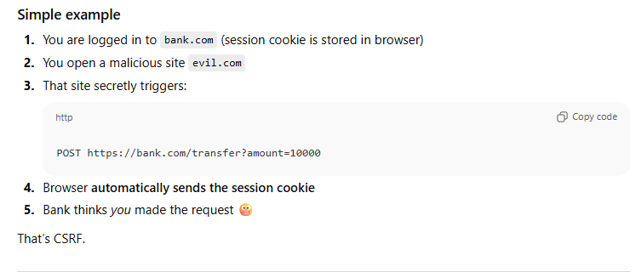

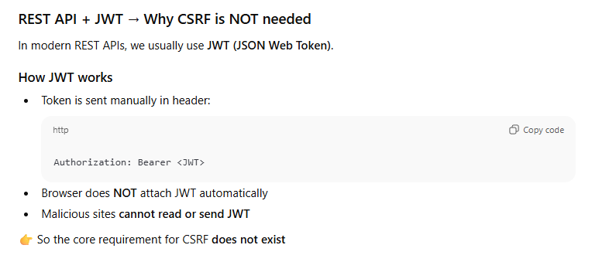  
-------------------------------------------------------------------------------------------------------

**Step 5: Create Authentication Endpoint  
code :**@RestController

public class AuthController {

@Autowired

private AuthenticationManager authenticationManager;

@Autowired

private JwtUtil jwtUtil;

@PostMapping("/authenticate")

public String createToken(@RequestBody AuthRequest authRequest) throws Exception {

    authenticationManager.authenticate(

            new UsernamePasswordAuthenticationToken(authRequest.getUsername(), authRequest.getPassword())

    );

    return jwtUtil.generateToken(authRequest.getUsername());

}

**🔍 Line-by-line:**

* @PostMapping("/authenticate"): Maps this method to POST requests at /authenticate.
* @RequestBody AuthRequest authRequest: Accepts a JSON body with username and password.
* authenticationManager.authenticate(...): Authenticates the user using Spring Security.
* If successful, jwtUtil.generateToken(...) creates a JWT token for the user.

The token is returned as a plain string (you can wrap it in a JSON object if preferred).  
  
**AuthRequest.java (DTO )**public class AuthRequest {

    private String username;

    private String password;

    // Getters and setters

}

**🔍 Explanation:**

* A simple POJO (Plain Old Java Object) to hold login credentials.
* Used to map the incoming JSON request body.

✅ **Summary**: This controller:

* Accepts login credentials via /authenticate
* Authenticates the user
* Returns a JWT token if credentials are valid  
  -----------------------------------------------------------------------------------------  
  **Jwt token parts and how it is implemented in spring boot application?  
    
  JWT Token Structure**
* A JWT consists of **three parts**, separated by dots (.):
* **xxxxx.yyyyy.zzzzz  
    
  [1]Header**

Specifies the token type (JWT) and the signing algorithm (e.g., HS256, RS256).  
  
{

  "alg": "HS256",

  "typ": "JWT"

} **[2] Payload**

Contains the claims (user data, metadata).

Example:

{

  "sub": "ankur.chakraborty",

  "role": "consultant",

  "exp": 1695825600

}  
  
[3] **Signature**

* Used to verify the token’s integrity.
* Created by encoding the header and payload, then signing it with a secret key.  
    
  **1. JWT Utility Class (JwtUtil)**
* This class handles **token creation**, **extraction**, and **validation**.
* **Key Methods:**
* generateToken(String username):  
  Creates a JWT with a subject (username), issue time, expiration time, and signs it using a secret key.
* extractUsername(String token):  
  Parses the token and retrieves the username (subject).
* validateToken(String token, UserDetails userDetails):  
  Checks if the token is valid and not expired.
* **Interview Tip:**
* "This class encapsulates all JWT-related logic, making it reusable and testable. It uses the io.jsonwebtoken library to handle token operations."
* **🧱 2. JWT Filter (JwtRequestFilter)**
* This is a **custom filter** that intercepts every HTTP request to check for a valid JWT in the Authorization header.
* **Key Logic:**
* Extracts the token from the header.
* Validates the token.
* If valid, sets the authentication in the SecurityContext.
* **Interview Tip:**
* "This filter ensures that only authenticated requests reach protected endpoints. It runs before the standard Spring Security filter."
* **🔐 3. Security Configuration (SecurityConfig)**
* This configures Spring Security to:
* Disable CSRF (for stateless APIs).
* Allow unauthenticated access to /authenticate.
* Require authentication for other endpoints.
* Register the JWT filter.
* **Interview Tip:**
* "This configuration integrates our JWT filter into Spring Security's filter chain and defines access rules."

**🔓 4. Authentication Endpoint (AuthController)**

This controller exposes an endpoint (/authenticate) where users send their credentials.

**Key Flow:**

Authenticates the user using AuthenticationManager.

If successful, generates a JWT and returns it.

**Interview Tip:**

"This endpoint is the entry point for login. Once authenticated, the client receives a JWT to use in future requests."

**🧪 Example Flow in an Interview**

You can explain the flow like this:

"When a user logs in via /authenticate, we validate their credentials and generate a JWT. This token is sent back to the client. For subsequent requests, the client includes this token in the Authorization header. Our custom filter intercepts the request, validates the token, and sets the authentication context. This allows Spring Security to authorize access to protected resources."

-------------------------------------------------------------------------------------  
**what is difference between general security oauth2 and jwt token?**  
**🔐 OAuth 2.0: General Security Protocol**

**OAuth 2.0** is an **authorization framework** that allows third-party applications to obtain limited access to a user's resources without exposing their credentials.

**Key Features:**

* **Delegated access**: A user can grant an app access to their data on another service (e.g., Google, Facebook) without sharing their password.
* **Token-based**: It issues **access tokens** to clients after successful authorization.
* **Flow-based**: It supports multiple flows (Authorization Code, Client Credentials, Implicit, etc.) depending on the use case.
* **Does not define token format**: OAuth 2.0 doesn’t mandate what the token looks like — it could be opaque or a JWT.

**Example Use Case:**

A mobile app wants to access your Google Calendar. It uses OAuth 2.0 to get permission from you and receives an access token to interact with Google APIs.

**🧾 JWT (JSON Web Token): Token Format**

**JWT** is a **token format** — a compact, URL-safe way of representing claims between two parties.

**Key Features:**

* **Self-contained**: Contains all the information (claims) needed to verify the user, such as user ID, roles, expiration time.
* **Signed**: Usually signed using HMAC or RSA to ensure integrity and authenticity.
* **Stateless**: No need to store session data on the server — the token itself carries the data.
* **Used in OAuth 2.0**: JWTs are often used as **access tokens** or **ID tokens** in OAuth 2.0 and OpenID Connect.

**Example Use Case:**

After logging in, a user receives a JWT that includes their user ID and roles. This token is sent with each request to authenticate and authorize access to resources.  
  
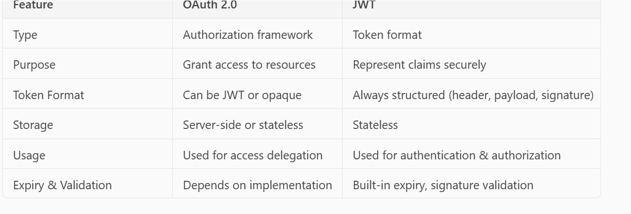

* Microservices Architecture :  
  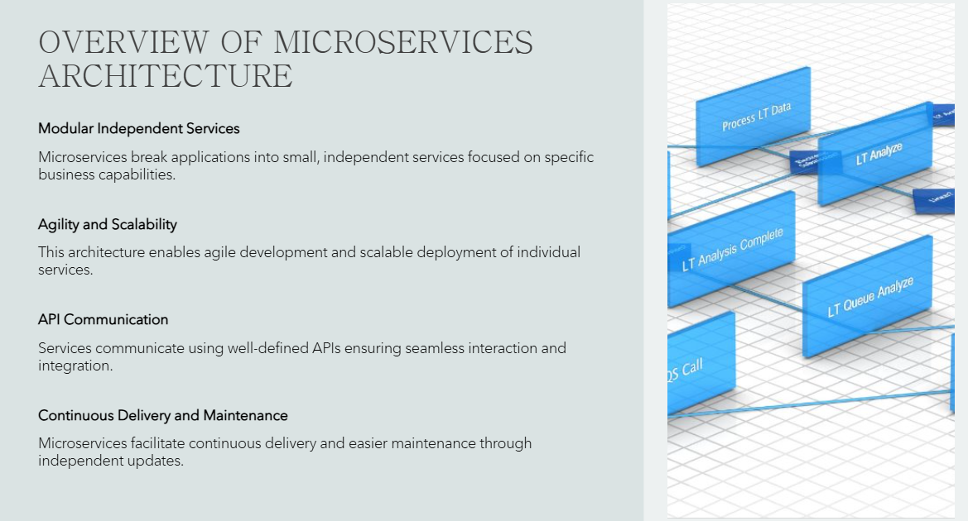  
    
  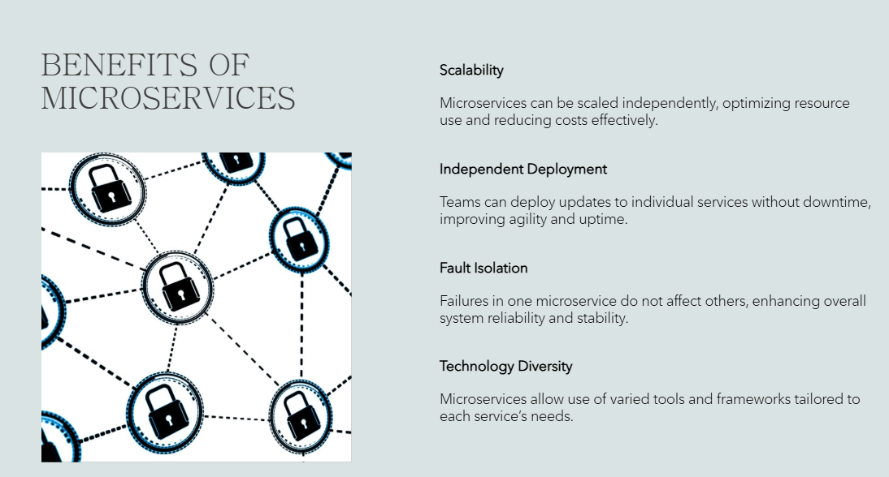  
    
  DESIGN PATTEN IN MICROSERVICES:  
    
  Refer link :   
  [Microservices_Eventdriven_Architecture.pptx](https://capgemini-my.sharepoint.com/:p:/p/tamilselvi_j/EZxAt27RHI1LvJ4-UxMBBWwBKHbsNauFZoFL-n-AjU7eEw?wdOrigin=TEAMS-MAGLEV.undefined_ns.rwc&wdExp=TEAMS-TREATMENT&wdhostclicktime=1756972780027&web=1)  
    
  GATEWAY API DESIGN PATTERN :   
    
  A **Gateway API** (often called an API Gateway) acts as a single entry point for all client requests to a microservices-based system.  
    
  1. Core Components :  
  **API Gateway Service**: A standalone service that receives all client requests.
* **Routing Logic**: Determines which microservice(s) should handle the request.
* **Authentication & Authorization**: Validates tokens or credentials before forwarding requests.
* **Rate Limiting & Throttling**: Controls traffic to prevent overload.
* **Caching**: Stores frequent responses to reduce load.
* **Request Aggregation**: Combines responses from multiple microservices into one.
* **Protocol Translation**: Converts between protocols (e.g., HTTP to gRPC).  
    
  **Use Cases of Gateway API Pattern**
* **✅ 1. Simplified Client Communication**
* Clients interact with a single endpoint rather than multiple microservices. This reduces complexity and improves maintainability.
* **✅ 2. Security Enforcement**
* Centralized authentication and authorization logic ensures consistent security across services.
* **✅ 3. Request Aggregation**
* Useful when a client needs data from multiple microservices. The gateway can fetch and combine the data before sending it back.
* **✅ 4. Protocol Bridging**
* Allows clients to use HTTP while backend services use gRPC, WebSockets, etc.
* **✅ 5. Load Balancing & Failover**
* Distributes requests across instances and handles retries or fallbacks.
* **✅ 6. Canary Releases & A/B Testing**
* Routes a percentage of traffic to new versions of services for testing.

**Example Scenario**

Imagine an **e-commerce platform** with microservices like:

* Product Service
* User Service
* Order Service
* Review Service

Instead of the mobile app calling each service directly, it sends requests to the **API Gateway**, which:

* Authenticates the user
* Routes the request to the correct service
* Aggregates product + review data
* Returns a unified response

Here's a simple example of how to implement a **Spring Cloud Gateway** in a microservices architecture.  
  
**Project Structure**

Assume you have:

* gateway-service (Spring Cloud Gateway)
* user-service (Microservice)
* order-service (Microservice)
* **1. Add Dependencies (Maven)**
* <dependencies>
* <dependency>
* <groupId>org.springframework.cloud</groupId>
* <artifactId>spring-cloud-starter-gateway</artifactId>
* </dependency>
* <dependency>
* <groupId>org.springframework.cloud</groupId>
* <artifactId>spring-cloud-starter-netflix-eureka-client</artifactId>
* </dependency>
* </dependencies>

2. Configure application.yml  
server:

  port: 8080

spring:

  application:

    name: gateway-service

  cloud:

    gateway:

      routes:

        - id: user-service

          uri: lb://user-service

          predicates:

            - Path=/users/**

        - id: order-service

          uri: lb://order-service

          predicates:

* - Path=/orders/**  
    
  Explanation of Code :  
  **Defines routes** for the Gateway to forward requests.
* id: A unique identifier for each route.
* uri: lb://user-service means it uses **load-balanced routing** via a service registry like **Eureka**.
* predicates: Conditions to match incoming requests. Here, it matches paths like /users/** and /orders/**.

3. **Enable Eureka Client**

In GatewayApplication.java:

@SpringBootApplication

@EnableEurekaClient

public class GatewayApplication {

    public static void main(String[] args) {

        SpringApplication.run(GatewayApplication.class, args);

    }

}

4. **4. Sample Routing**

* Request to http://localhost:8080/users/123 → routed to user-service
* Request to http://localhost:8080/orders/456 → routed to order-service

**What is Eureka Service Registry?**

**Eureka** is a **service discovery** tool from Netflix, commonly used in Spring Cloud microservices architecture. It helps microservices **register themselves** and **discover each other** without hardcoding URLs.

**🔄 Key Roles of Eureka:**

1. **Service Registration**: Each microservice registers itself with Eureka when it starts.
2. **Service Discovery**: Other services (or the API Gateway) can query Eureka to find the location (IP/port) of a registered service.
3. **Load Balancing**: Eureka works with Ribbon or Spring Cloud LoadBalancer to distribute requests across multiple instances.
4. **Health Checks**: Eureka periodically checks if services are alive and removes unhealthy ones.

**Why Use @EnableEurekaClient in the Gateway or Microservice?**

The annotation @EnableEurekaClient tells Spring Boot that this application should:

* **Register itself** with the Eureka server
* **Fetch service registry** to discover other services

**📌 In the Gateway:**

* It needs to discover backend services like user-service, order-service, etc.
* So it must be a Eureka client to use lb://service-name URIs in application.yml.

**📌 In Microservices:**

* They register themselves with Eureka so the gateway (or other services) can find them.

**Example Flow**

1. user-service starts → registers with Eureka
2. order-service starts → registers with Eureka
3. gateway-service starts → registers with Eureka and fetches registry
4. Client sends request to gateway-service
5. Gateway uses Eureka to route request to user-service or order-service

CQRS DESIGN PATTERN :   
The **CQRS (Command Query Responsibility Segregation)** design pattern is a powerful architectural approach used in microservices to separate **read** and **write** operations.  
  
CQRS separates the **command side** (write operations like create, update, delete) from the **query side** (read operations like fetch or search). This allows each side to be optimized independently.  
  
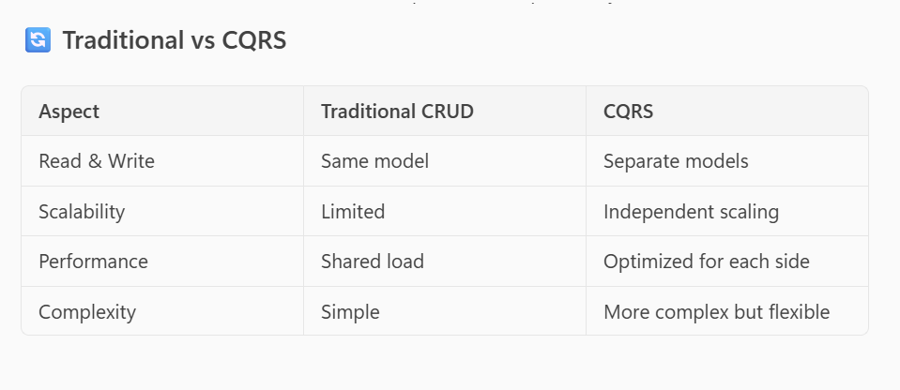  
  
**CQRS in Product Order Service**

**🧩 Microservices Involved**

* **Product Service**
* **Order Service**
* **Query Service** (for read operations)
* **Command Service** (for write operations)
* **Event Store / Message Broker** (e.g., Kafka, RabbitMQ)

**Implementation Flow**

**✅ 1. Command Side (Write)**

* Client sends a **CreateOrderCommand** to the **Command Service**.
* Command Service validates and processes the request.
* It emits an **OrderCreatedEvent** to a message broker.
* The **Order Service** listens to this event and updates its database.

**🔍 2. Query Side (Read)**

* Client sends a **GetOrderQuery** to the **Query Service**.
* Query Service reads from a **read-optimized database** (e.g., denormalized view).
* Returns the result quickly without affecting write performance.
* **Example: Place Order**
* Client → Command API → CreateOrderCommand → Kafka → Order Service → Write DB
* **Example: Get Order Details**
* Client → Query API → GetOrderQuery → Read DB → Response  
    
  **Benefits of CQRS**
* **Scalability**: Read and write workloads scale independently.
* **Performance**: Read models can be optimized for fast queries.
* **Flexibility**: Different data models for read/write.
* **Event Sourcing Compatibility**: Works well with event-driven systems

**What is Event Sourcing in CQRS?**

**Event Sourcing** is a pattern where **state changes are stored as a sequence of events**, rather than just storing the current state in a database.

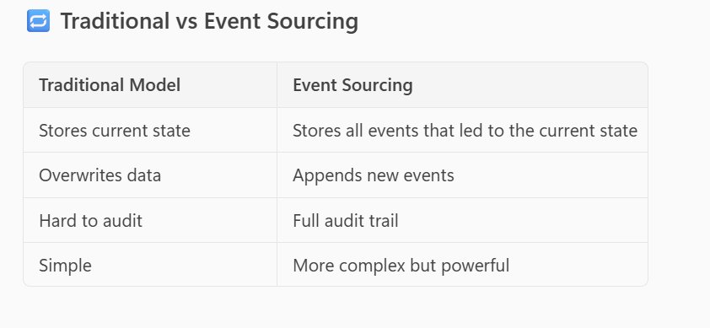  
  
**Example in Product Order Service**

**🧱 Events:**

* ProductCreatedEvent
* OrderPlacedEvent
* OrderCancelledEvent

**🧱 Commands:**

* CreateProductCommand
* PlaceOrderCommand
* CancelOrderCommand

**🧱 State:**

* Rebuilt by replaying events from the **event store**.

**Spring Boot CQRS Code Structure (Simplified) Integrated with Kafka :  
Architecture Overview**

**🔁** Flow:

1. Command API receives a request to place an order.
2. It creates a PlaceOrderCommand and processes it.
3. An OrderPlacedEvent is generated and:
   * Stored in an Event Store
   * Published to Kafka
4. A Query Service listens to Kafka and updates a read model (e.g., MongoDB).
5. Clients query the Query API for order details.  
     
   **Key Components**

**1. Command: PlaceOrderCommand.java**

Code :  
public class PlaceOrderCommand {

    private String orderId;

    private String productId;

    private int quantity;

    // Getters and setters

}

**2. Event: OrderPlacedEvent.java**public class OrderPlacedEvent {

    private String orderId;

    private String productId;

    private int quantity;

    // Constructor, getters, setters

}

3. **Event Store with Kafka Integration**

@Component

public class EventStore {

private final List<Object> events = new ArrayList<>();

@Autowired

private KafkaTemplate<String, Object> kafkaTemplate;

private final String topicName = "order-events";

public void save(Object event) {

events.add(event); // Store locally

kafkaTemplate.send(topicName, event); // Publish to Kafka

}

public List<Object> getEvents() {

return events;

}

}

* 1. **Command Handler**

@Service

public class OrderCommandHandler {

    @Autowired

    private EventStore eventStore;

    public void handle(PlaceOrderCommand command) {

        OrderPlacedEvent event = new OrderPlacedEvent(

            command.getOrderId(),

            command.getProductId(),

            command.getQuantity()

        );

        eventStore.save(event);

    }

}

* 1. **Kafka Consumer in Query Service**

@Service

public class OrderEventListener {

    @KafkaListener(topics = "order-events", groupId = "order-query-group")

    public void consume(OrderPlacedEvent event) {

        // Update read model (e.g., MongoDB)

        System.out.println("Received event: " + event.getOrderId());

        // Save to read DB

    }

}

* 1. **Kafka Configuration (application.yml)**

spring:

  kafka:

    bootstrap-servers: localhost:9092

    consumer:

      group-id: order-query-group

      key-deserializer: org.apache.kafka.common.serialization.StringDeserializer

      value-deserializer: org.springframework.kafka.support.serializer.JsonDeserializer

      properties:

        spring.json.trusted.packages: '*'

    producer:

      key-serializer: org.apache.kafka.common.serialization.StringSerializer

      value-serializer: org.springframework.kafka.support.serializer.JsonSerializer

**Benefits of This Setup**

* **Scalable**: Read and write sides scale independently.
* **Auditable**: Full history of events.
* **Decoupled**: Services communicate via Kafka.
* **Flexible**: Read models can be optimized for queries.

**What is a Messaging Queue in Kafka?**

Kafka is not a traditional messaging queue like RabbitMQ or ActiveMQ. Instead, it's a **distributed event streaming platform** that behaves like a **log-based message broker**.

**🔁 Messaging Queue vs Kafka**

| **Feature** | **Traditional Queue (e.g., RabbitMQ)** | **Kafka** |
| --- | --- | --- |
| Message Model | Queue (FIFO) | Log (append-only) |
| Message Retention | Deleted after consumption | Retained for configured time |
| Consumer Model | Message removed after read | Consumers track their own offset |
| Scalability | Limited | Highly scalable and distributed |
| Replay Capability | No | Yes (replay from offset) |

**🔄 Kafka in CQRS + Event Sourcing**

In our example:

**✅ Kafka as a Message Queue**

* **Producer**: The EventStore publishes events like OrderPlacedEvent to a Kafka topic (order-events).
* **Topic**: Acts like a queue where events are stored in order.
* **Consumer**: The **Query Service** listens to the topic and updates the read model.

**✅ Kafka as an Event Log**

* Events are **not deleted** after consumption.
* Consumers can **replay events** by resetting their offset.
* This supports **event sourcing**, where the system state is rebuilt by replaying events.

**🧠 Why Kafka is Ideal for CQRS + Event Sourcing**

* **Durability**: Events are persisted.
* **Replayability**: You can rebuild read models anytime.
* **Decoupling**: Producers and consumers are independent.
* **Scalability**: Handles high throughput and distributed systems.

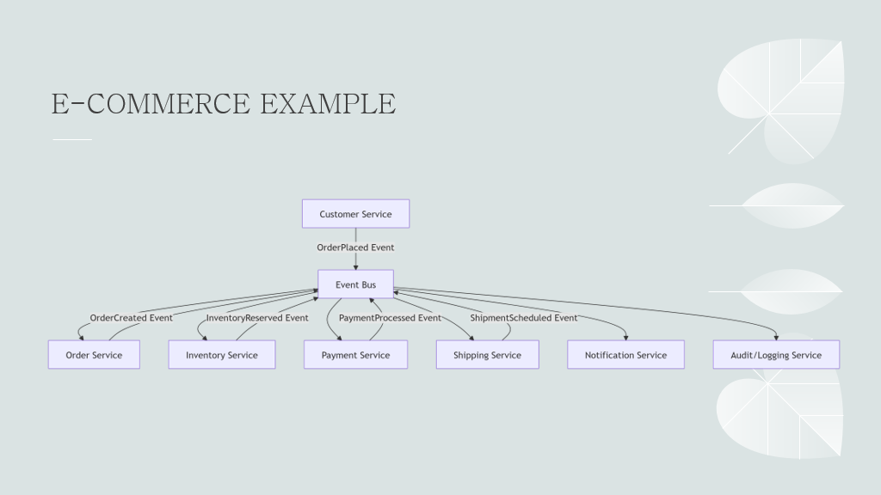

**SAGA DESIGN PATTERN :**The **Saga Design Pattern** is a crucial concept in **microservices architecture** for managing **distributed transactions**. Since traditional ACID transactions don't work well across microservices, Saga provides a way to ensure data consistency using a sequence of **local transactions** and **compensating actions**.

In the context of **microservices architecture**, **ACID transactions** refer to operations that follow the **ACID properties** — **Atomicity, Consistency, Isolation, and Durability** — to ensure reliable processing of data. However, implementing ACID transactions across microservices is **challenging** due to their **distributed nature**.

Let’s break this down:

**🔍 What Are ACID Properties?**

1. **Atomicity**: All steps in a transaction succeed or none do.
2. **Consistency**: The system moves from one valid state to another.
3. **Isolation**: Concurrent transactions do not interfere with each other.
4. **Durability**: Once a transaction is committed, it remains so even in case of failures.

**🧩 ACID in Microservices: Why It's Hard**

Microservices are typically:

* **Distributed across different databases**
* **Loosely coupled**
* **Independently deployable**

This makes **traditional ACID transactions** (like those in monolithic systems using a single relational database) difficult to implement across services.

**✅ How ACID Is Achieved in Microservices**

Instead of strict ACID, microservices often use **eventual consistency** and **patterns** like:

**1. Saga Pattern**

* Breaks a transaction into a series of **local transactions**.
* Each service performs its part and publishes an event.
* If something fails, **compensating transactions** are triggered to undo previous steps.

**Types of Saga Design Pattern**

There are two main types:

**1. Choreography-Based Saga**

* **No central coordinator**.
* Services communicate via **events**.
* Each service listens for events and performs its transaction, then publishes the next event.

**Use Case**: Lightweight, loosely coupled systems where services can react to events independently.

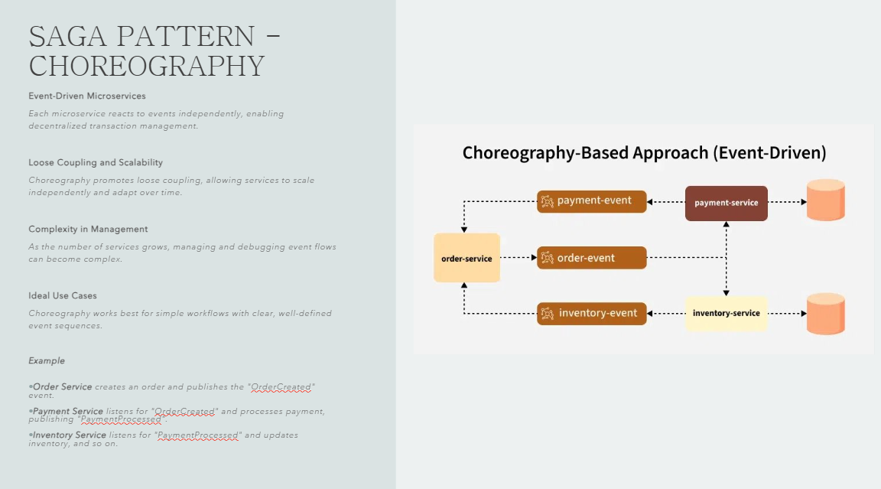  
  
2. **2. Orchestration-Based Saga**

* A **central orchestrator** controls the saga.
* It sends commands to services and listens for replies.
* Easier to manage and debug.

**Use Case**: Complex workflows where centralized control is preferred.  
 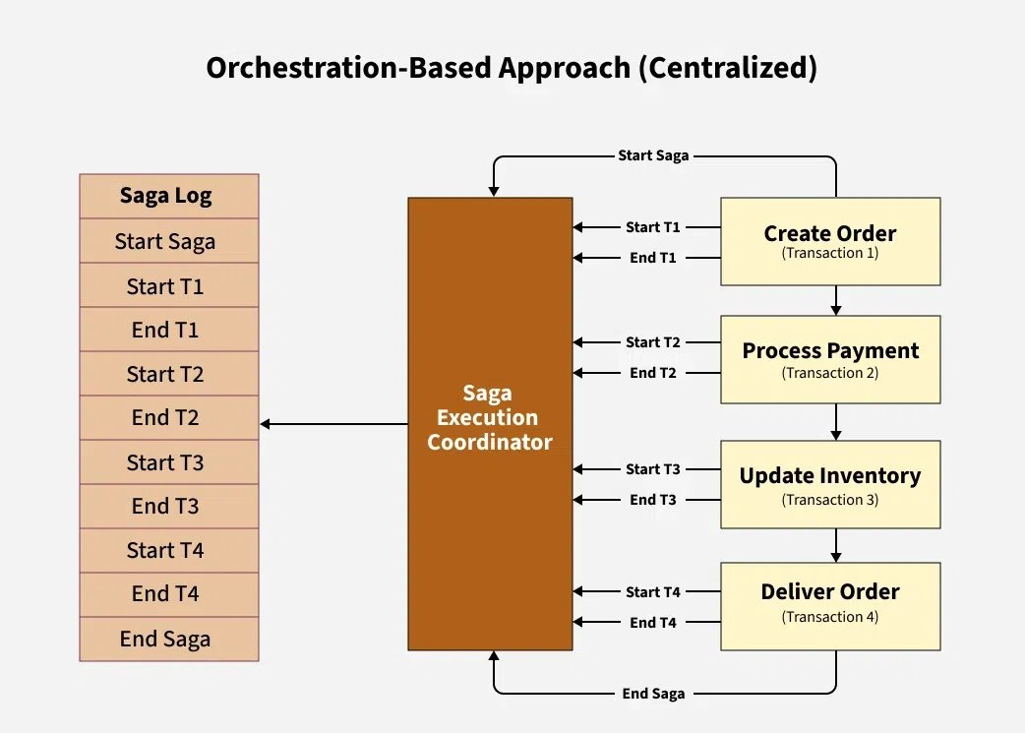

**Example: Spring Boot Implementation**

Let’s walk through both types with a simple **Order Service** scenario:

* **Order Service** creates an order.
* **Payment Service** processes payment.
* **Inventory Service** reserves items.

**Choreography-Based Saga (Spring Boot + Kafka)**

**[1]Order Service publishes OrderCreatedEvent:**public void createOrder(Order order) {

    orderRepository.save(order);

    kafkaTemplate.send("order-events", new OrderCreatedEvent(order.getId()));

}

[2] **Payment Service listens and publishes PaymentCompletedEvent**

@KafkaListener(topics = "order-events")

public void handleOrderCreated(OrderCreatedEvent event) {

    // process payment

    kafkaTemplate.send("payment-events", new PaymentCompletedEvent(event.getOrderId()));

}  
  
**Inventory Service listens and reserves items**

@KafkaListener(topics = "payment-events")

public void handlePaymentCompleted(PaymentCompletedEvent event) {

    // reserve inventory

    kafkaTemplate.send("inventory-events", new InventoryReservedEvent(event.getOrderId()));

}

**Orchestration-Based Saga (Spring Boot + Camunda or Custom Orchestrator)**

**1. Saga Orchestrator initiates the saga**

public void startSaga(Order order) {

    orderService.createOrder(order);

    paymentService.processPayment(order.getId());

}  
  
**2. Orchestrator handles responses and calls next service**public void handlePaymentResponse(PaymentResponse response) {

    if (response.isSuccess()) {

        inventoryService.reserveItems(response.getOrderId());

    } else {

        orderService.cancelOrder(response.getOrderId());

}

}

**Compensation Logic**

Each service should implement a rollback method:

**Java**

public void cancelOrder(Long orderId) {

Order order = orderRepository.findById(orderId).orElseThrow();

order.setStatus("CANCELLED");

orderRepository.save(order);

}

| **Type** | **Communication** | **Complexity** | **Use Case** |
| --- | --- | --- | --- |
| Choreography | Event-driven | Low | Simple workflows |
| Orchestration | Central control | High | Complex workflows |

----------------------------------------------------------------------------------------------  
**Service Registry Pattern :**In a microservices architecture, services often need to discover and communicate with each other dynamically. A **Service Registry** acts as a **central directory** where services register themselves and discover other services.  
  
**Benefits:**

* **Dynamic discovery**: Services can find each other without hardcoding URLs.
* **Load balancing**: Registry can integrate with load balancers.
* **Fault tolerance**: Helps reroute traffic if a service goes down.
* **Scalability**: Easily add/remove services.

**Common Tools for Service Registry**

* **Eureka** (from Netflix) – most popular with Spring Boot.
* **Consul** – by HashiCorp.
* **Zookeeper** – often used with Kafka.
* **Implementing Service Registry in Spring Boot using Eureka**
* **1. Set up Eureka Server**

Add dependencies in pom.xml :  
<dependency>

    <groupId>org.springframework.cloud</groupId>

    <artifactId>spring-cloud-starter-netflix-eureka-server</artifactId>

</dependency>

2. Enable Eureka Server in your main class:  
  
@SpringBootApplication

@EnableEurekaServer

public class EurekaServerApplication {

    public static void main(String[] args) {

        SpringApplication.run(EurekaServerApplication.class, args);

    }

}

3. In application.yml or application.properties:  
server:

  port: 8761

eureka:

  client:

    register-with-eureka: false

    fetch-registry: false

**register-with-eureka: false**

This tells the Eureka Server **not to register itself** with another Eureka instance.

* ✅ **Why?** Because it's the **main registry**—it doesn't need to register with another server.
* 🔄 If you had a **cluster of Eureka servers**, you might set this to true so they can replicate data between each other.

**🔍 fetch-registry: false**

This tells the Eureka Server **not to fetch the registry** from another Eureka instance.

* ✅ **Why?** Again, it's the **source of truth** for service registrations.
* 🔄 In a **peer-aware setup** (multiple Eureka servers), you might set this to true to enable syncing between them.
* **2. Create a Microservice and Register with Eureka**
* Add Eureka client dependency:

<dependency>

    <groupId>org.springframework.cloud</groupId>

    <artifactId>spring-cloud-starter-netflix-eureka-client</artifactId>

</dependency>

Enable Eureka Client:  
  
@SpringBootApplication

@EnableEurekaClient

public class ProductServiceApplication {

    public static void main(String[] args) {

        SpringApplication.run(ProductServiceApplication.class, args);

    }

}  
  
In application.yml:  
  
server:

  port: 8081

spring:

  application:

    name: product-service

eureka:

  client:

    service-url:

      defaultZone: http://localhost:8761/eureka/  
  
**3. Service Discovery Using RestTemplate or Feign**

**Using RestTemplate:**

@Autowired

private RestTemplate restTemplate;

public String getOrderDetails() {

    return restTemplate.getForObject("http://order-service/orders", String.class);

}

**Make sure to annotate RestTemplate with @LoadBalanced:**@Bean

@LoadBalanced

public RestTemplate restTemplate() {

    return new RestTemplate();

}  
  
**How Eureka Service Discovery Works**

1. Service Registration

Each microservice (e.g., order-service, product-service) registers itself with the Eureka Server when it starts up.

In its application.yml:

spring:

  application:

    name: order-service

eureka:

  client:

    service-url:

      defaultZone: http://localhost:8761/eureka/  
  
This means:

* The service will **send a heartbeat** to http://localhost:8761/eureka/ to register itself.
* It uses the spring.application.name (order-service) as its **service ID**.
* **2. Service Discovery**
* When another service (e.g., product-service) wants to call order-service, it doesn't need the actual IP or port. Instead, it uses the **logical name**:

restTemplate.getForObject("http://order-service/orders", String.class);

This works because:

* RestTemplate is annotated with @LoadBalanced, which enables **client-side load balancing** using **Ribbon** (or Spring Cloud LoadBalancer).
* Eureka provides a list of instances for order-service.
* Ribbon picks one instance and resolves the actual IP and port.

**3. Behind the Scenes**

Here's what happens step-by-step:

1. product-service starts and registers with Eureka.
2. It also **fetches the registry** from Eureka (list of all services).
3. When RestTemplate calls http://order-service/orders, it:
   * Looks up order-service in the registry.
   * Gets the actual IP and port (e.g., http://localhost:8082).
   * Makes the HTTP call.

---------------------------------------------------------------------------------------------------------  
**Circuit breaker pattern its usage and how it is implemented in microservices**  
  
The **Circuit Breaker Pattern** is a crucial design pattern in **microservices architecture** that helps improve system resilience and fault tolerance. Here's a breakdown of its **usage**, **benefits**, and **implementation**:  
  
**What is the Circuit Breaker Pattern?**

It’s inspired by electrical circuit breakers. In software systems, it prevents a service from repeatedly trying to execute an operation that's likely to fail—especially when a downstream service is unavailable or slow.

**Why Use It in Microservices?**

Microservices often depend on other services. If one service fails or becomes slow, it can cause cascading failures. The circuit breaker pattern helps by:

* **Preventing resource exhaustion** (e.g., thread pools, memory)
* **Failing fast** instead of waiting for timeouts
* **Allowing recovery** by retrying after a cooldown period
* **Improving system stability and responsiveness**

**States of a Circuit Breaker**

1. **Closed**: Requests flow normally. If failures exceed a threshold, it transitions to **Open**.
2. **Open**: Requests are blocked immediately. After a timeout, it transitions to **Half-Open**.
3. **Half-Open**: A limited number of requests are allowed. If they succeed, it goes back to **Closed**; if they fail, it returns to **Open**.

**Example with Resilience4j (Spring Boot)**@Bean

public CircuitBreakerRegistry circuitBreakerRegistry() {

    return CircuitBreakerRegistry.ofDefaults();

}

@CircuitBreaker(name = "myService", fallbackMethod = "fallbackMethod")

public String callExternalService() {

    // Call to external microservice

}

public String fallbackMethod(Throwable t) {

    return "Fallback response";

#### } **3. Configuration Options**

* Failure rate threshold
* Wait duration in open state
* Permitted calls in half-open state
* Timeout duration

**Monitoring and Metrics**

Integrate with tools like:

* **Prometheus + Grafana**
* **Spring Boot Actuator**
* **ELK Stack**

------------------------------------------------------------------------------------------------------------  
 **complete example** of how to implement the **Circuit Breaker Pattern** in a **Spring Boot application** using **Resilience4j** and **Spring Boot Actuator** for monitoring.  
**Step-by-Step Implementation**

**1. Add Dependencies**

In your pom.xml:

<dependencies>

    <!-- Spring Boot Starter Web -->

    <dependency>

        <groupId>org.springframework.boot</groupId>

        <artifactId>spring-boot-starter-web</artifactId>

    </dependency>

    <!-- Resilience4j Circuit Breaker -->

    <dependency>

        <groupId>io.github.resilience4j</groupId>

        <artifactId>resilience4j-spring-boot2</artifactId>

    </dependency>

    <!-- Spring Boot Actuator -->

    <dependency>

        <groupId>org.springframework.boot</groupId>

        <artifactId>spring-boot-starter-actuator</artifactId>

    </dependency>

</dependencies>  
  
---------------------------------------------------------------------------------------------------------  
**2. Create a Service with Circuit Breaker**

@CircuitBreaker(name = "externalService", fallbackMethod = "fallbackResponse")

public String callExternalService() {

    // This might fail due to network issues, timeouts, etc.

    return restTemplate.getForObject("http://some-service/api", String.class);

}

public String fallbackResponse(Throwable t) {

    // This gets called when the above method fails or circuit is open

    return "Service is currently unavailable. Please try again later.";

}  
  
**Explanation:**

* @CircuitBreaker(name = "externalServiceCB"): Tells Resilience4j to apply circuit breaker logic.
* fallbackResponse(Throwable t): Called when the circuit is open or the method fails.

**3. Create a REST Controller**import org.springframework.web.bind.annotation.GetMapping;

import org.springframework.web.bind.annotation.RestController;

@RestController

public class ApiController {

    private final ExternalService externalService;

    public ApiController(ExternalService externalService) {

        this.externalService = externalService;

    }

    @GetMapping("/test")

    public String testCircuitBreaker() {

        return externalService.callExternalApi();

    }

}  
  
**4. Configure Circuit Breaker in application.yml**resilience4j:

  circuitbreaker:

    instances:

      externalServiceCB:

        registerHealthIndicator: true

        slidingWindowSize: 5

        failureRateThreshold: 50

        waitDurationInOpenState: 10s

        permittedNumberOfCallsInHalfOpenState: 2

        minimumNumberOfCalls: 5

        automaticTransitionFromOpenToHalfOpenEnabled: true

management:

  endpoints:

    web:

      exposure:

        include: health,info,metrics

**Explanation of config:**

* failureRateThreshold: If 50% of calls fail, the circuit opens.
* waitDurationInOpenState: Time to wait before transitioning to half-open.
* permittedNumberOfCallsInHalfOpenState: Number of test calls allowed.
* registerHealthIndicator: Enables health check via Actuator.

**5. Monitor with Actuator**

Once running, you can access:

* **Health endpoint**: http://localhost:8080/actuator/health
* **Metrics endpoint**: http://localhost:8080/actuator/metrics/resilience4j.circuitbreaker.calls

These show the state of the circuit breaker and metrics like success/failure rates.  
  
**✅ Summary**

This setup:

* Protects your service from cascading failures.
* Automatically retries after a cooldown.
* Provides observability via Spring Boot Actuator.

----------------------------------------------------------------------------------------------------------------  
  
**Marker interface:  
In Java, a marker interface is an interface that does not contain any methods or fields**. It is used to **mark** or **tag** a class so that it can be recognized by the JVM or other frameworks for **special behaviour.  
  
Purpose of Marker Interface**

Marker interfaces are typically used to signal to the compiler or JVM that a class has a particular property or should be treated in a specific way.

**🔹 Common Examples in Java**

* Serializable
* Cloneable
* Remote

These interfaces are used by the JVM or libraries to enable certain functionalities.  
  
Serializable Marker Interface :   
  
**Serialization is the process of converting an object into a format(Bytes) that can be easily stored or transmitted and then reconstructed later. The reverse process is called deserialization.**

import java.io.*;

class Employee implements Serializable {

    int id;

    String name;

    public Employee(int id, String name) {

        this.id = id;

        this.name = name;

    }

}

public class MarkerInterfaceExample {

    public static void main(String[] args) {

        Employee emp = new Employee(101, "Ankur");

        try {

            // Serialize the object

            FileOutputStream fos = new FileOutputStream("employee.ser");

            ObjectOutputStream oos = new ObjectOutputStream(fos);

            oos.writeObject(emp);

            oos.close();

            fos.close();

            System.out.println("Object has been serialized");

            // Deserialize the object

            FileInputStream fis = new FileInputStream("employee.ser");

            ObjectInputStream ois = new ObjectInputStream(fis);

            Employee deserializedEmp = (Employee) ois.readObject();

            ois.close();

            fis.close();

            System.out.println("Deserialized Employee: " + deserializedEmp.name);

        } catch (Exception e) {

            e.printStackTrace();

        }

    }

}  
-----------------------------------------------------------------------------------------------------------  
**what is string buffer and string builder** ?  
In Java, both **StringBuffer** and **StringBuilder** are classes used to create and manipulate **mutable strings**—strings that can be changed after they are created. They are alternatives to the immutable String class.  
  
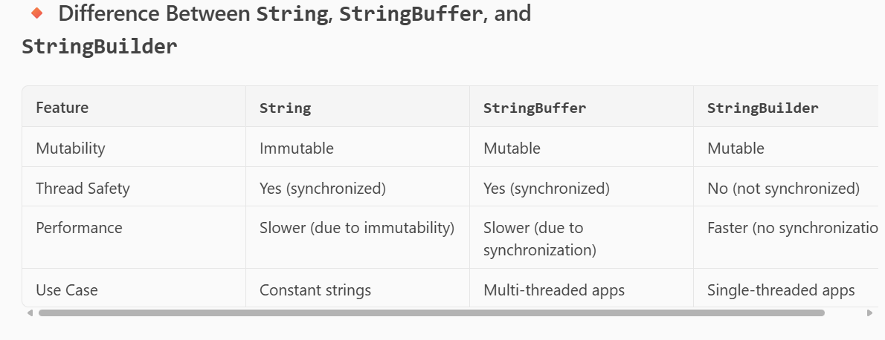  
  
**StringBuffer Example (Thread-safe)**:  
  
public class StringBufferExample {

    public static void main(String[] args) {

        StringBuffer sb = new StringBuffer("Hello");

        sb.append(" World");

        sb.insert(5, ",");

        sb.replace(6, 11, "Java");

        sb.reverse();

        System.out.println(sb);  // Output: avaJ ,olleH

    }

}  
---------------------------------------------------------------------------------------------------------  
**🔸 Explanation:**

* append() adds text.
* insert() inserts text at a position.
* replace() replaces part of the string.
* reverse() reverses the string.

----------------------------------------------------------------------------------------------------------  
  
**StringBuilder Example (Not thread-safe but faster)**:  
  
public class StringBuilderExample {

    public static void main(String[] args) {

        StringBuilder sb = new StringBuilder("Hello");

        sb.append(" World");

        sb.insert(5, ",");

        sb.replace(6, 11, "Java");

        sb.reverse();

        System.out.println(sb);  // Output: avaJ ,olleH

    }

}

------------------------------------------------------------------------------------------------------  
**✅ When to Use What?**

* Use **String** when the content won’t change.
* Use **StringBuffer** when working in **multi-threaded** environments.
* Use **StringBuilder** for **better performance** in **single-threaded** environments.

-------------------------------------------------------------------------------------------------------  
Data Types :   
**🔹 Primitive Data Types**

These are the **basic building blocks** of data. They are predefined by the programming language.

Examples:

* **int** – Integer (e.g., 5, -10)
* **float** – Decimal numbers (e.g., 3.14)
* **char** – Single character (e.g., 'A')
* **boolean** – True or False

**🔹 Non-Primitive Data Types**

These are **more complex** and are created using primitive types. They can store multiple values.

Examples:

* **Array**
* **String**
* **Class**
* **Object**
* **List**, **Map**, **Set** (in languages like Java, Python, etc.)

**----------------------------------------------------------------------------------------------------------------**

**shallow copy vs deep copy  
  
🔹 Shallow Copy**

**A shallow copy creates a new object, but does not create copies of nested objects. Instead, it copies references to them.**

import copy

original = [[1, 2], [3, 4]]

shallow = copy.copy(original)

shallow[0][0] = 99

print("Original:", original)

print("Shallow:", shallow)  
  
**Output:**

**Original: [[99, 2], [3, 4]]**

**Shallow: [[99, 2], [3, 4]]  
----------------------------------------------------------------------------------------------------------  
✅ The outer list is copied,  
❌ but the inner lists are shared between original and shallow.  
----------------------------------------------------------------------------------------------------------------  
Deep Copy**

A **deep copy** creates a **new object and recursively copies all nested** objects  
  
import copy

original = [[1, 2], [3, 4]]

deep = copy.deepcopy(original)

deep[0][0] = 99

print("Original:", original)

print("Deep:", deep)

-----------------------------------------------------------------------------------------------  
**Output:**

Original: [[1, 2], [3, 4]]

Deep: [[99, 2], [3, 4]]

------------------------------------------------------------------------------------------------  
✅ Both the outer and inner lists are **completely independent**. **---------------------------------------------------------------------------------------------**

**Java Cloning with Cloneable**

In Java, the Cloneable interface allows an object to be cloned using the clone() method from the Object class. By default, clone() performs a **shallow copy**.

-----------------------------------------------------------------------------------------------  
✅ **Shallow Copy Example (Using Cloneable):**class Address {

    String city;

    Address(String city) {

        this.city = city;

    }

}

class Person implements Cloneable {

    String name;

    Address address;

    Person(String name, Address address) {

        this.name = name;

        this.address = address;

    }

    public Object clone() throws CloneNotSupportedException {

        return super.clone(); // shallow copy

    }

}

public class Main {

    public static void main(String[] args) throws CloneNotSupportedException {

        Address addr = new Address("Bangalore");

        Person p1 = new Person("Ankur", addr);

        Person p2 = (Person) p1.clone();

        p2.address.city = "Mumbai";

        System.out.println(p1.address.city); // Output: Mumbai

        System.out.println(p2.address.city); // Output: Mumbai

    }

}  
  
-------------------------------------------------------------------------------------------------------  
**What happened?**

* p1 and p2 are different objects.
* But their address field **points to the same object** → shallow copy.

----------------------------------------------------------------------------------------------------  
**✅ Deep Copy Example (Manual Cloning)**

To achieve deep copy, you need to **manually clone nested objects**:

-------------------------------------------------------------------------------  
class Address implements Cloneable {

    String city;

    Address(String city) {

        this.city = city;

    }

    public Object clone() throws CloneNotSupportedException {

        return super.clone();

    }

}

class Person implements Cloneable {

    String name;

    Address address;

    Person(String name, Address address) {

        this.name = name;

        this.address = address;

    }

    public Object clone() throws CloneNotSupportedException {

        Person cloned = (Person) super.clone();

        cloned.address = (Address) address.clone(); // deep copy

        return cloned;

    }

}

public class Main {

    public static void main(String[] args) throws CloneNotSupportedException {

        Address addr = new Address("Bangalore");

        Person p1 = new Person("Ankur", addr);

        Person p2 = (Person) p1.clone();

        p2.address.city = "Mumbai";

        System.out.println(p1.address.city); // Output: Bangalore

        System.out.println(p2.address.city); // Output: Mumbai

    }

}  
---------------------------------------------------------------------------------------------------------

Interview crisp :   
**Shallow Copy in Java**

* **Definition**: Copies the object and its primitive fields, but **references** to nested objects are shared.
* **Method**: Achieved using Object.clone() with Cloneable interface.
* **Effect**: Changes to nested objects in the clone affect the original.  
  -------------------------------------------------------------------------  
  **public Object clone() throws CloneNotSupportedException {**

**return super.clone(); // shallow copy**

**}**  
------------------------------------------------------------------

**✅ Deep Copy in Java**

* **Definition**: Copies the object and **recursively clones all nested objects**.
* **Method**: Requires manual cloning of nested objects.
* **Effect**: Changes in the clone do **not** affect the original.  
    
  --------------------------------------------------------------------  
  public Object clone() throws CloneNotSupportedException {

    Person cloned = (Person) super.clone();

    cloned.address = (Address) address.clone(); // deep copy

    return cloned;

}

-------------------------------------------------------------------  
  
Design Patterns in Java :  
  
**Creational Patterns**

These deal with object creation mechanisms.

1. **Singleton**
   * Ensures only one instance of a class exists.
   * Used for logging, configuration, etc.
   * private constructor + static instance + getInstance()
2. **Factory Method**
   * Defines an interface for creating objects, but lets subclasses decide which class to instantiate.
   * Promotes loose coupling.
3. **Abstract Factory**
   * Provides an interface to create families of related objects.
   * Example: GUI toolkit for different OS.
4. **Builder**
   * Separates object construction from its representation.
   * Useful for creating complex objects step-by-step.
5. **Prototype**
   * Clones existing objects instead of creating new ones.
   * Uses clone() method.

**Structural Patterns**

These deal with object composition.

1. **Adapter**
   * Converts one interface to another.
   * Example: USB to Ethernet adapter.
2. **Decorator**
   * Adds behavior to objects dynamically.
   * Example: Adding scrollbars to a window.
3. **Facade**
   * Provides a simplified interface to a complex subsystem.
   * Example: JDBC hides database connection complexity.
4. **Composite**
   * Treats individual objects and compositions uniformly.
   * Example: File system (files and folders).
5. **Proxy**
   * Controls access to another object.
   * Example: Virtual proxy for lazy loading.

**Behavioral Patterns**

These deal with object interaction and responsibility.

1. **Observer**
   * One-to-many dependency; when one object changes, others are notified.
   * Example: Event listeners in GUI.
2. **Strategy**
   * Defines a family of algorithms, encapsulates each, and makes them interchangeable.
   * Example: Sorting strategies.
3. **Command**
   * Encapsulates a request as an object.
   * Example: Undo/Redo functionality.
4. **Template Method**
   * Defines the skeleton of an algorithm, deferring steps to subclasses.
   * Example: Game loop structure.
5. **State**
   * Allows an object to change its behavior when its internal state changes.
   * Example: Traffic light system.
6. **Chain of Responsibility**
   * Passes request along a chain of handlers.
   * Example: Logging levels (INFO → DEBUG → ERROR).  
       
     ---------------------------------------------------------------------------------  
     Singelton pattern -> refer from java arora 200 questions.  
       
     **What is Singleton Design Pattern?**Singleton design pattern comes under Creational Design Patterns category

and **this pattern ensures that only one instance of class exists in the JVM**.  
  
*How to implement Singleton Pattern*

To implement a Singleton pattern, we have different approaches but all of

them have the below common concepts:

**- private constructor to restrict instantiation of the class from the other classes.**

**- private static variable of the same class that is the only instance of the class.**

**- public static method that returns the instance of the class,this is the global access point for outer world to get the instance of the singleton class.  
-----------------------------------------------------------------------------------  
  
Eager Initialization :**In **eager Initialization** the instance of Singleton Class is

**created at the time of class loading**, this is the easiest method to create a

singleton class but **it has a drawback that instance is created even though**

**client application might not even use it.  
  
  
  
Output :** **---------------------------------------------------------------------------------------------------  
Lazy Initialization : using this way of creating Singleton class, the object will**

**not get created unless someone asks for it. Here we will create the class**

**instance inside the global access method.  
  
  
  
suppose there are 2 threads and both have checked that the instance is null and now they are inside the “if(…)” condition, it will destroy our singleton pattern and both threads will have different instances.  
  
Thread Safe Singleton implementation**: here the easiest way to prevent

multiple threads from creating more than one instance is to make the

global access method ‘synchronized’, this way threads will acquire a lock

first before entering the getInstance() method.  
  
  
---------------------------------------------------------------------------  
Using **enum for Singleton** in Java is considered the **most effective and safest way** to implement the Singleton design pattern.  
**Why enum is Useful for Singleton**

1. **Thread Safety**: Enum instances are created in a thread-safe manner by the JVM.
2. **Serialization Safe**: Enum handles serialization internally and guarantees a single instance.
3. **Reflection Safe**: You cannot create another instance of an enum using reflection.
4. **Simplicity**: Very concise and readable code.  
   -----------------------------------------------------------------------------------------------  
   public enum SingletonEnum {

    INSTANCE;

public void showMessage() {

        System.out.println("Hello from Enum Singleton!");

}}  
------------------------------------------------------------  
Usage :  
public class Main {

    public static void main(String[] args) {

        SingletonEnum singleton = SingletonEnum.INSTANCE;

        singleton.showMessage();

    }

}  
---------------------------------------------------------------------------  
**How to Break Singleton Pattern**

Here are **three common ways** to break Singleton in Java (similar concepts apply in other languages too):

**[1]Using Cloning**

If the Singleton class implements Cloneable, cloning can create a new instance:  
  
Singleton instance1 = Singleton.getInstance();

Singleton instance2 = (Singleton) instance1.clone();

System.out.println(instance1 == instance2); // false  
  
[2] **Using Serialization/Deserialization**

Serialization can create a new instance during deserialization.

ObjectOutputStream out = new ObjectOutputStream(new FileOutputStream("singleton.ser"));

out.writeObject(Singleton.getInstance());

ObjectInputStream in = new ObjectInputStream(new FileInputStream("singleton.ser"));

Singleton instance2 = (Singleton) in.readObject();

System.out.println(Singleton.getInstance() == instance2); // false  
  
-------------------------------------------------------------------------------------------

[3] Using Reflection :   
Even if a class enforces Singleton using a private constructor, **reflection can bypass it** and create a new instance.  
  
Example: Breaking Singleton

class Singleton {

    private static Singleton instance = new Singleton();

    private Singleton() {

        // Prevent instantiation

    }

    public static Singleton getInstance() {

        return instance;

    }

}

----------------------------------------------------------------------------------------  
**What is Reflection in Java?**

**Reflection** in Java is a powerful feature that allows a program to inspect and manipulate classes, methods, fields, and constructors **at runtime**, even if they are private.

It’s part of the java.lang.reflect package and is commonly used in:

* Frameworks (like Spring, Hibernate)
* Dependency injection
* Testing tools
* Serialization/deserialization

-----------------------------------------------------------------------------------------  
When to Use Singleton Pattern

Use Singleton when:

1. Exactly one instance of a class is needed to coordinate actions across the system.
2. You need global access to that instance.
3. The instance holds shared resources like:
   * Configuration settings
   * Logging
   * Thread pools
   * Database connections
   * Caches  
       
     ----------------------------------------------------------------------------------------------  
     Factory Design Pattern :  
     The **Factory Design Pattern** is a **creational design pattern** used in object-oriented programming to create objects without specifying the exact class of object that will be created. It's especially useful when the creation process is complex or when the code needs to be decoupled from the specific classes it instantiates.  
     ----------------------------------------------------------------------------------------------  
       
     **Real-World Analogy**
   * Imagine a **car factory**. You request a car by type (e.g., SUV, Sedan), and the factory gives you the correct model. You don’t need to know how it's built internally.  
     ---------------------------------------------------------------------------------------------

**Basic Structure**

1. **Product Interface** – defines the common interface.
2. **Concrete Products** – classes that implement the interface.
3. **Factory Class** – contains logic to instantiate the correct product.

Code :  
// Step 1: Product Interface

interface Shape {

    void draw();

}

// Step 2: Concrete Products

class Circle implements Shape {

    public void draw() {

        System.out.println("Drawing a Circle");

    }

}

class Square implements Shape {

    public void draw() {

        System.out.println("Drawing a Square");

    }

}

// Step 3: Factory Class

class ShapeFactory {

    public Shape getShape(String shapeType) {

        if (shapeType == null) return null;

        if (shapeType.equalsIgnoreCase("CIRCLE")) return new Circle();

        if (shapeType.equalsIgnoreCase("SQUARE")) return new Square();

        return null;

    }

}

// Step 4: Client Code

public class FactoryPatternDemo {

    public static void main(String[] args) {

        ShapeFactory shapeFactory = new ShapeFactory();

        Shape shape1 = shapeFactory.getShape("CIRCLE");

        shape1.draw();

        Shape shape2 = shapeFactory.getShape("SQUARE");

        shape2.draw();

    }

}  
  
---------------------------------------------------------------------------------------------  
**Key Benefits**

* **Encapsulation** of object creation.
* **Loose coupling** between client and concrete classes.
* **Scalability** – easy to add new types without changing existing code.  
  -------------------------------------------------------------------------------------------------  
    
  When to use Factory Design Pattern :  
  **“I use the Factory Pattern when I want to abstract away the instantiation logic, especially when dealing with multiple implementations of an interface. It helps keep the client code clean and promotes scalability.”  
    
  🔹 1. When You Have Multiple Subclasses**
* If a class has multiple subclasses and you need to instantiate one based on input or configuration, a factory can centralize this logic.
* **Example**: Creating different types of Shape objects like Circle, Square, Triangle.
* **🔹 2. When Object Creation Is Complex**
* If creating an object involves complex logic (e.g., setting up dependencies, configurations), a factory hides this complexity from the client.
* **🔹 3. When You Want to Decouple Client Code**
* Clients should not be tightly coupled to specific classes. Factory pattern allows you to use interfaces or abstract classes, making the system more flexible and testable.
* **🔹 4. When You Need Runtime Decision Making**
* If the type of object to be created is determined at runtime (e.g., based on user input or external config), a factory can handle this dynamically.
* **🔹 5. When You Want to Follow SOLID Principles**
* **Single Responsibility**: Factory handles creation logic.
* **Open/Closed**: Easy to add new types without modifying existing code.
* **Dependency Inversion**: Clients depend on abstractions, not concrete classes.
* ----------------------------------------------------------------------------------------------  
  SOLID PRINCIPAL IN JAVA:  
  **S – Single Responsibility Principle (SRP)**
* A class should have **only one reason to change**, meaning it should have **only one job** or responsibility.
* ✅ Helps in making code **easier to maintain and test**.
* **🔹 O – Open/Closed Principle (OCP)**
* Software entities (classes, modules, functions) should be **open for extension** but **closed for modification**.
* ✅ You can **add new functionality** without changing existing code.
* **🔹 L – Liskov Substitution Principle (LSP)**
* Subtypes must be **substitutable** for their base types without altering the correctness of the program.
* ✅ Ensures **polymorphism works safely**.
* **🔹 I – Interface Segregation Principle (ISP)**
* Clients should **not be forced to depend** on interfaces they do not use.
* ✅ Promotes **smaller, more specific interfaces**.
* **🔹 D – Dependency Inversion Principle (DIP)**
* High-level modules should **not depend on low-level modules**. Both should depend on **abstractions**.
* ✅ Encourages **loose coupling** and **flexibility**.  
  -----------------------------------------------------------------------------------------
* **🔹 Real-World Examples**
* GUI toolkits: Creating buttons for different OS (WindowsButton, MacButton).
* Notification systems: EmailNotification, SMSNotification, PushNotification.

Payment gateways: PayPal, Stripe, Razorpay.  
  
--------------------------------------------------------------------------------------------------  
@Qualifer annotation : **We can achieve same thing using @Qualifer annotation  
Questions asked : What to do if two beans are there in same class ?**  
**\* Two classes implement common interface** 🡪 Goal   
  
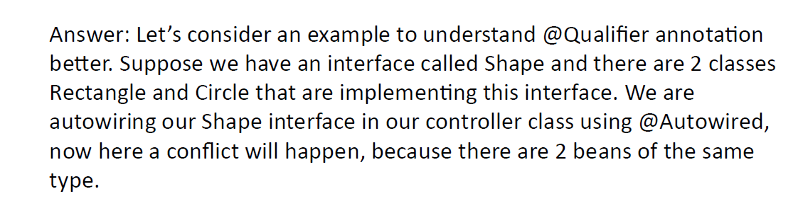  
  
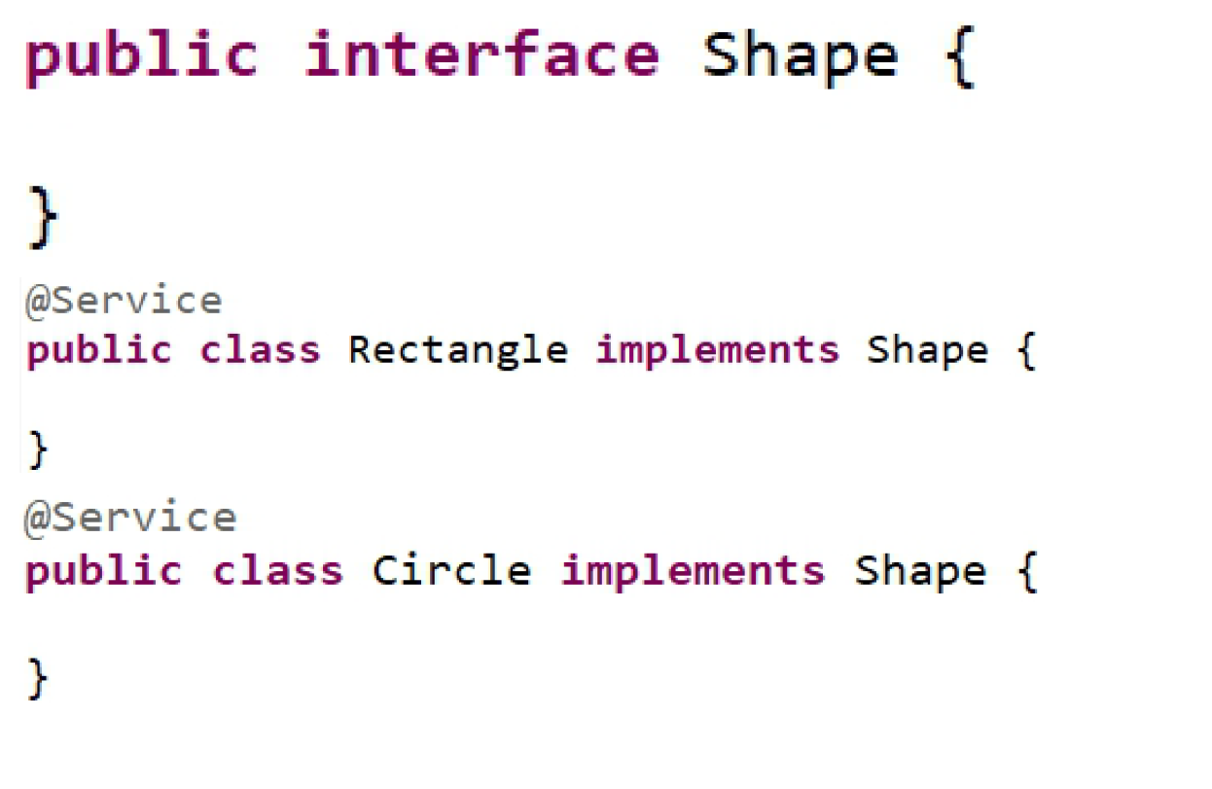  
------------------------------------------------------------------------------------------------  
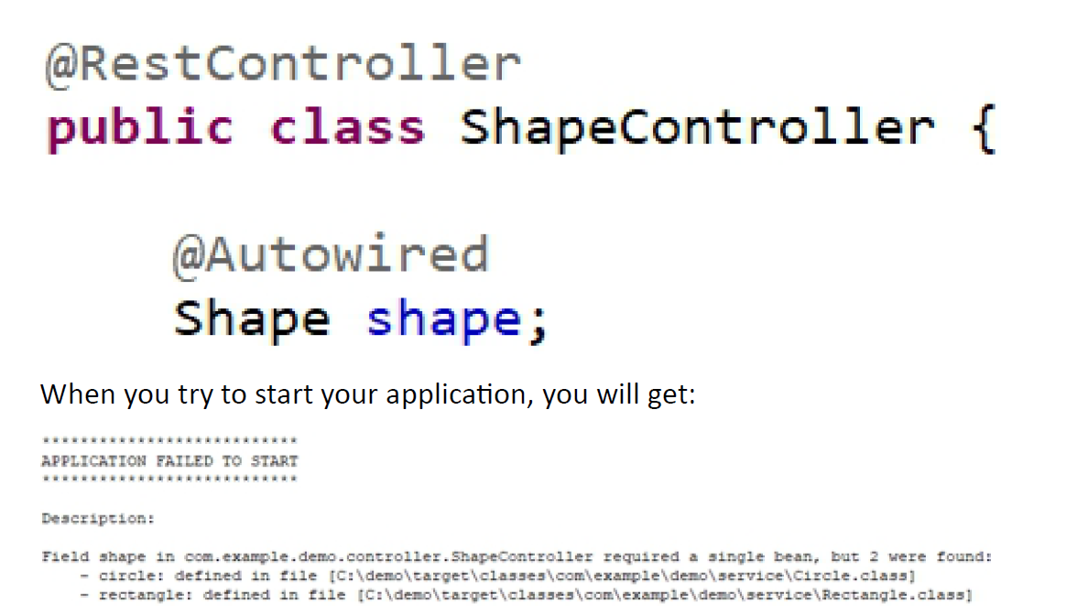  
  
So you will get the error two beans were found so to resolve this @Qualifer annotation will be used :  
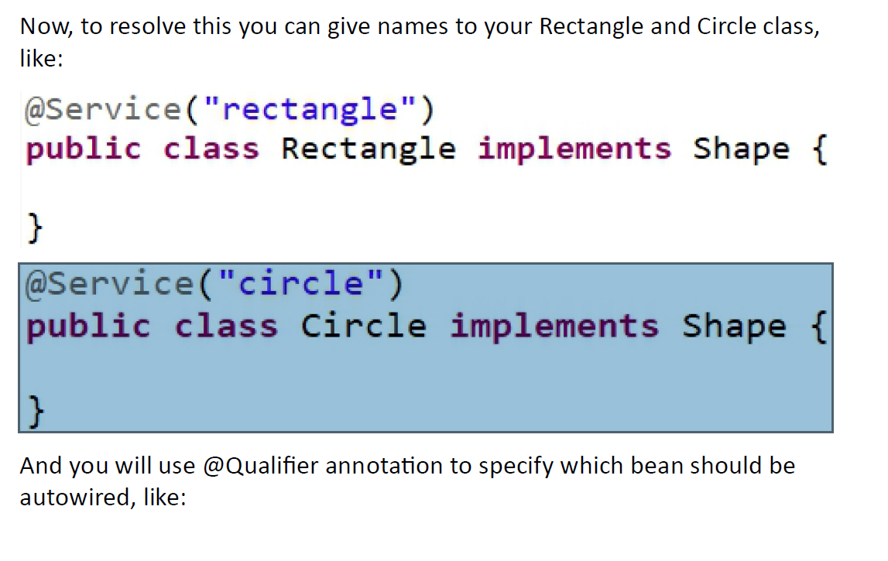  
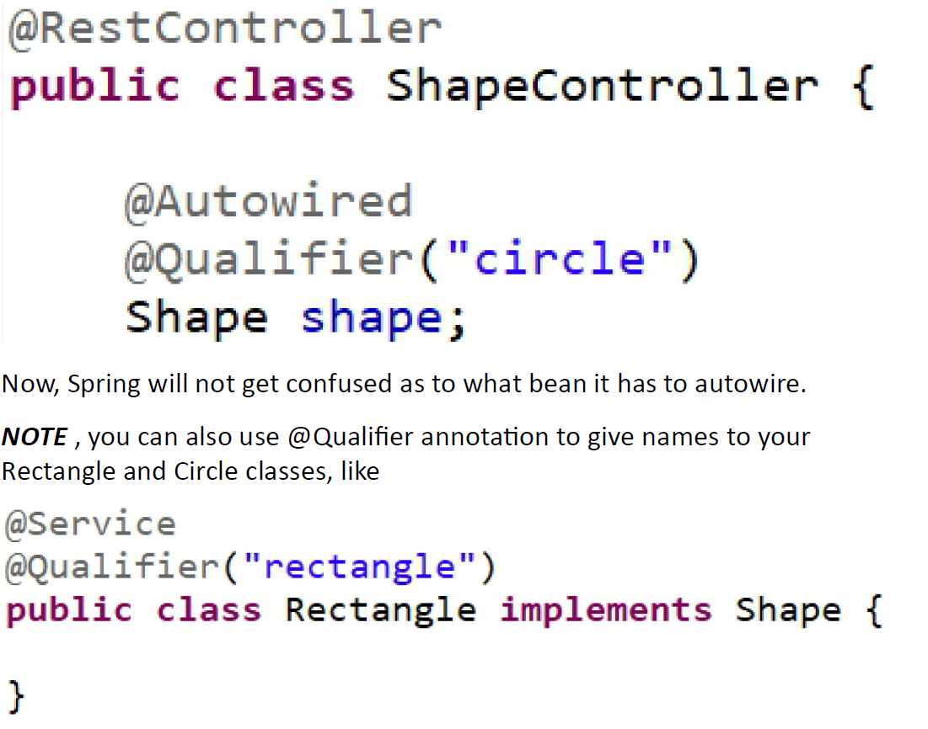  
  
.  
  
-------------------------------------------------------------------------------------------------------  
**Basic Kafka Terms:  
Apache Kafka :** [**(19) Post | Feed | LinkedIn**](https://www.linkedin.com/feed/update/urn:li:activity:7154458436900925440/)

----------------------------------------------------------------------------------------------------  
Commands used in kafka :  
**Summary Table**

| **Step** | **Command Example** |
| --- | --- |
| Start Zookeeper | bin/zookeeper-server-start.sh config/zookeeper.properties |
| Start Kafka Broker | bin/kafka-server-start.sh config/server.properties |
| Create Topic | bin/kafka-topics.sh --create --topic my-topic ... |
| List Topics | bin/kafka-topics.sh --list ... |
| Describe Topic | bin/kafka-topics.sh --describe --topic my-topic ... |
| Produce Messages | bin/kafka-console-producer.sh --topic my-topic ... |
| Consume Messages | bin/kafka-console-consumer.sh --topic my-topic --from-beginning ... |

**What is zookeeper and why it is used in Kafka?**ZooKeeper is a centralized service for maintaining configuration information, naming, providing distributed synchronization, and group services. It is a distributed coordination service used by distributed applications.  
  
**Why is ZooKeeper used in Kafka?**

* **Broker Coordination: Kafka uses ZooKeeper to manage and coordinate Kafka brokers (servers).**
* **Leader Election: ZooKeeper helps in electing a controller broker and partition leaders.**
* **Cluster Metadata: It stores metadata about topics, partitions, and broker status.**
* **Fault Tolerance: ZooKeeper helps Kafka handle node failures and ensures high availability.**

**In short:  
ZooKeeper acts as the “manager” for Kafka’s distributed system, ensuring all brokers are aware of each other and can recover from failures.  
  
-------------------------------------------------------------------------------------  
Explain me the life cycle of spring bean?  
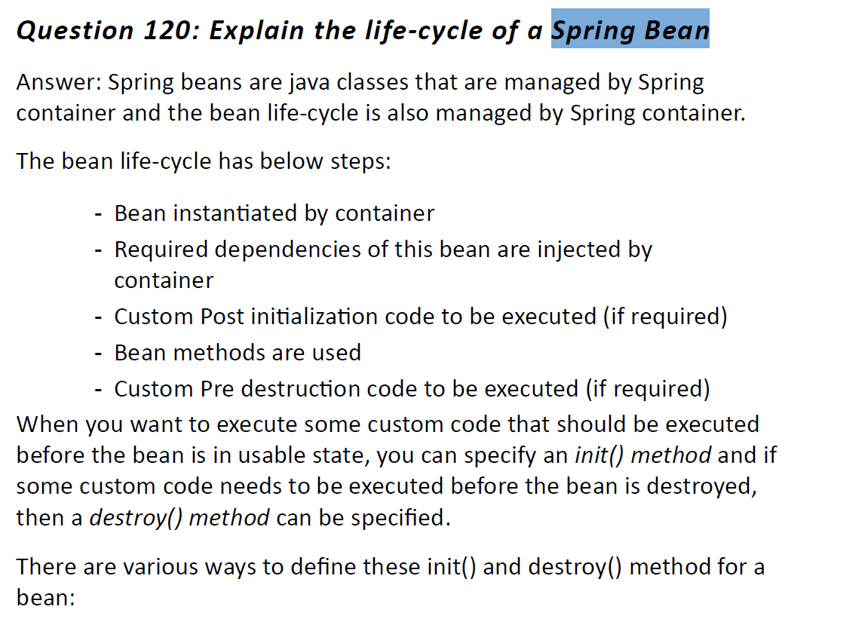  
  
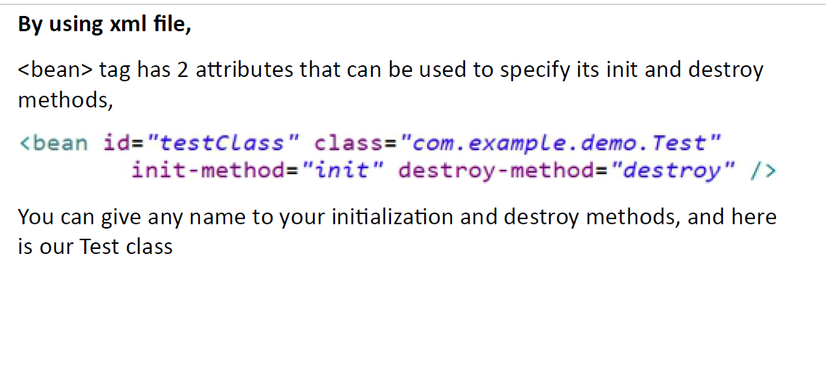  
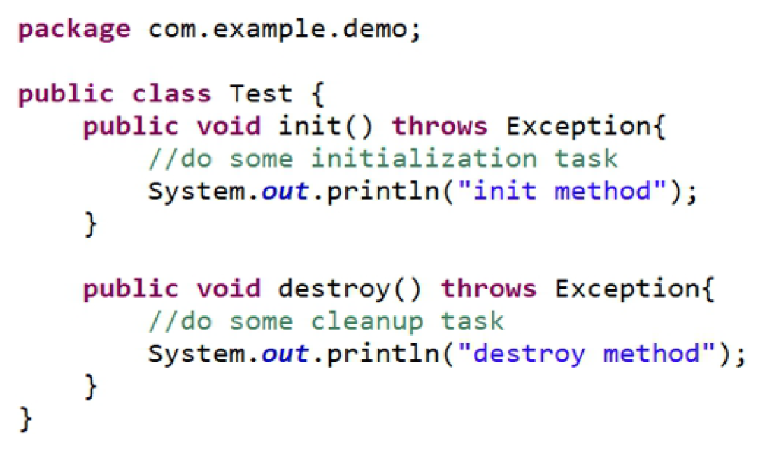  
[2]** 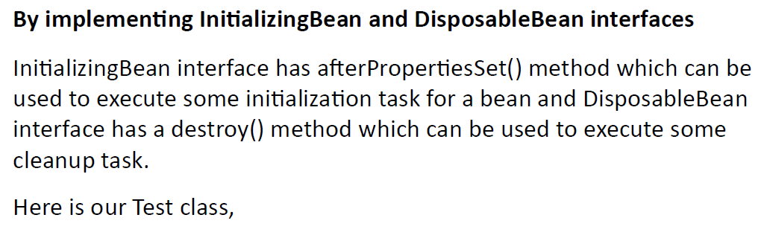  
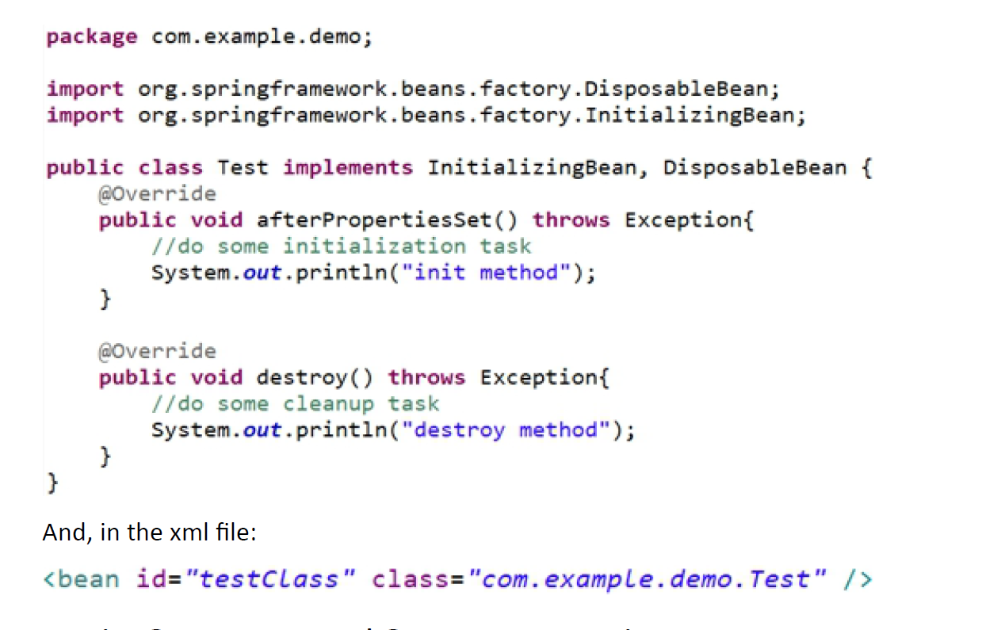  
[3] **By using @PostConstruct and @PreDestroy annotations  
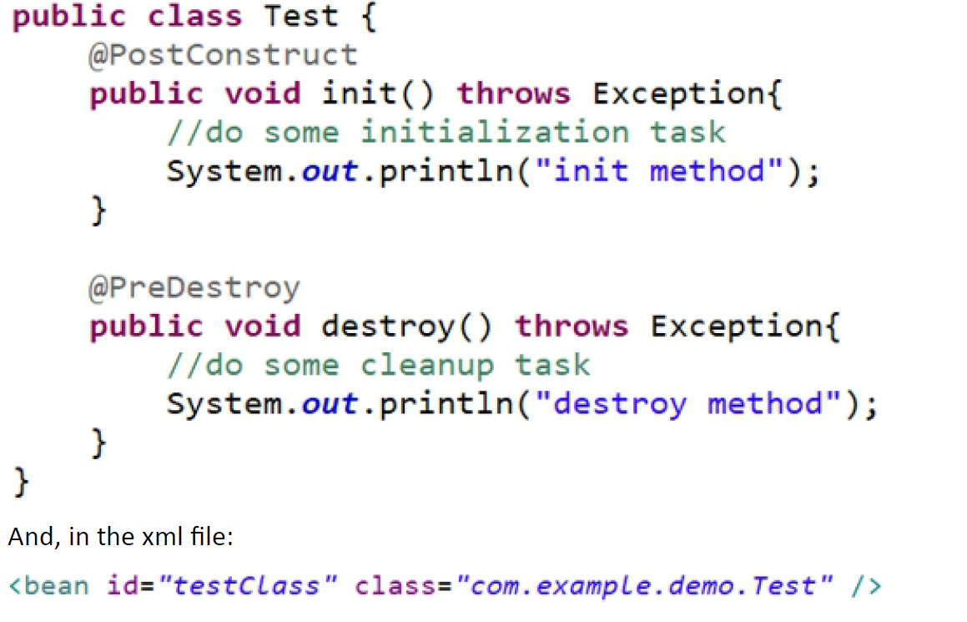**

------------------------------------------------------------------------------------What are different scopes of bean ?  
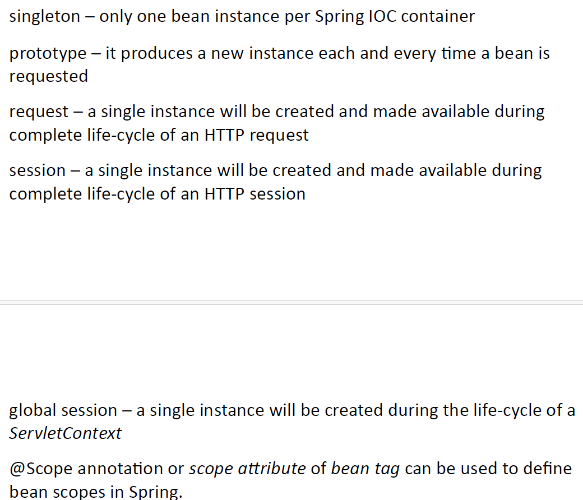  
  
------------------------------------------------------------------------------

**how Spring Boot simplifies Spring MVC:**

* Auto-configuration: Automatically configures Spring MVC components based on classpath.
* Embedded server: No need for external deployment; runs with built-in Tomcat/Jetty.
* Starter dependencies: Bundled libraries via spring-boot-starter-web simplify setup.
* Minimal configuration: Uses application.properties or application.yml instead of XML.
* Opinionated defaults: Sensible defaults for error handling, static resources, etc.
* Rapid development: DevTools enable hot reload and faster iteration.
* Built-in Actuator: Easy monitoring and health checks via REST endpoints.  
    
  --------------------------------------------------------------------------------------  
  **Spring boot actuator 🡪**Used to monitor our application provided with different endpoints   
  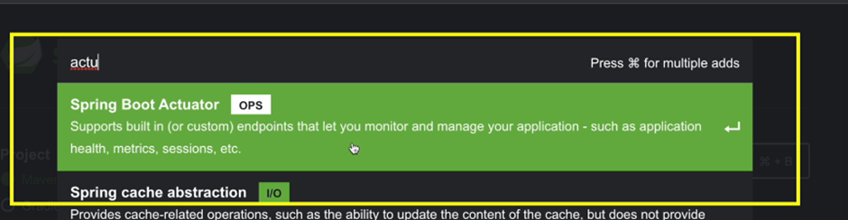

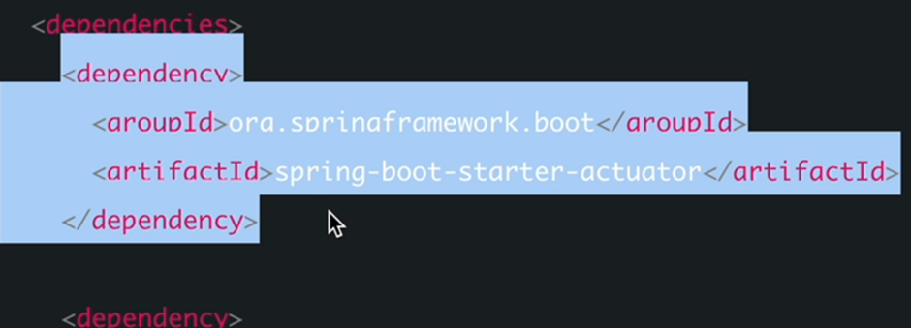Basic end points provided with actuator .

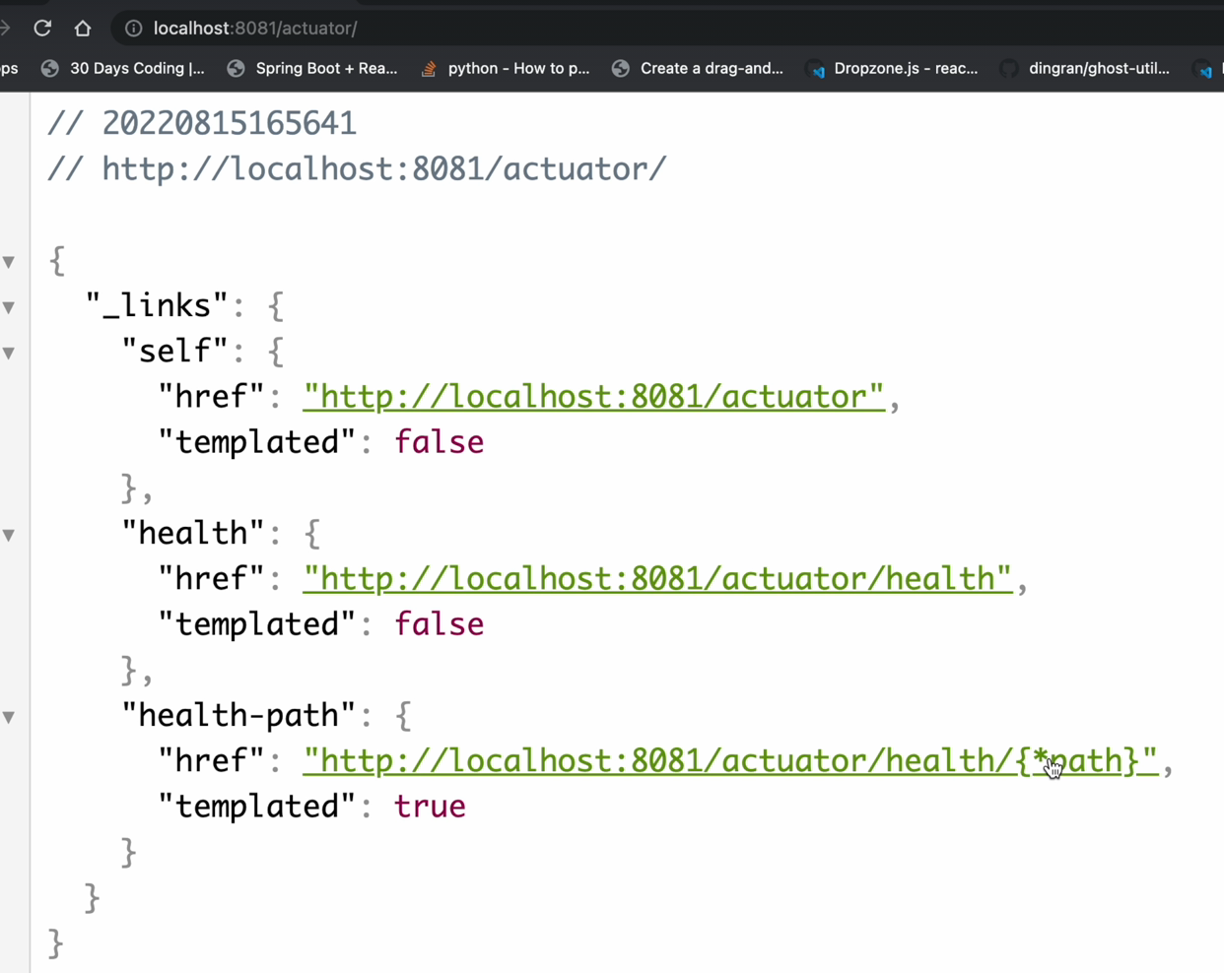  
  
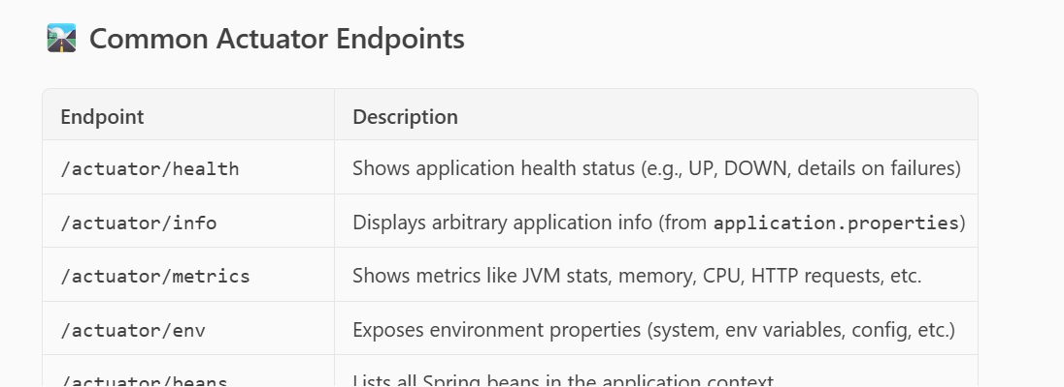  
  
By default all end points are not exposed for security reasons.  
  
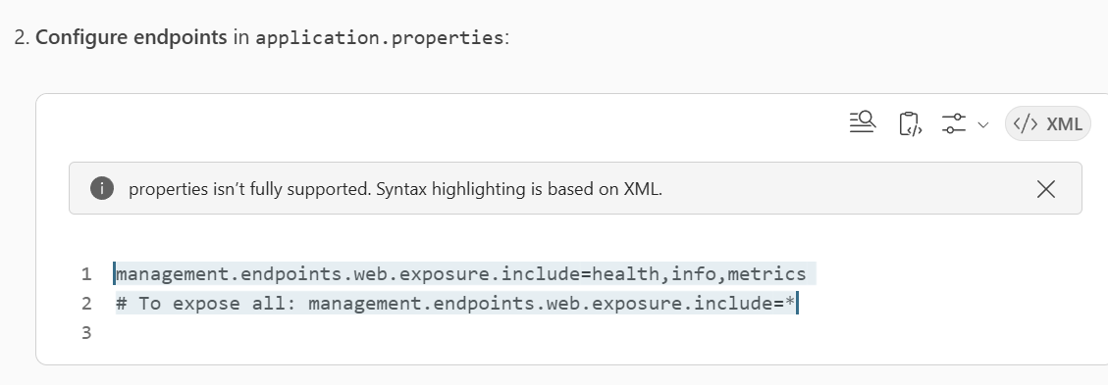  
---------------------------------------------------------------------------------------------------  
  
Spring Boot Devtools 🡪   
As mentioned devtools dependency is mainly **used for live reload functionality** so that we don’t need to sart our application again and again .  
----------------------------------------------------------------------------------------  
  
**Functional Interface : Single abstract method interface .**  
Theory read :   
<https://www.linkedin.com/feed/update/urn:li:groupPost:3983267-7184812936459145216?utm_source=social_share_send&utm_medium=member_desktop_web&rcm=ACoAACn3M3EB8CcD_b5ufQc_Qa2j5SPSKjSD7sk>  
  
**Need and Problem it solves :**  
  
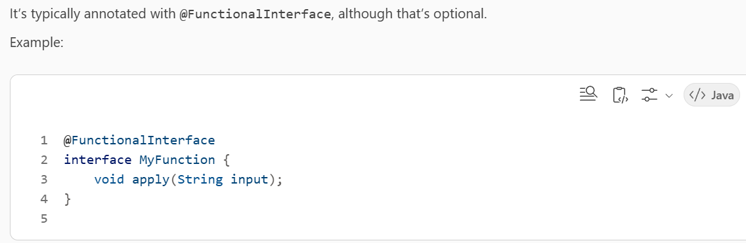  
  
**Why is it used?**

Functional interfaces are primarily used to enable **lambda expressions** and **method references**, which are concise ways to represent instances of single-method interfaces.

This is especially useful in:

* **Functional programming** style in Java
* **Stream API** operations
* **Event handling**
* **Custom behavior injection** (e.g., passing logic as parameters)  
    
  **✅ What problem does it solve?**
* Before Java 8, you had to use **anonymous inner classes** to pass behavior, which was verbose and hard to read.
* **Problem:**

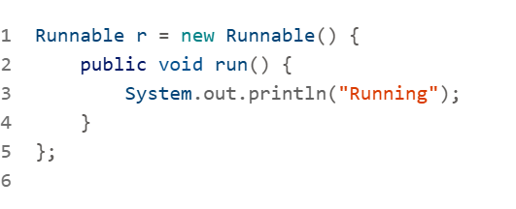  
  
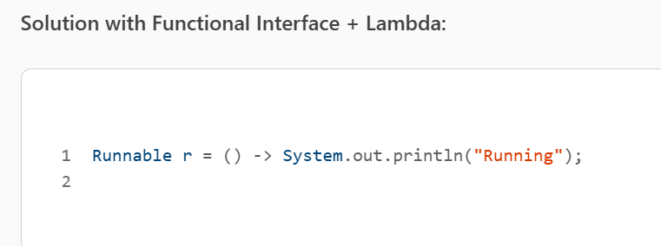  
  
This solves:

* **Boilerplate code**: Lambdas are shorter and cleaner.
* **Readability**: Code becomes more expressive.
* **Flexibility**: You can pass behavior as data (first-class functions).
* **Better use of multicore processors**: Especially with the Stream API and parallel processing.  
  --------------------------------------------------------------------------------------------------  
  **What is a Method Reference?  
  Use function as a Parameter to invoke a method .--> Method Reference**  
    
  In **Java**, a **method reference** is a shorthand syntax for calling a method using a reference to it, rather than invoking it directly. It’s part of the **Java 8** features introduced to support **functional programming**.
* It’s a cleaner alternative to using **lambda expressions** when the lambda simply calls an existing method.
* **🔧 Syntax of Method Reference**
* There are **four types** of method references:
* **Static method reference**  
  ClassName::staticMethodName  
  Example: Math::max
* **Instance method of a particular object**  
  instance::instanceMethodName  
  Example: System.out::println
* **Instance method of an arbitrary object of a particular type**  
  ClassName::instanceMethodName  
  Example: String::toLowerCase
* **Constructor reference**  
  ClassName::new  
  Example: ArrayList::new

### 🧩 What Problem Does It Solve?

**Method references solve the problem of verbosity (unwanted extra Code )and readability in lambda expressions**. Here's how:

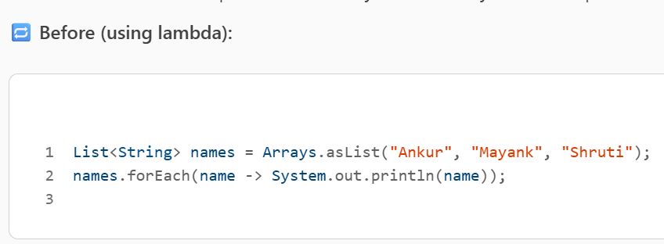  
  
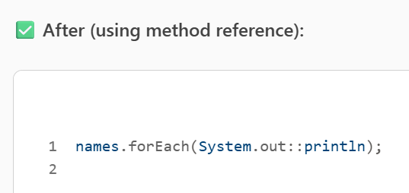  
  
**Benefits:**

* **Concise**: Less code to write and read.
* **Readable**: Easier to understand at a glance.
* **Reusable**: Encourages reuse of existing methods.

-----------------------------------------------------------------------------------------------------------  
Optional 🡪 Wrapper class to Check Null Values feature in Java 8   
• **Why it’s useful**:

* **Prevents NullPointerException**
* Encourages functional programming style
* Makes APIs more expressive

• **Best practices**:

* **Use Optional as return types, not fields**
* Avoid overusing it in performance-critical code
* **Don’t use Optional.get() without checking presence**

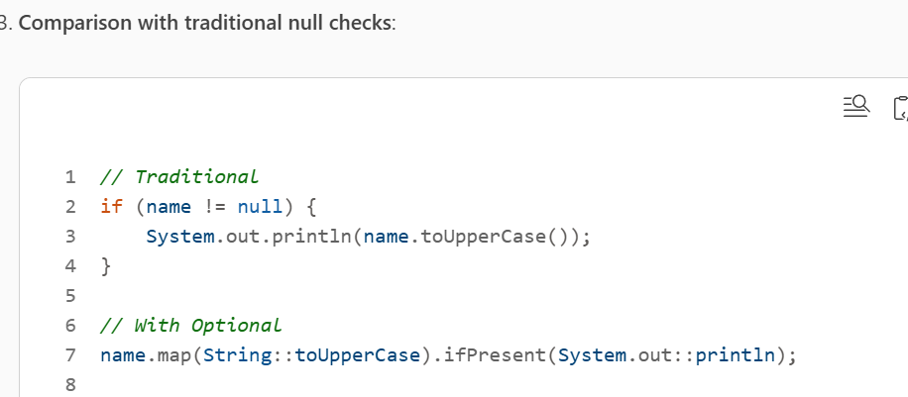  
  
**Optional.of Nullable()**  
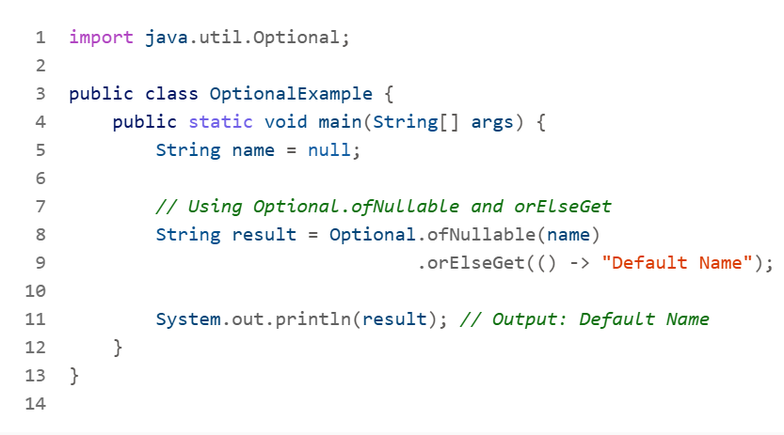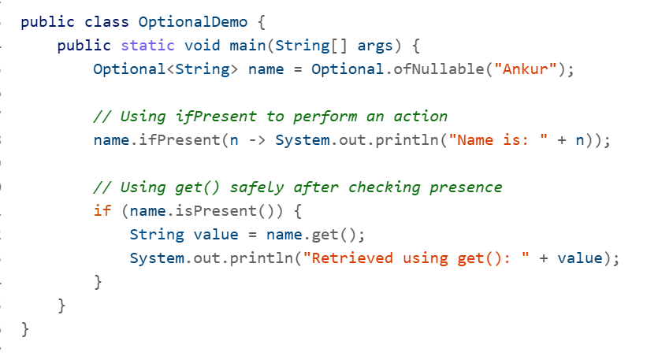 **----------------------------------------------------------------------------------------------------------------  
what are different methods of optional class provided by java?**

**✅ Creation Methods**

* **Optional.of(T value)  
  Creates an Optional with a non-null value. Throws NullPointerException if value is null.**
* **Optional.ofNullable(T value)  
  Creates an Optional that can hold a null value.**
* **Optional.empty()  
  Creates an empty Optional.**

**✅ Value Retrieval**

* **get()  
  Returns the value if present, else throws NoSuchElementException.**
* **orElse(T other)  
  Returns the value if present, else returns other.**
* **orElseGet(Supplier<? extends T> supplier)  
  Returns the value if present, else uses a supplier to generate a value.**
* **orElseThrow(Supplier<? extends X> exceptionSupplier)  
  Returns the value if present, else throws an exception provided by the supplier.**

**✅ Check Presence**

* **isPresent()  
  Returns true if a value is present.**
* **isEmpty() *(Java 11+)*  
  Returns true if no value is present.**

**--------------------------------------------------------------------------------------------------------------**

| **Feature** | **HashMap** | **HashSet** | **ConcurrentHashMap** |
| --- | --- | --- | --- |
| **Package** | **java.util** | **java.util** | **java.util.concurrent** |
| **Stores** | **Key-Value pairs** | **Unique elements (no duplicates)** | **Key-Value pairs** |
| **Underlying Structure** | **Hash table** | **Backed by a HashMap internally** | **Segmented hash table for concurrency** |
| **Null Allowed?** | **One null key, multiple null values** | **One null element allowed** | **No null keys or values allowed** |
| **Thread-Safe?** | **No** | **No** | **Yes (uses internal locking)** |
| **Performance** | **Fast (O(1) average)** | **Fast (O(1) average)** | **Slightly slower due to thread-safety** |
| **Use Case** | **Key-value storage** | **Unique collection of elements** | **Key-value storage in multi-threaded apps** |

**✅ Key Points:**

* **HashMap → Non-thread-safe, allows null key/value.**
* **HashSet → Stores only unique elements, internally uses HashMap.**
* **ConcurrentHashMap → Thread-safe alternative to HashMap, disallows nulls.**

**----------------------------------------------------------------------------------------------------------------  
Threads in Java :**<https://www.linkedin.com/feed/update/urn:li:groupPost:3983267-7243632911583764481?utm_source=social_share_send&utm_medium=member_desktop_web&rcm=ACoAACn3M3EB8CcD_b5ufQc_Qa2j5SPSKjSD7sk>  
  
**Multithreading 🡪**  
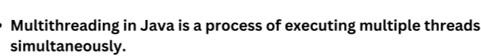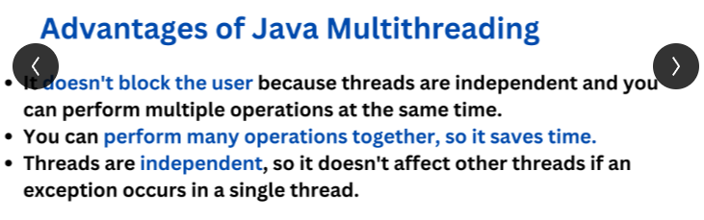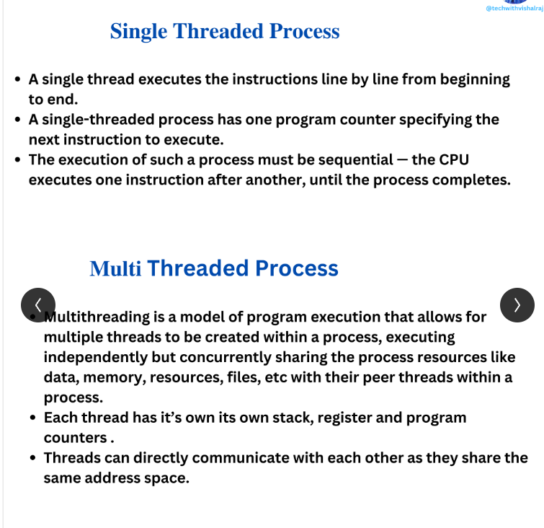 **Ways to create a Thread 🡪   
[1]By extending Thread Class [2] By Implementing Runnable Interface .  
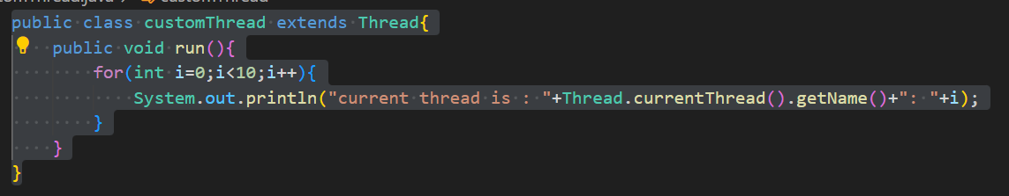  
Main class :  
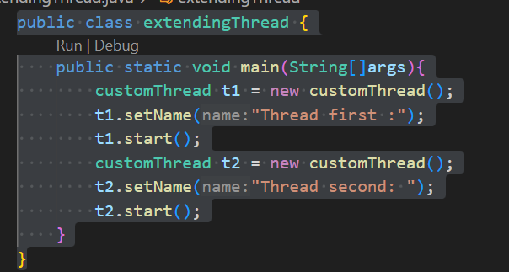  
  
Output :   
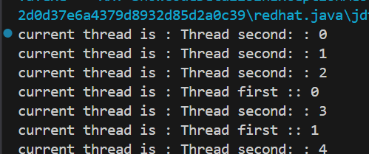  
  
So here you observe thread execution is randomly by Thread scheduler .**both threads **(t1 and t2) are executing concurrently**, and the **output reflects the non-deterministic nature of thread scheduling in Java.**[2] By implementing Runnable interface :  
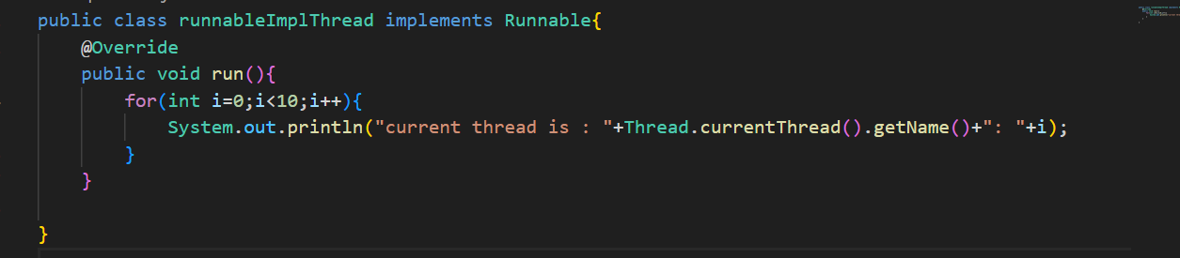  
Main class :  
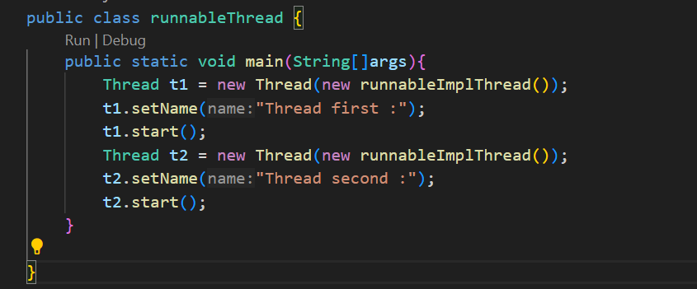  
  
**So here you observe : earlier in extends Thread class we create an instance of customThread but here we create object of Thread why is like that :**  
  
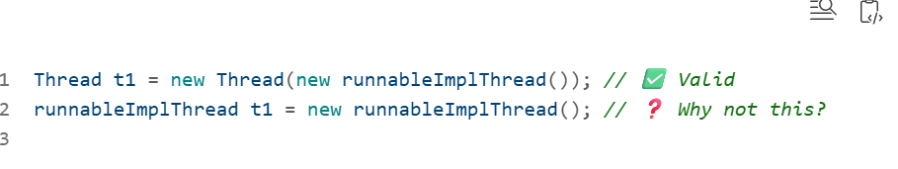  
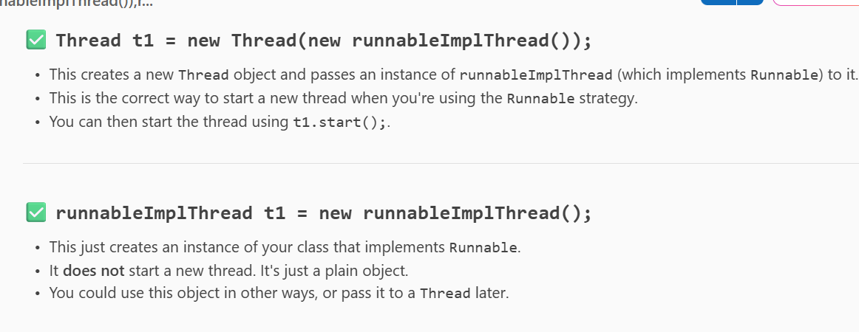  
Key Concepts And output same as discussed earlier .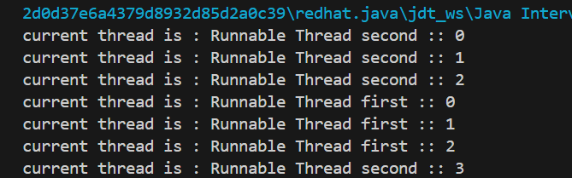  
  
Thread States in Java :  
**Main Class Thread states :**  
  
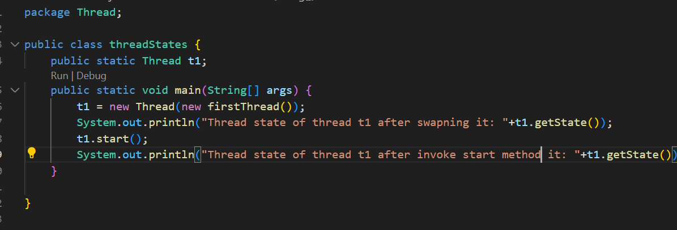  
  
[2] firstThread 🡪   
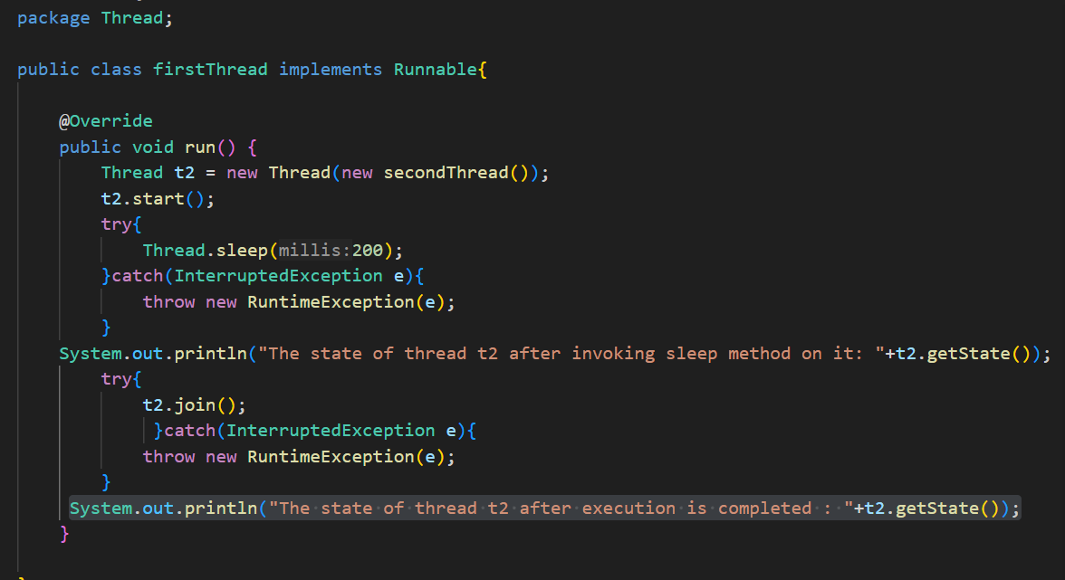  
  
[3]secondThread 🡪  
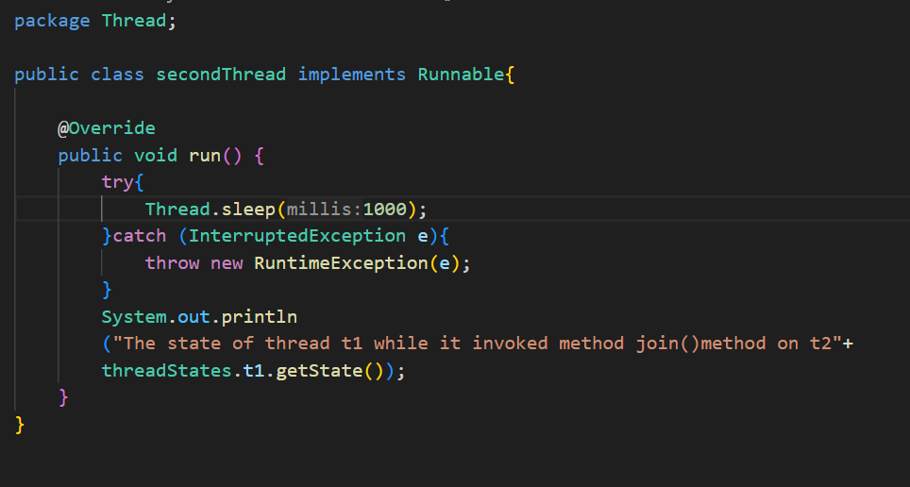  
  
Output 🡪  
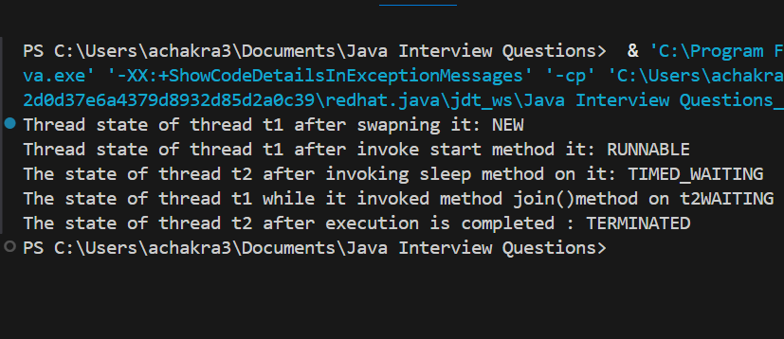  
  
So here   
1. **Main class 🡪threadStates , [2] firstThread 🡪 main Thread [3] secondThread 🡪childThread**  
[2]So when we instantiate with new keyword 🡪 the thread is in new state .  
[3] After invoke start t1 goes to runnable   
[4]In firstThread there is a child thread t2 so t2 invokes sleep method goes to timed waiting  
[5]When we invoke join() method on t2 then the main thread t1 goes to waiting   
[6]and t2 completes its execution it is Terminated.  
  
--------------------------------------------------------------------------------------------------------  
wait() , notify() ,notifyAll() 🡪 Methods   
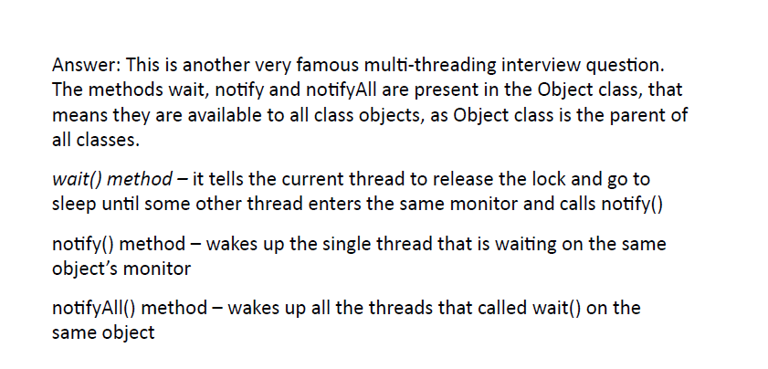  
  
**Scenario:**

We have a shared MessageQueue where:

* **Producer** adds messages.
* **Consumer** waits if the queue is empty and consumes messages when available.
* We use wait(), notify(), and notifyAll() to coordinate them.

**Key Concepts Demonstrated**

* synchronized ensures mutual exclusion.
* wait() makes the thread release the lock and wait.
* notify() wakes up one waiting thread.
* while loop ensures condition is rechecked after wake-up (avoids spurious wakeups).
* System.out.println shows thread state transitions.  
    
  **In the messageQueue 🡪 while loop is important because of the  
  🧵 When Will These Print Statements Execute?**

**✅ Producer waiting, message already present.**

This will print when:

* The **producer thread** tries to produce a new message.
* But the **previous message hasn't been consumed yet** (hasMessage == true).
* So the producer must **wait** until the consumer consumes the message and sets hasMessage = false.

**✅ Consumer waiting, no message to consume.**

This will print when:

* The **consumer thread** tries to consume a message.
* But **no message has been produced yet** (hasMessage == false).
* So the consumer must **wait** until the producer produces a message and sets hasMessage = true.

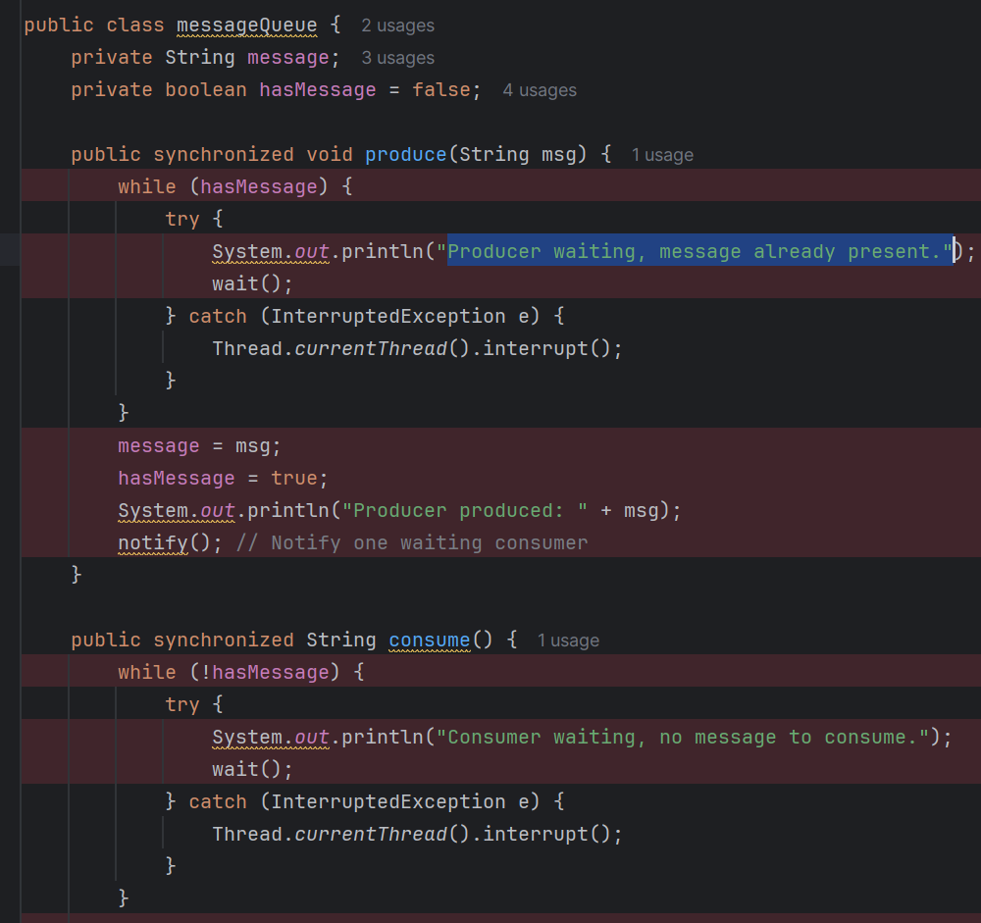  
  
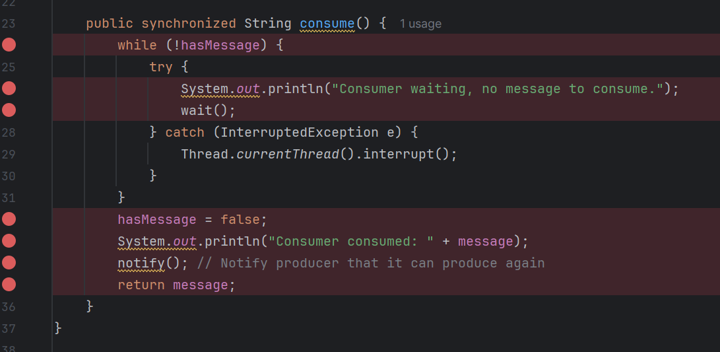  
  
**If the methods in messageQueue are not synchronized()?**  
  
**IllegalMonitorStateException**

* **Cause**: Calling wait(), notify(), or notifyAll() **without owning the object's monitor**.
* **Why**: These methods must be called **inside a synchronized block or method**.
* **Example**:

  
[2]**Race Conditions**

* **Cause**: Multiple threads access and modify shared data (like hasMessage or message) **without synchronization**.
* **Effect**: Leads to inconsistent or corrupted state.
* **Example**: Producer and consumer both read/write hasMessage at the same time, causing:
  + Message overwrite
  + Missed consumption
  + Unexpected behavior

**3. Missed Notifications**

* **Cause**: If notify() is called before another thread enters wait(), the signal is lost.
* **Effect**: The waiting thread may block **forever** (deadlock).
* **Fix**: Proper synchronization ensures correct timing and visibility of state changes.

**4. Visibility Issues**

* **Cause**: Without synchronized, changes made by one thread may **not be visible** to others due to CPU caching.
* **Effect**: Consumer may not see hasMessage = true even after producer sets it.

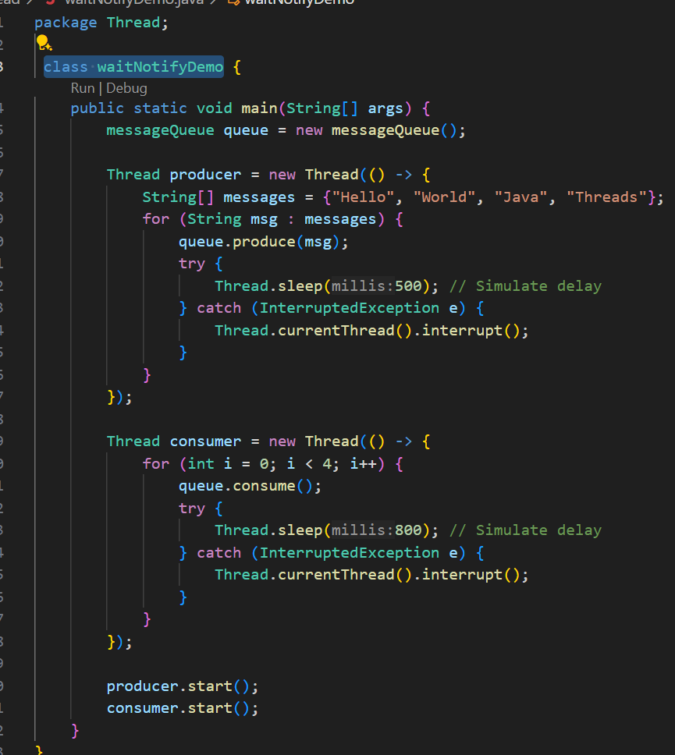  
  
 **What is thread pool and executor service in thread and how it is implemented ?  
Thread Pool**

* A thread pool is a collection of pre-instantiated reusable threads.
* It helps manage a large number of concurrent tasks efficiently by reusing threads instead of creating new ones for each task.
* This improves performance and avoids overhead from frequent thread creation/destruction.

✅ ExecutorService

* ExecutorService is an interface in java.util.concurrent that provides a higher-level API for managing threads.
* It abstracts thread creation and management using a thread pool underneath.
* Key methods:
  + submit(): Submits a task and returns a Future.
  + execute(): Executes a task without returning a result.
  + shutdown(): Initiates an orderly shutdown.

**import java.util.concurrent.*;**

**public class ThreadPoolExample {**

**public static void main(String[] args) {**

**ExecutorService executor = Executors.newFixedThreadPool(5); // Create a pool of 5 threads**

**for (int i = 0; i < 10; i++) {**

**executor.submit(() -> {**

**System.out.println("Task executed by: " + Thread.currentThread().getName());**

**});**

**}**

**executor.shutdown(); // Graceful shutdown**

**}**

**}**

**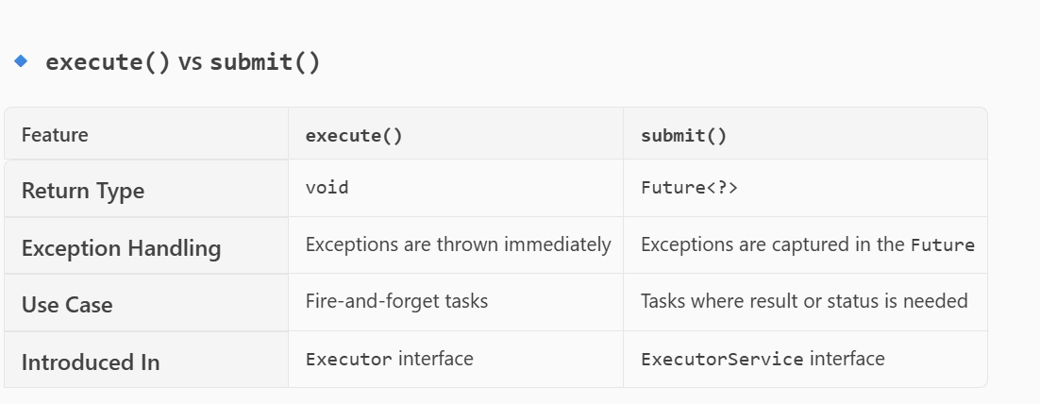  
  
What does future object means in java ?**In Java, a Future object represents the result of an asynchronous computation. It acts as a placeholder for a value that will eventually be available after a task completes.

**Here's a breakdown of what a Future does:**

* **Asynchronous Execution: When you submit a task (like a Callable) to an executor service, it runs in a separate thread. The Future object lets you interact with that task while it's running or after it's done.**
* **Methods Provided by Future:** 
  + **get(): Retrieves the result of the computation, blocking if necessary until it's available.**
  + **get(long timeout, TimeUnit unit): Retrieves the result but waits only for the specified time.**
  + **cancel(boolean mayInterruptIfRunning): Attempts to cancel the task.**
  + **isDone(): Checks if the task has completed.**

**isCancelled(): Checks if the task was cancelled before completion.  
  
----------------------------------------------------------------------------------**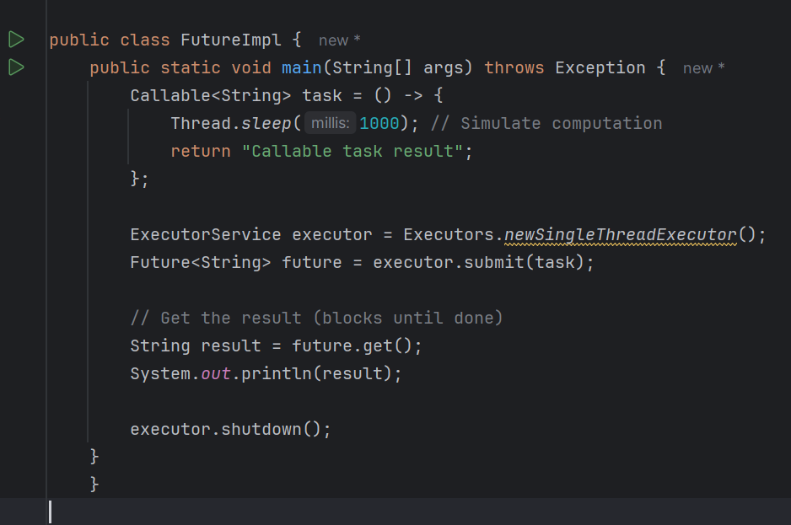

--------------------------------------------------------------------------------------  
**Runnable and Callable interface :**  
  
**Runnable Interface**

* **Package**: java.lang
* **Purpose**: Represents a task that can be executed by a thread.
* **Method**: public void run()
* **Return Type**: void (does **not** return a result)
* **Exception Handling**: Cannot throw checked exceptions.  
    
  Code :  
  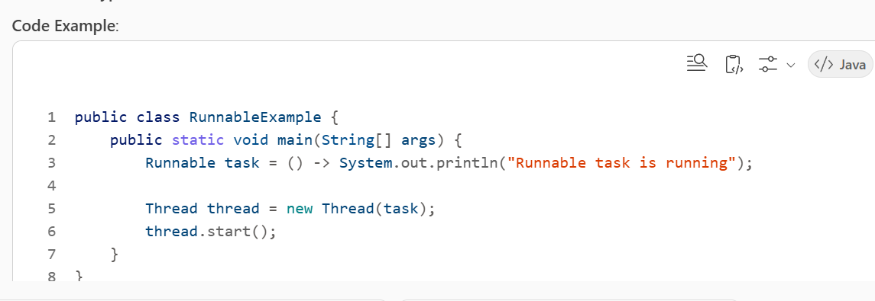  
    
  **Callable Interface**
* **Package**: java.util.concurrent
* **Purpose**: Represents a task that returns a result and may throw an exception.
* **Method**: public V call() throws Exception
* **Return Type**: Generic V (returns a result)

**Exception Handling**: Can throw checked exceptions.  
  
**Code :  
import java.util.concurrent.*;**

**public class CallableExample {**

**public static void main(String[] args) throws Exception {**

**Callable<String> task = () -> {**

**Thread.sleep(1000); // Simulate computation**

**return "Callable task result";**

**};**

**ExecutorService executor = Executors.newSingleThreadExecutor();**

**Future<String> future = executor.submit(task);**

**// Get the result (blocks until done)**

**String result = future.get();**

**System.out.println(result);**

**executor.shutdown();**

**}**

**}**

* Multiple Task when submitted :  
  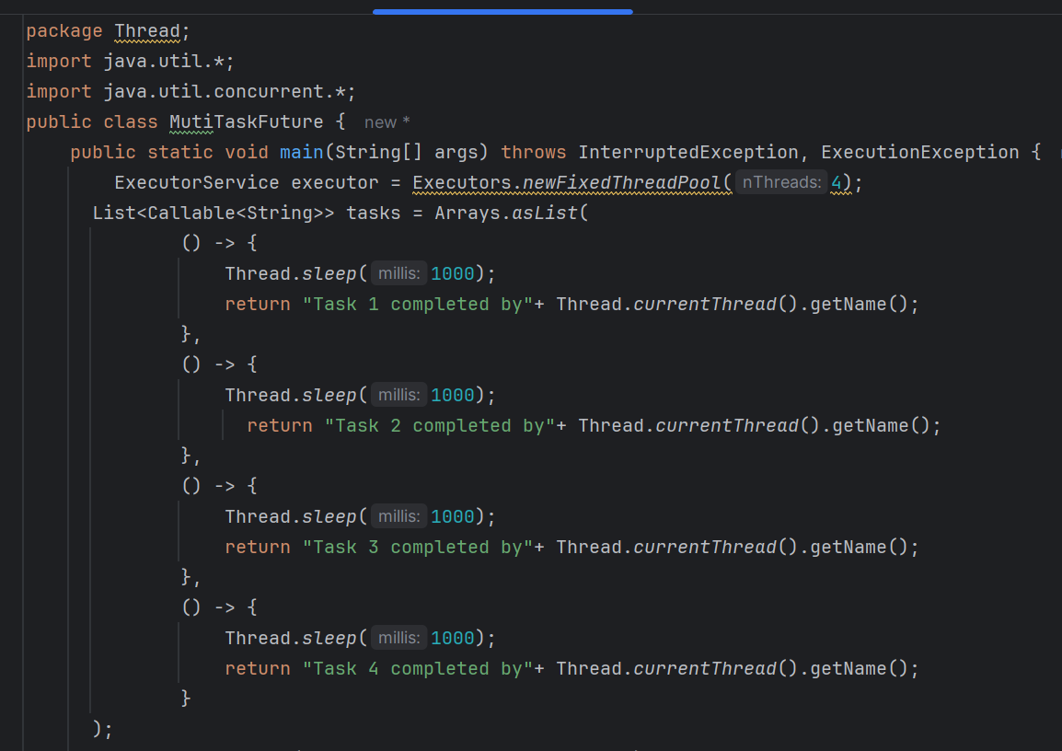  
    
  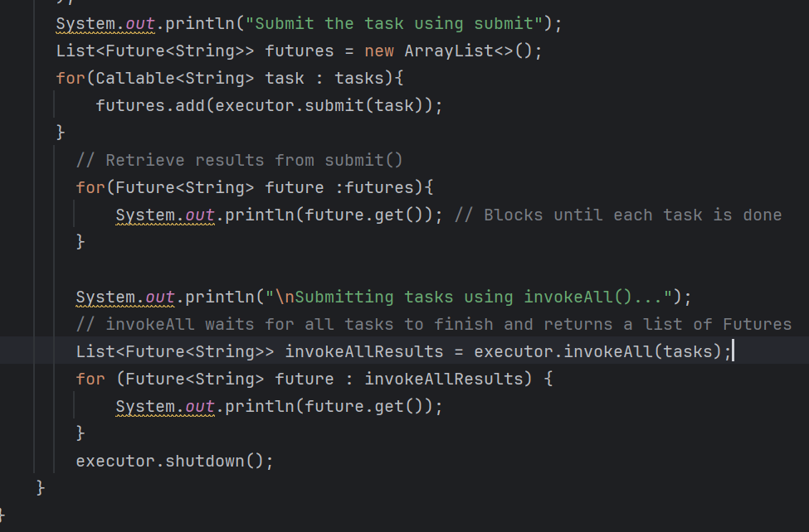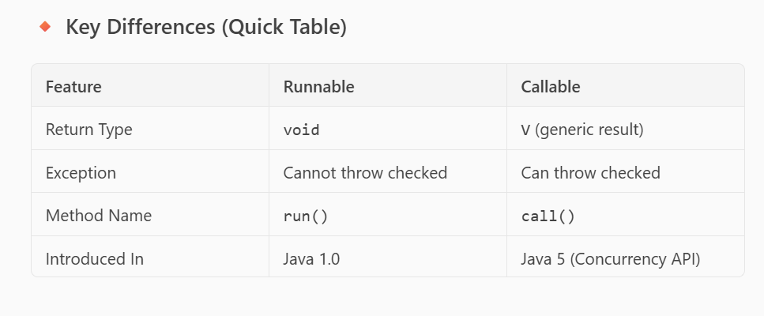  
    
  **How do we set priority in multithreading(Java)?**In **Java**, you can set thread priority using the setPriority() method of the Thread class. Here’s how it works:

**✅ Priority Range**

* **MIN_PRIORITY** = 1
* **NORM_PRIORITY** = 5 (default)
* **MAX_PRIORITY** = 10

class MyThread extends Thread {

public void run() {

System.out.println("Thread running: " + Thread.currentThread().getName());

}

}

public class PriorityExample {

public static void main(String[] args) {

MyThread t1 = new MyThread();

MyThread t2 = new MyThread();

MyThread t3 = new MyThread();

t1.setPriority(Thread.MIN_PRIORITY); // Priority 1

t2.setPriority(Thread.NORM_PRIORITY); // Priority 5

t3.setPriority(Thread.MAX_PRIORITY); // Priority 10

t1.start();

t2.start();

t3.start();

}

}

**✅ Important Notes**

* **Priority is a hint**, not a guarantee. The JVM and OS scheduler decide actual execution.
* Overusing high priority can cause **starvation** for lower-priority threads.  
    
  ------------------------------------------------------------------------------------------  
  **How would you design a high-throughput system using ForkJoinPool vs Virtual Threads (Project Loom)?**  
    
  Understanding Purpose :  
  **What is Project Loom?**
* Project Loom is an **OpenJDK initiative** that introduces **virtual threads** to Java, aiming to simplify concurrency and improve scalability. Traditional Java threads map 1:1 to OS threads, which are heavy and limited in number. Virtual threads, on the other hand, are **lightweight, managed by the JVM**, and allow you to create **millions of threads** without the overhead of OS threads. This makes it ideal for **I/O-bound, high-concurrency applications** like servers, microservices, and real-time systems.  
  Key features:
* **Virtual Threads**: Lightweight threads that reduce memory and context-switching overhead.
* **Structured Concurrency**: A new API for managing related tasks in a structured way.
* **Backward Compatibility**: Works with existing Java APIs like ExecutorService.  
    
  **Interview Precise :**  
  ----------------------------------------------------------------------------------------------------  
  **ForkJoinPool vs Virtual Threads for High-Throughput Systems**
* **ForkJoinPool**
* Designed for **CPU-bound tasks** using **divide-and-conquer** algorithms.
* Uses **work-stealing** to balance load across threads.
* Best for **parallel computations** (e.g., recursive algorithms, data processing).
* Limited scalability because it still relies on **platform threads** (OS threads).
* Thread count is typically tied to CPU cores (e.g., Runtime.getRuntime().availableProcessors()).
* **Virtual Threads (Project Loom)**
* Ideal for **I/O-bound workloads** (e.g., web servers, microservices).
* Enables **thread-per-request** model without worrying about thread pool limits.
* Can handle **millions of concurrent tasks** because virtual threads are cheap to create.
* Simplifies code: you can write **blocking code** without resorting to complex async frameworks.
* Uses a small pool of **carrier threads** internally (often a ForkJoinPool) to schedule virtual threads.

**✅ When to Use Which?**

* **ForkJoinPool** → High CPU utilization, parallel algorithms, data crunching.
* **Virtual Threads** → High concurrency with blocking I/O (HTTP calls, DB queries, messaging systems).
* For **mixed workloads**, you can combine both: use ForkJoinPool for compute-heavy tasks and virtual threads for request handling.  
    
  ---------------------------------------------------------------------------------------------------  
  **Example Design for High-Throughput System**
* **Scenario**: A web server handling thousands of requests, each doing DB calls and some computation.
* **Virtual Threads** for request handling

try (var executor = Executors.newVirtualThreadPerTaskExecutor()) {

for (int i = 0; i < 100_000; i++) {

executor.submit(() -> {

String data = fetchFromDatabase(); // blocking I/O

processData(data); // CPU-bound

});

}

}  
  
**For CPU-heavy parts, offload to a ForkJoinPool**ForkJoinPool pool = new ForkJoinPool();

pool.submit(() -> computeIntensiveTask());

------------------------------------------------------------------------  
**Benefits of Project Loom**

* **Massive scalability**: Millions of concurrent tasks.
* **Simpler code**: Write synchronous style without async complexity.
* **Better resource utilization**: Lower memory footprint and minimal context switching.
* **Compatible with existing APIs**: Works with ExecutorService, CompletableFuture, etc.

---------------------------------------------------------------------  
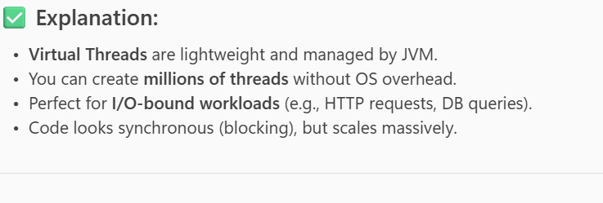  
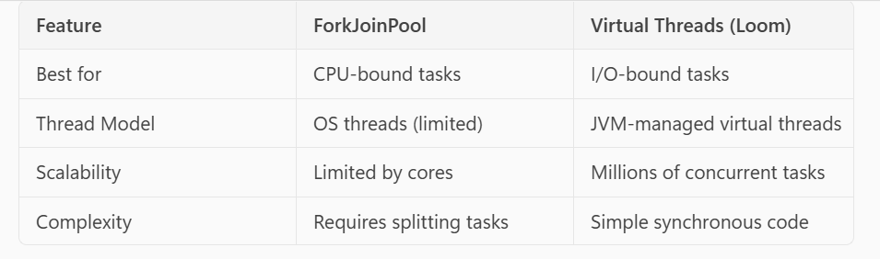  
---------------------------------------------------------------------  
**Understanding purpose -> How Fork join pool works and what is work stealing ?  
  
What is Work-Stealing?**

* In a ForkJoinPool, each worker thread has its **own deque (double-ended queue)** of tasks.
* When a thread finishes its tasks and becomes **idle**, instead of waiting, it **steals work** from other threads’ queues.
* It usually steals tasks from the **tail** of another thread’s deque (to minimize contention).
* This ensures **better load balancing** because idle threads help busy threads complete their tasks.

**✅ Why is it Important?**

* Prevents situations where some threads are overloaded while others are idle.
* Improves **CPU utilization** and reduces overall execution time.
* Ideal for **divide-and-conquer algorithms** (e.g., recursive tasks like sorting, matrix multiplication).

**-----------------------------------------------------------------------  
  
Code on How Fork Join Pool works ?**

**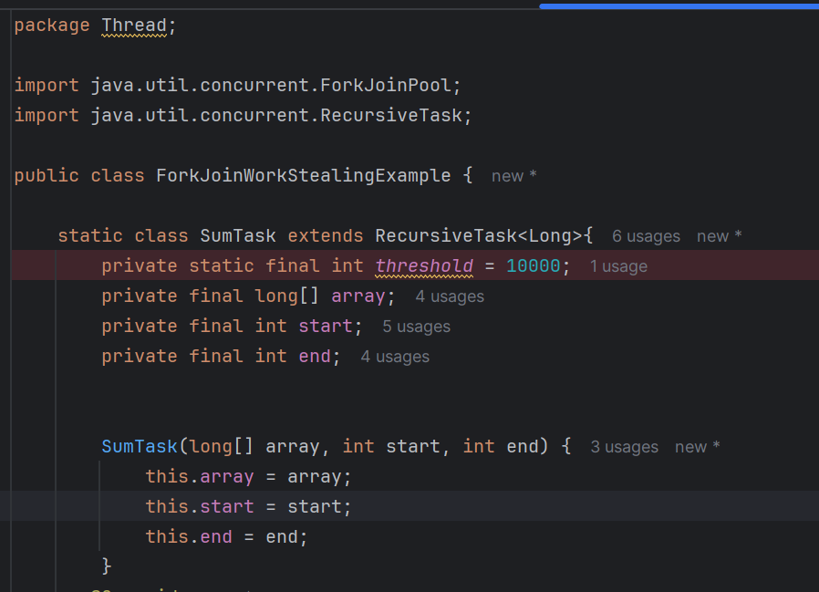  
  
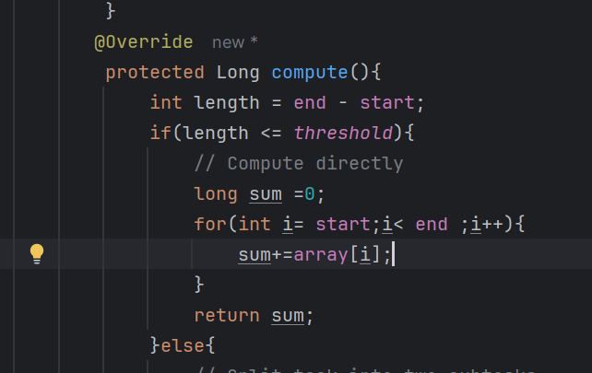  
  
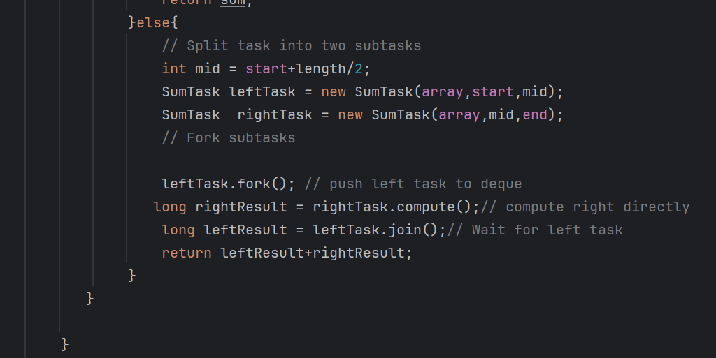**

**Does join() call compute()?**

* **No, join() does not call compute() directly.**
* **Here’s the sequence:** 
  1. **leftTask.fork() schedules the left task for execution by another thread (or possibly the same thread later).**
  2. **rightTask.compute() runs immediately in the current thread.**
  3. **leftTask.join() waits until the left task finishes and returns its result.**

**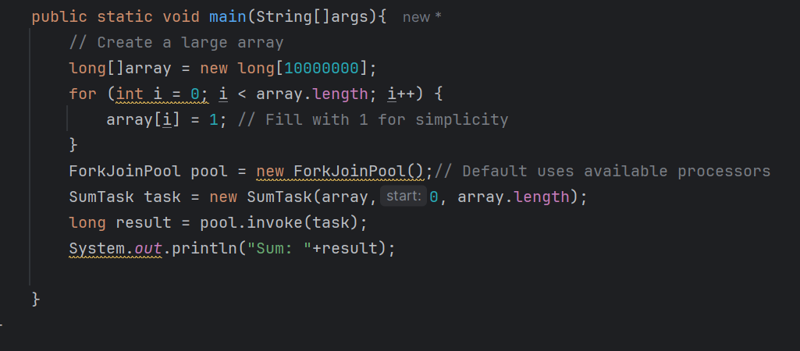  
  
How virtual threads work ?  
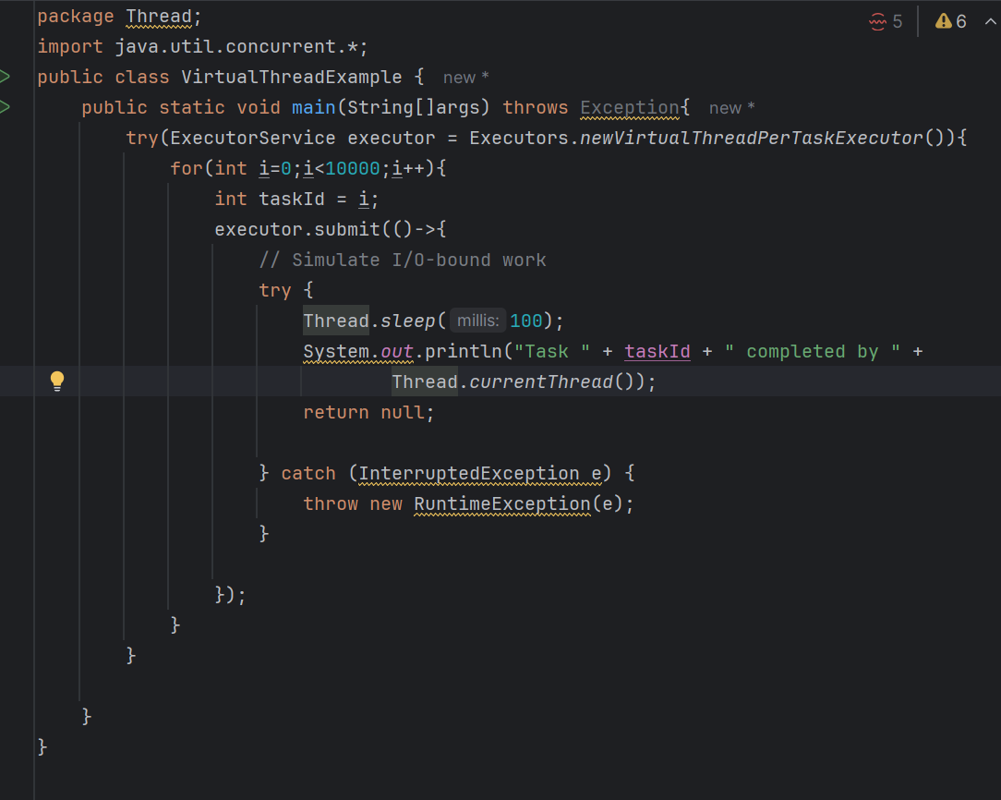**

**------------------------------------------------------------------------  
How does asynchronous programming implemented in java spring application followed with rollback?**In a Java Spring application, **asynchronous programming and rollback mechanisms are often used together to handle concurrent tasks** while maintaining data integrity  
 **1. Asynchronous Programming in Spring:**

**Spring provides several ways to implement asynchronous behaviour:**

**✅ Using @Async Annotation**

**You can annotate methods with @Async to run them in a separate thread.  
  
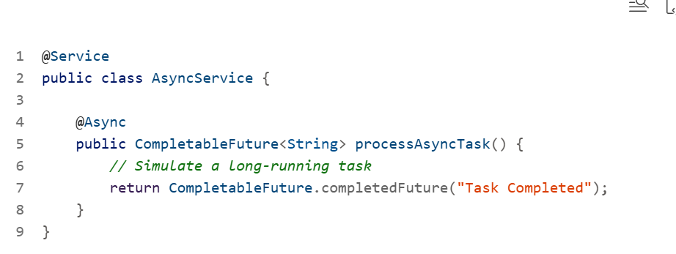  
  
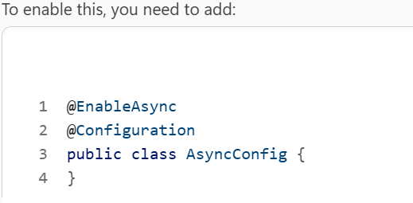  
  
Using CompletableFuture:**

**This allows chaining and combining multiple asynchronous tasks.  
  
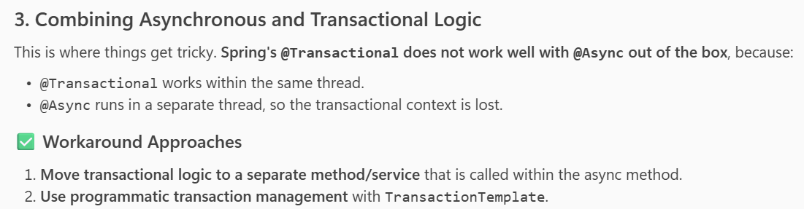  
  
------------------------------------------------------------------------**

**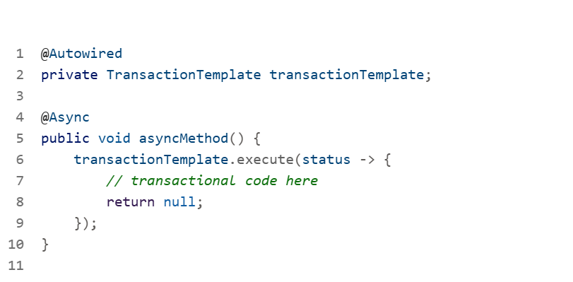  
  
With Code :  
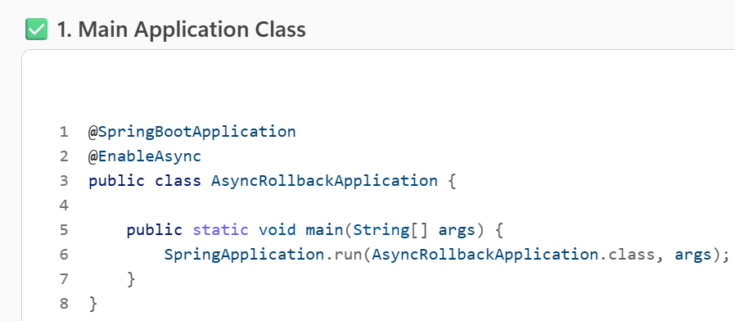  
  
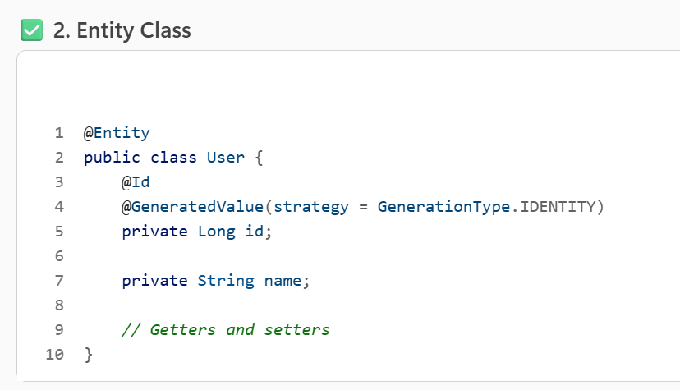  
  
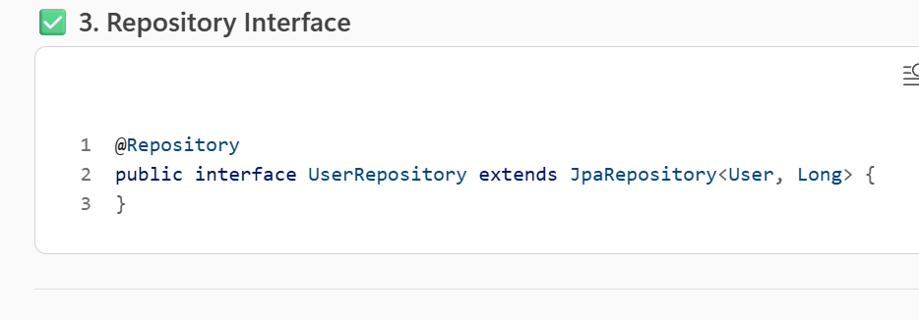  
  
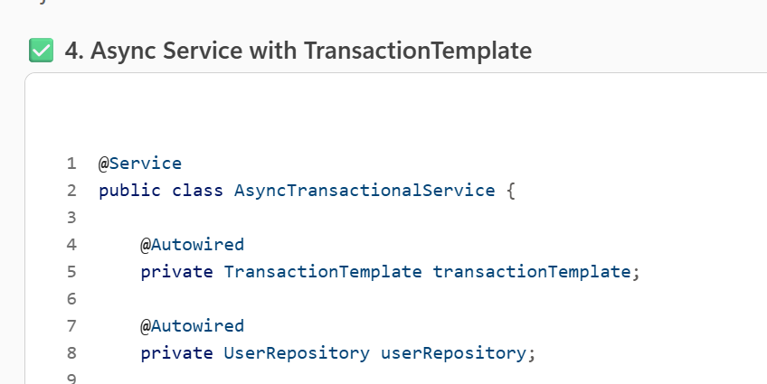  
  
  
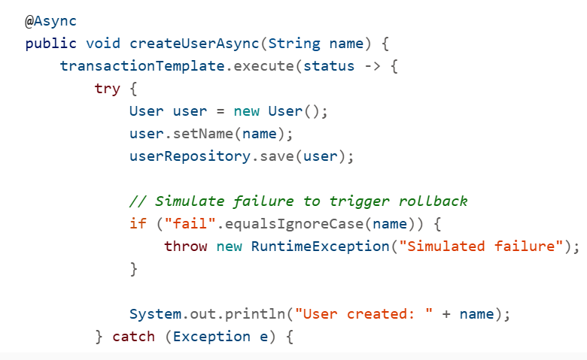**

**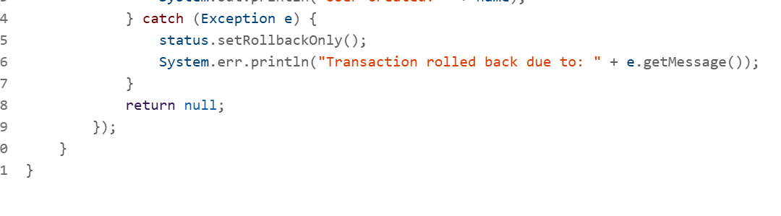  
---------------------------------------------------------------------  
What is deadlock in Java?**In Java multithreading**, a deadlock is a situation where two or more threads are blocked forever, each waiting for the other to release a resource**. This typically happens when multiple threads hold locks and try to acquire locks held by other threads.  
  
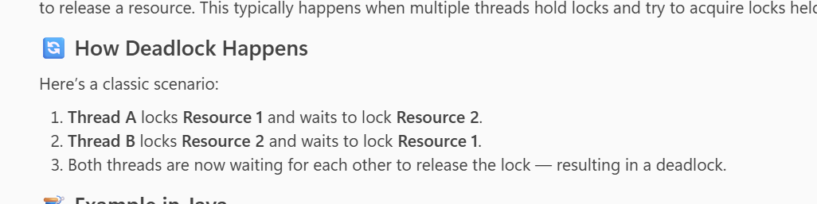  
  
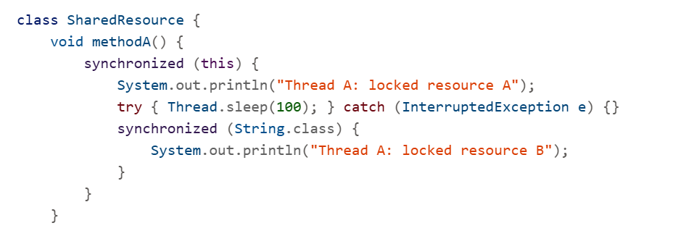  
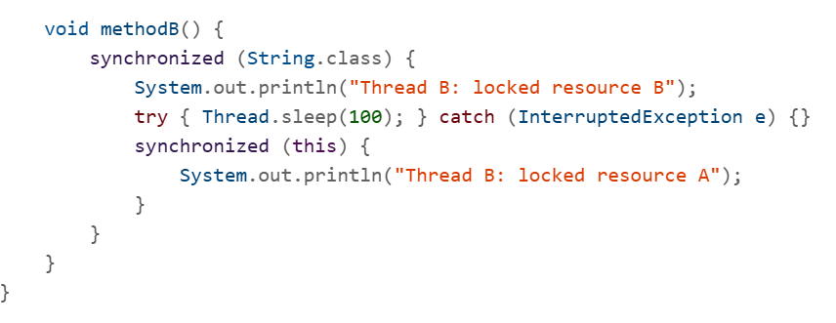  
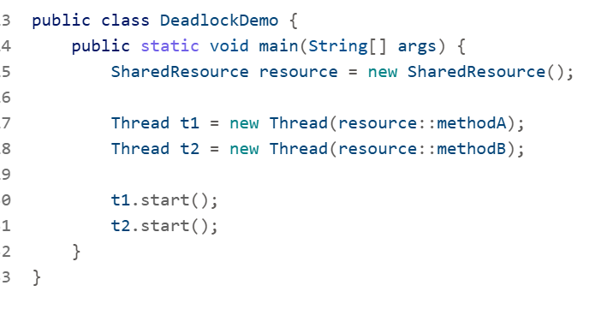  
  
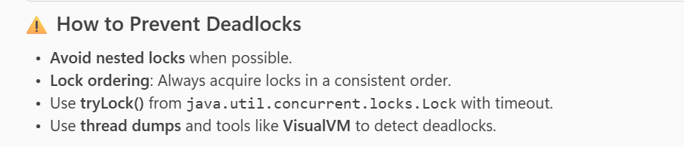  
----------------------------------------------------------------------  
**What is Fetch type in Jpa ?**In **JPA (Java Persistence API)**, the fetch type refers to how related entities are loaded from the database when a query is executed. It's specified using the fetch attribute in annotations like @OneToMany, @ManyToOne, @OneToOne, and @ManyToMany.  
  
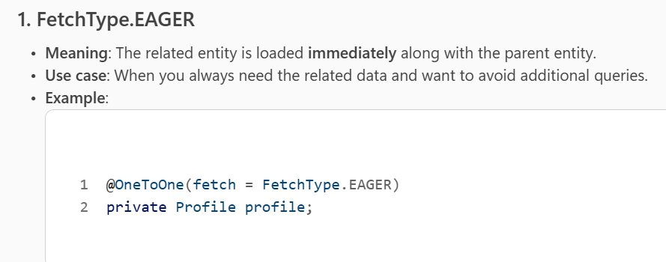  
  
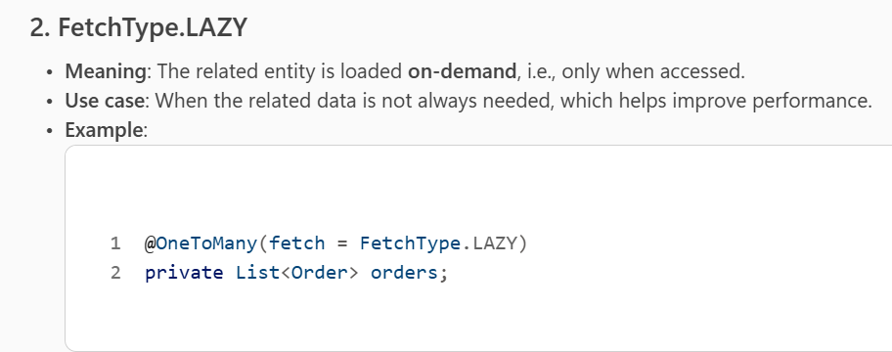  
  
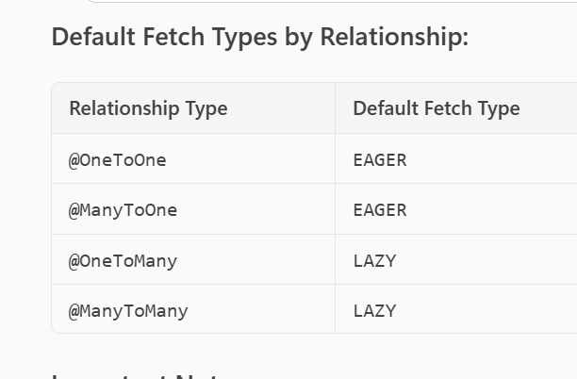  
  
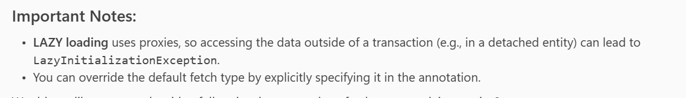  
  
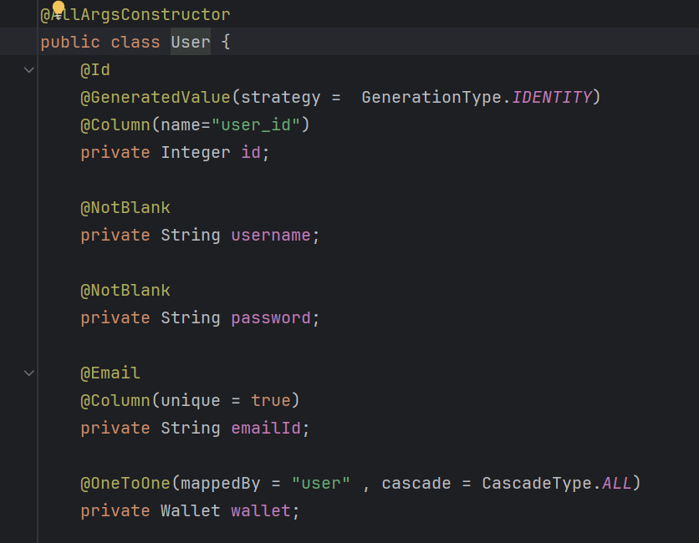  
  
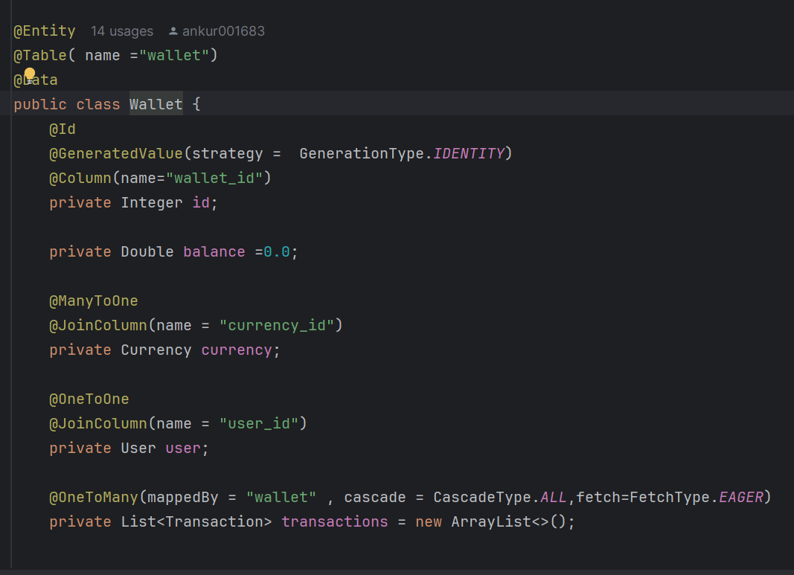

**Like in the above image how user and wallet are related**.  
----------------------------------------------------------------------  
**Difference between application.properties and application.yml**  
  
Both **application.properties** and **application.yml** are configuration files used in **Spring Boot** applications, but they differ mainly in **format**, **structure**, and **readability  
  
✅ 1. File Format**

* **application.properties**
  + Key-value pairs in a flat structure.
  + Simple, but can get messy for nested configurations (requires dot notation)

**application.yml**

* YAML format (hierarchical, indentation-based).
* More readable for complex/nested configs because of hierarchical structure.  
    
  **Both support comments and spring profile activate.  
    
  application.properties**:  
  spring.profiles.active=dev  
  ---------------------------------------------------------------------  
  Difference between @Value and @Configuration properties?

Both **@Value** and **@ConfigurationProperties** are used in Spring to inject values into beans, but they serve different purposes and have distinct characteristics:  
✅ **@Value  
[1]** Injects a single property value into a field.

[2] Ideal for **simple property injection** (like strings, numbers).

[3] Harder to manage when you have **many related properties** (becomes scattered).

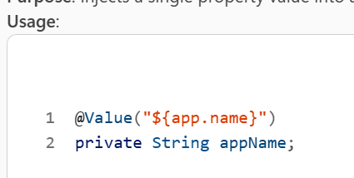  
  
**@ConfigurationProperties  
[1]** Binds a group of related properties to a POJO.

[2] Best for **structured configuration** (multiple related properties).

[3] Works well with YAML or properties files.

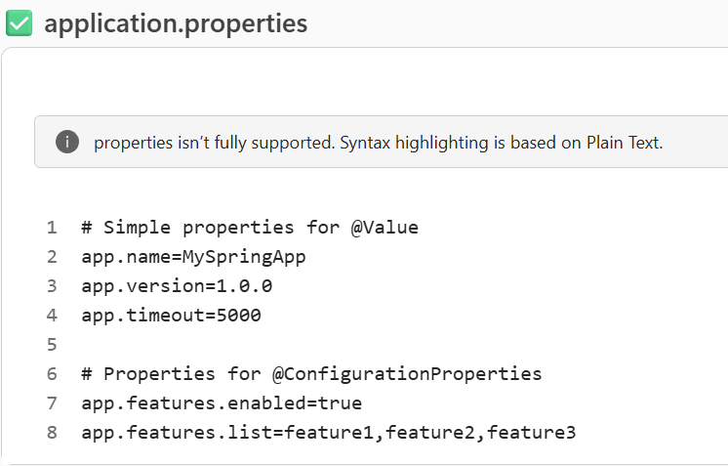  
  
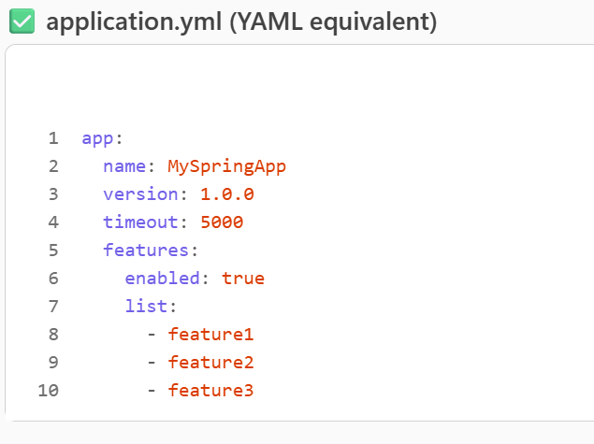

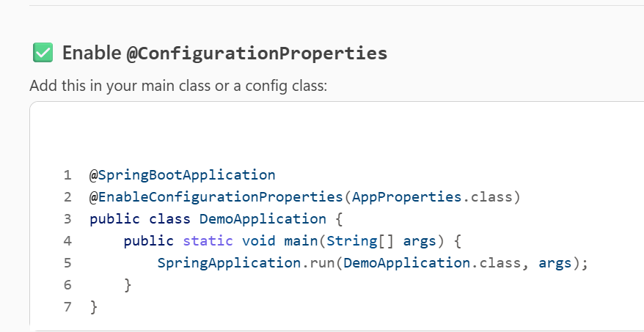  
  
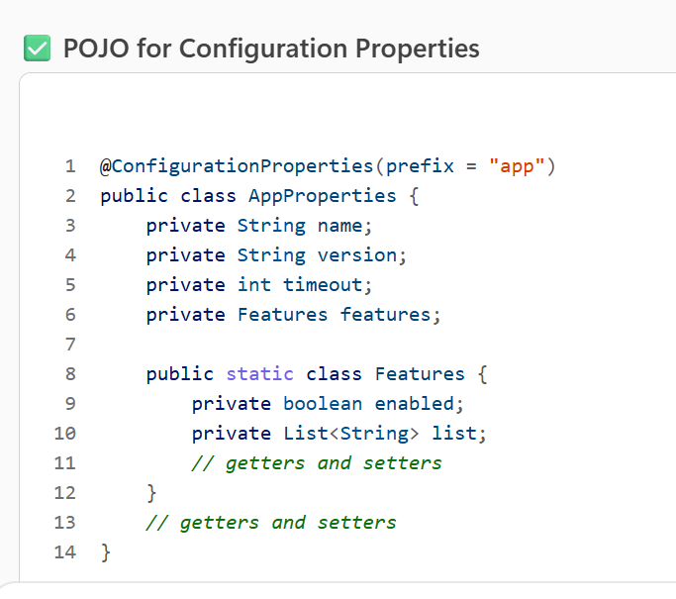  
  
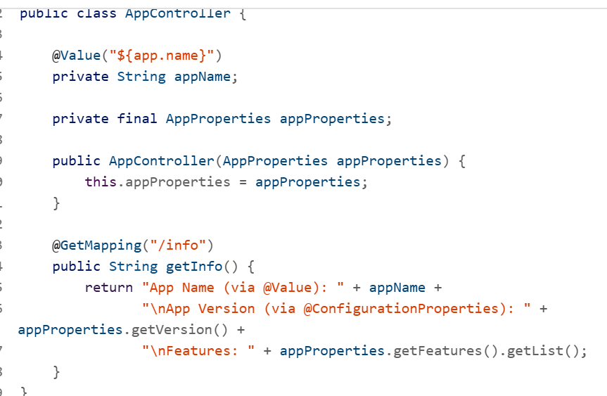

---------------------------------------------------------------------  
How to secure properties in application.properties?

**1. Use Environment Variables**

Instead of hardcoding secrets in application.properties, reference environment variables:  
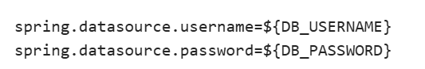  
2 . **Spring Boot Config Encryption (Jasypt or Spring Cloud Config)**

* **Jasypt**: Encrypt values and decrypt at runtime.

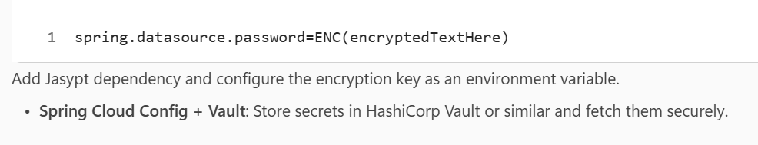

3. 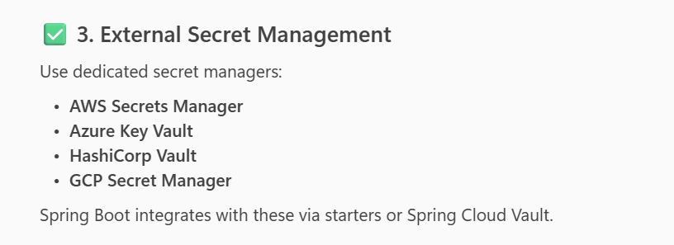

* 1. 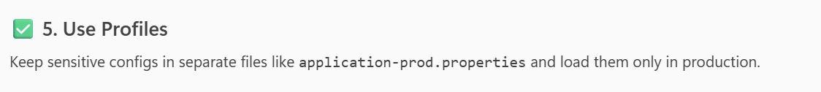

------------------------------------------------------------------------  
How to implement Paging and sorting in spring boot application?  
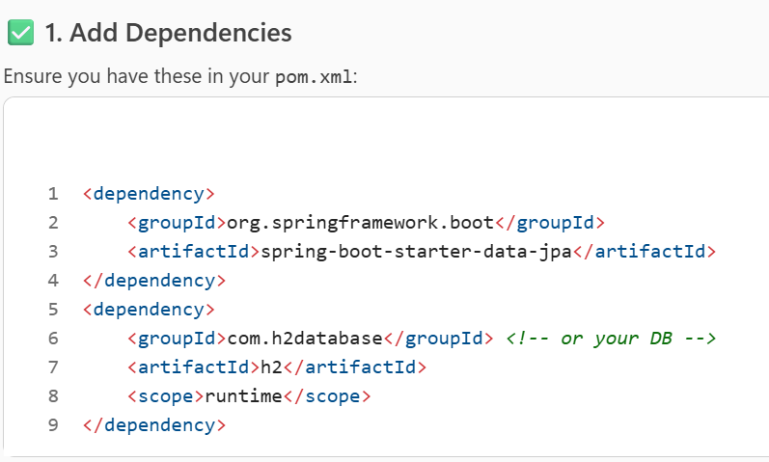

2. Define your entity and repository class :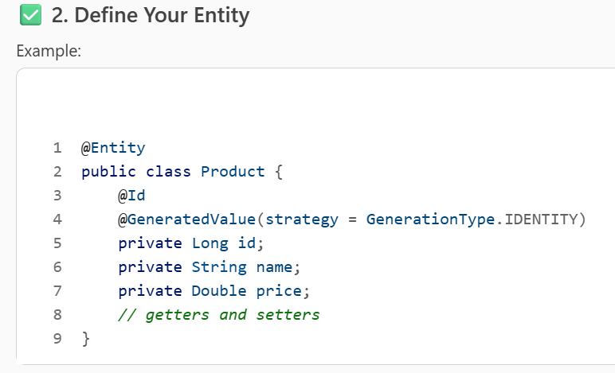  
  
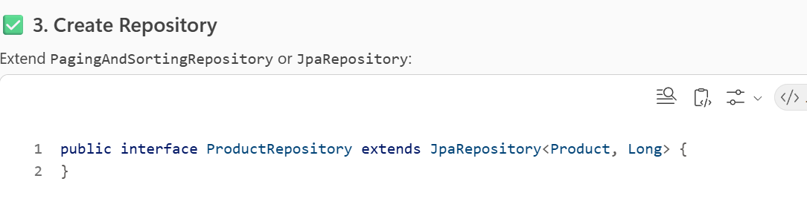

**4. Use Pageable and Sort in Service/Controller**

Spring provides Pageable and Sort for pagination and sorting.

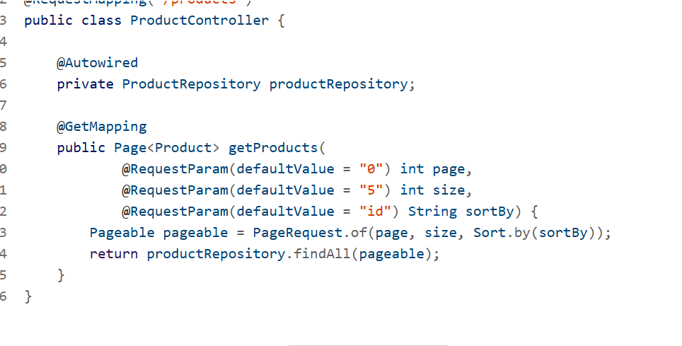  
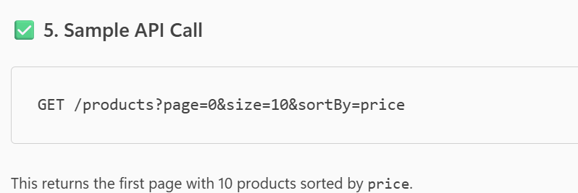  
  
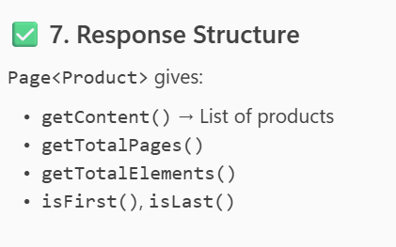  
  
---------------------------------------------------------------------  
How do you expose custom query methods in spring application?  
  
In a Spring application, if you want to expose **custom query methods via REST** (similar to @RestResource in Spring Data REST), here’s how you can do it:  
  
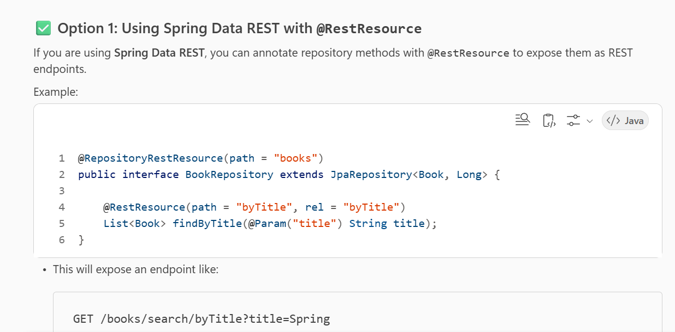  
  
[2] 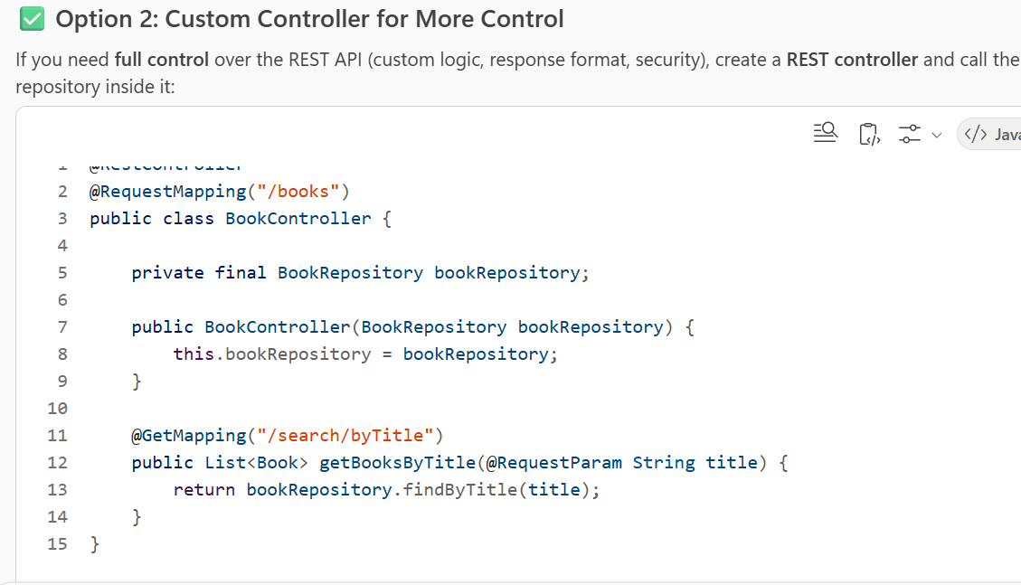

[3] 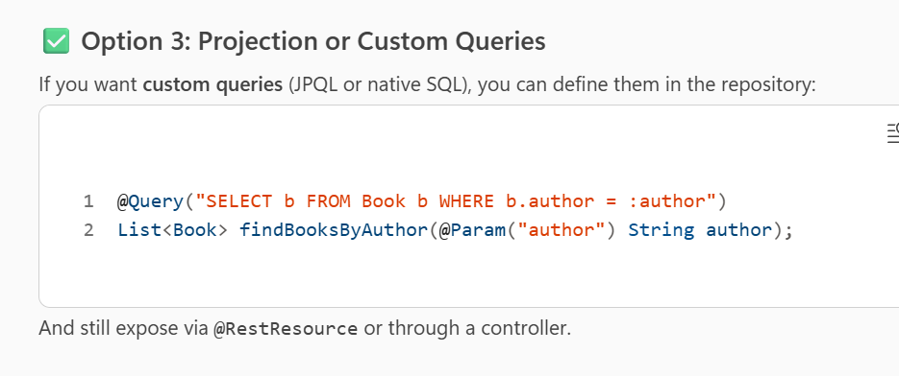  
  
----------------------------------------------------------------------------------------------------------  
What is @Transactional annotation?

The @Transactional annotation in **Spring Framework** is used to manage **transaction boundaries** declaratively. It tells Spring that the annotated method or class should run within a database transaction. Here’s what it does:  
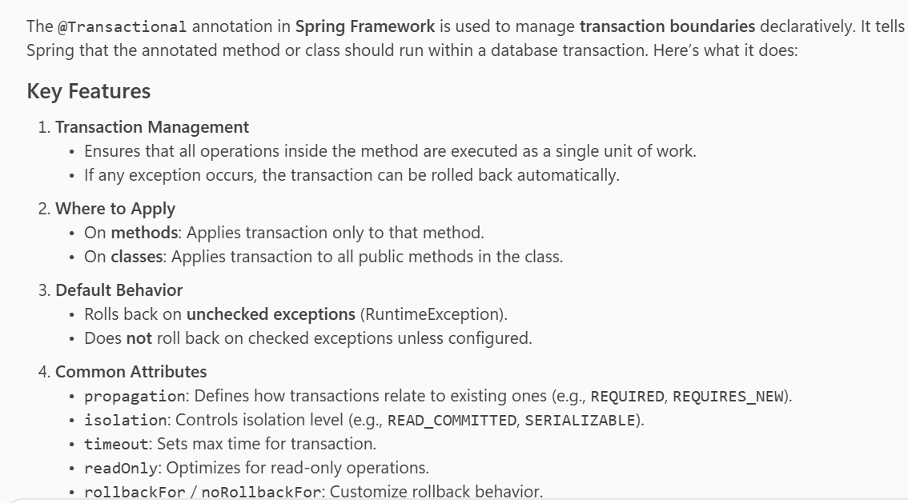

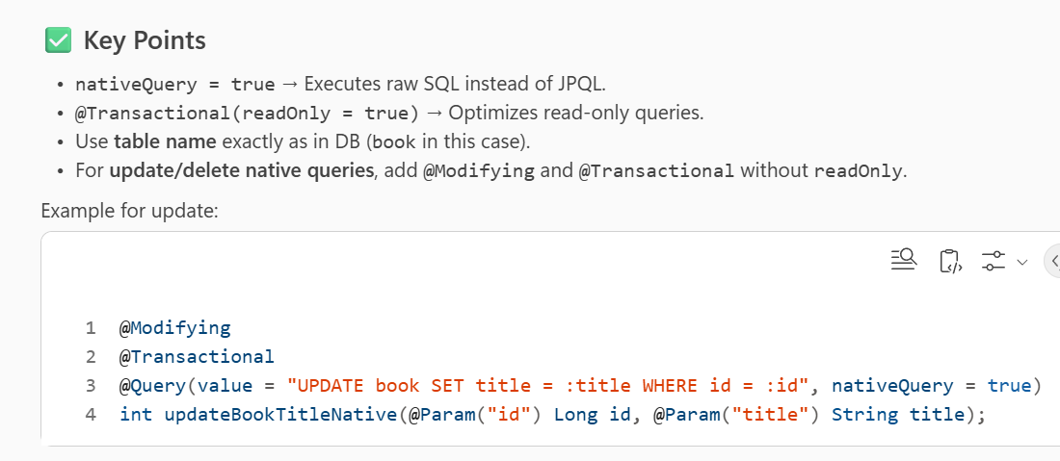  
When you use @Query(nativeQuery = true), it means **Spring Data JPA will execute the query as raw SQL against the database**, instead of converting JPQL (Java Persistence Query Language) into SQL.  
  
  
**What are sealed classes and sealed interfaces ?**Sealed classes and sealed interfaces are features introduced in **Java 17** (as part of Project Amber) to give developers more control over inheritance and polymorphism.  
  
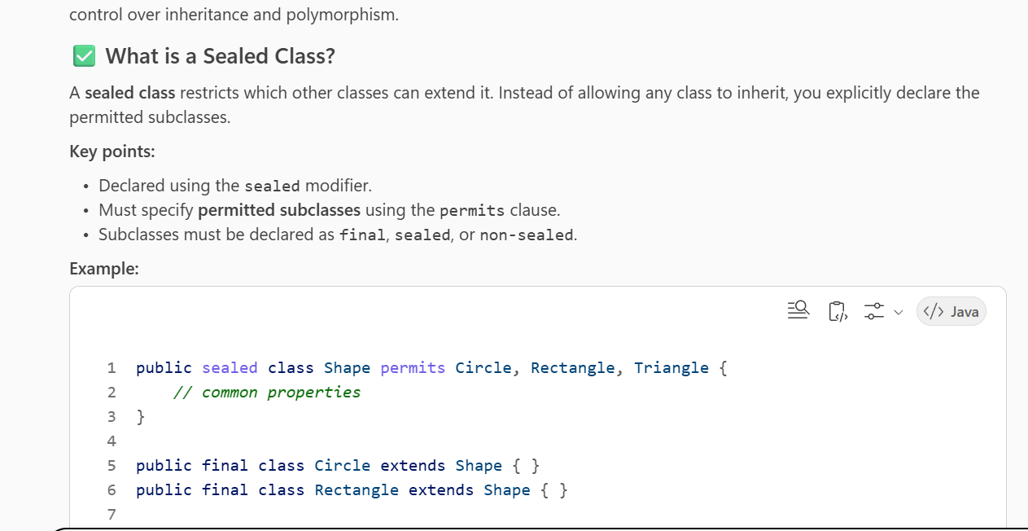  
  
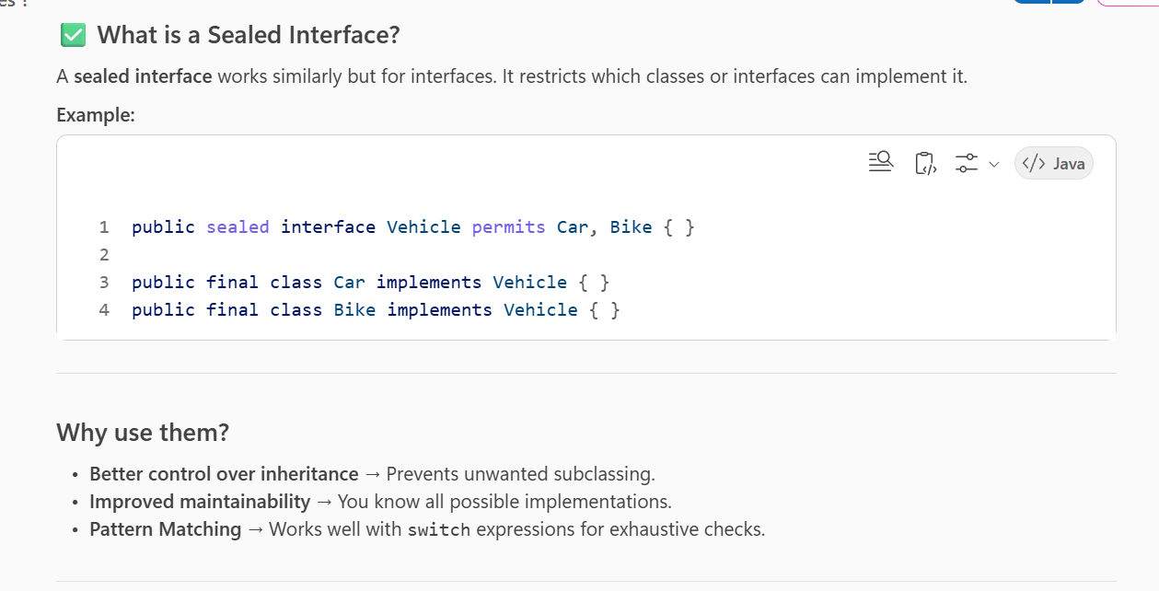  
  
  
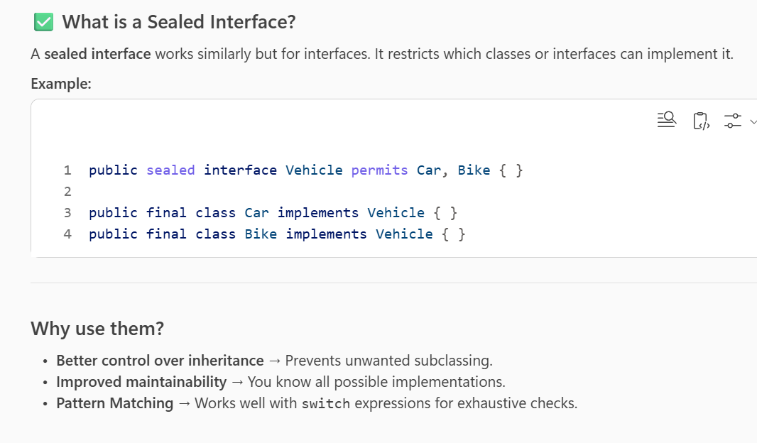  
------------------------------------------------------------------------  
What does immutablity actually means ?  
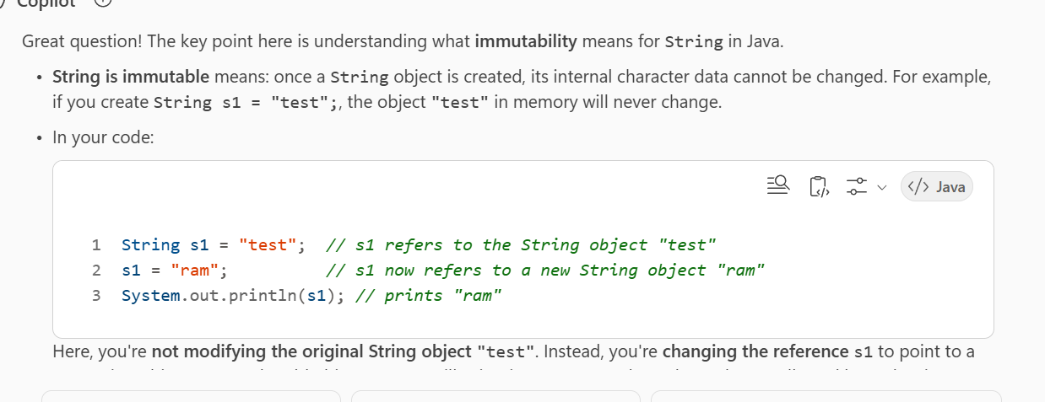  
------------------------------------------------------------------------  
How does concurrentHashMap handle concurrency differently from hashtable?

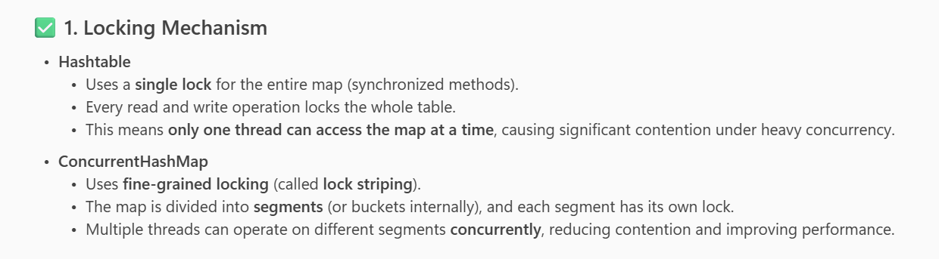

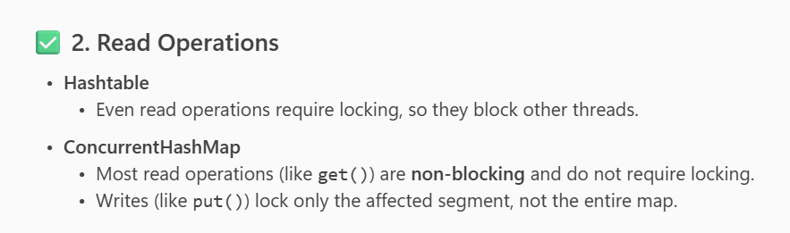  
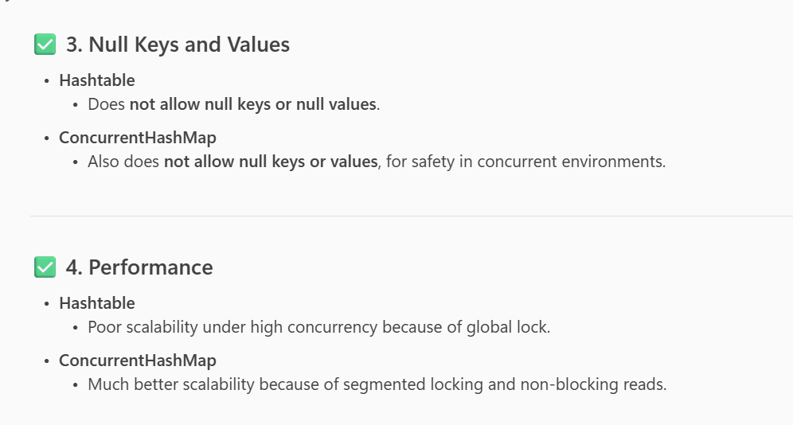  
  
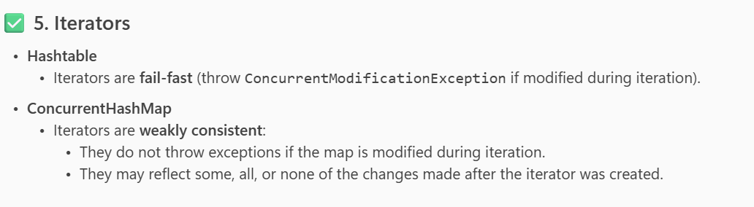  
  
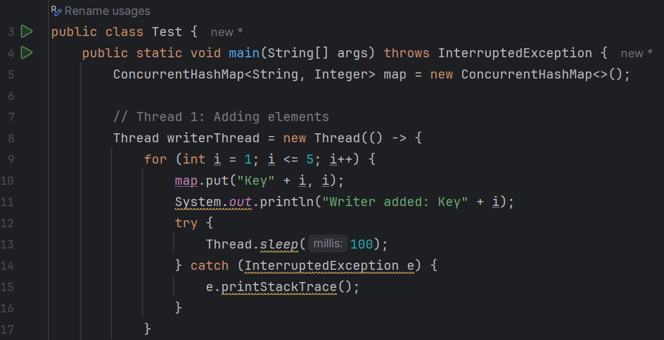  
  
  
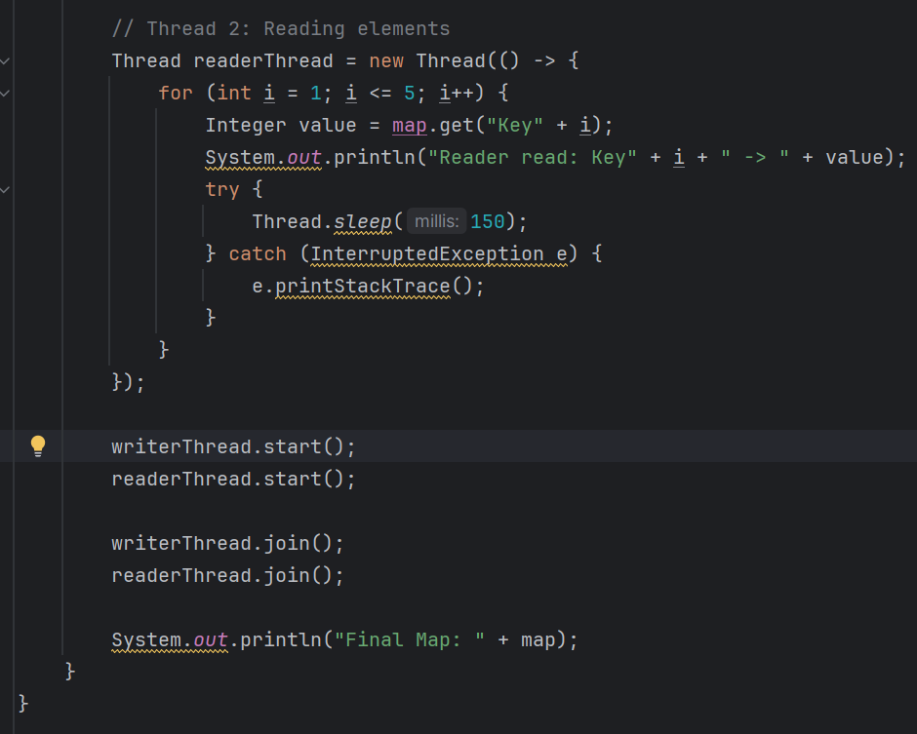  
  
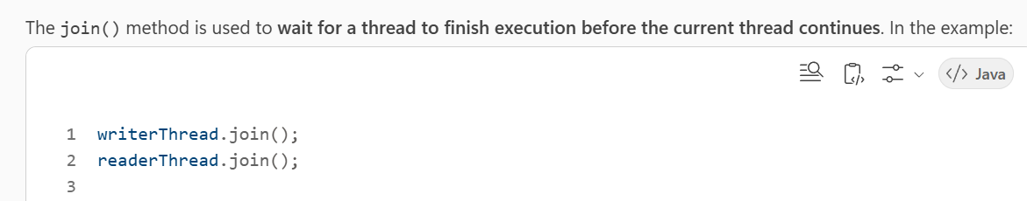  
  
Difference between map and flatmap in streams?

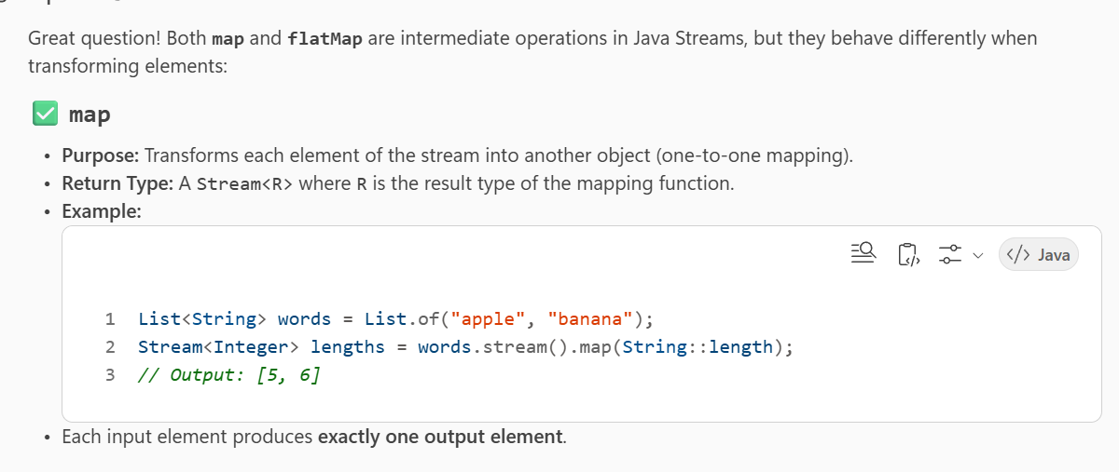

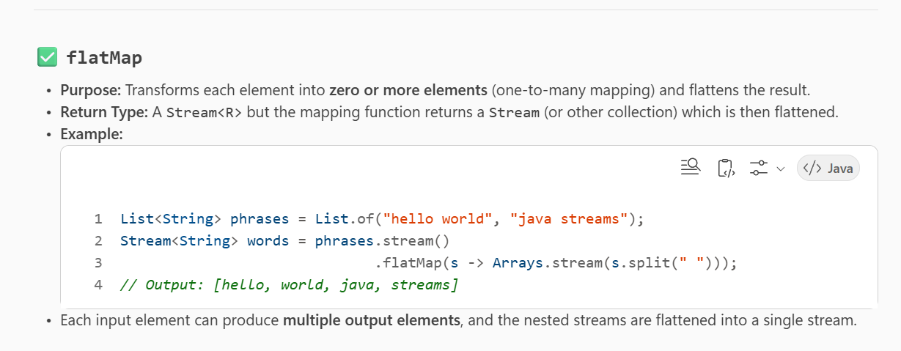  
  
Difference between feign client and rest template?

Feign Client and RestTemplate are both used in Spring applications to make HTTP calls, but they differ in design, usage, and capabilities  
  
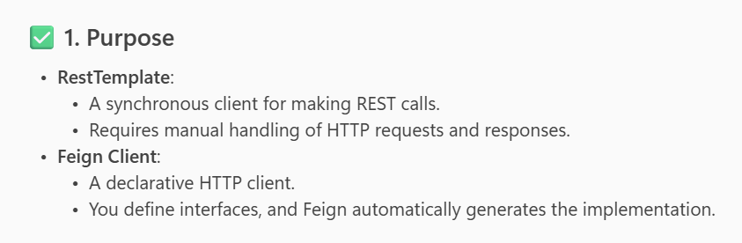  
  
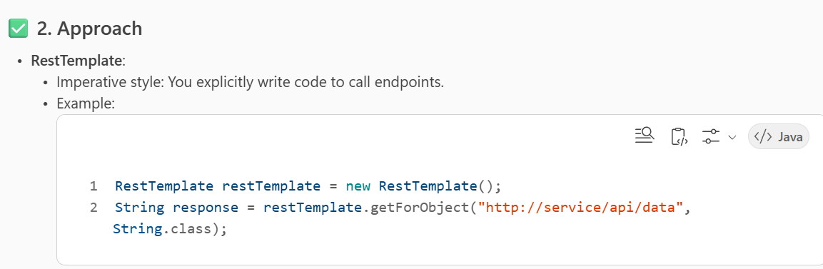  
  
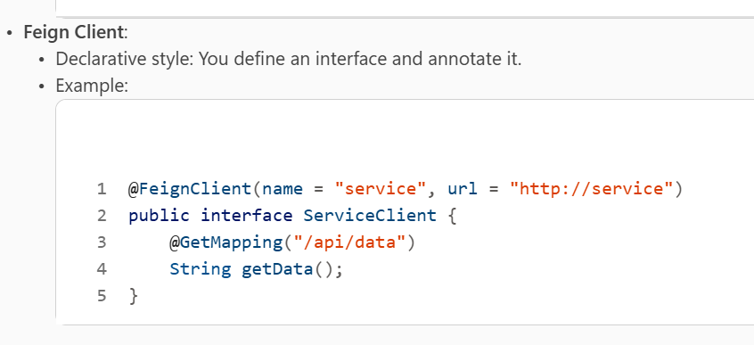  
  
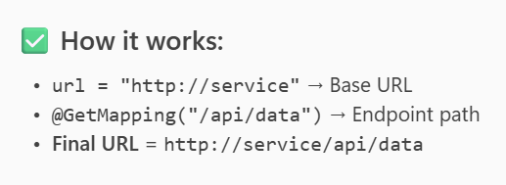  
  
  
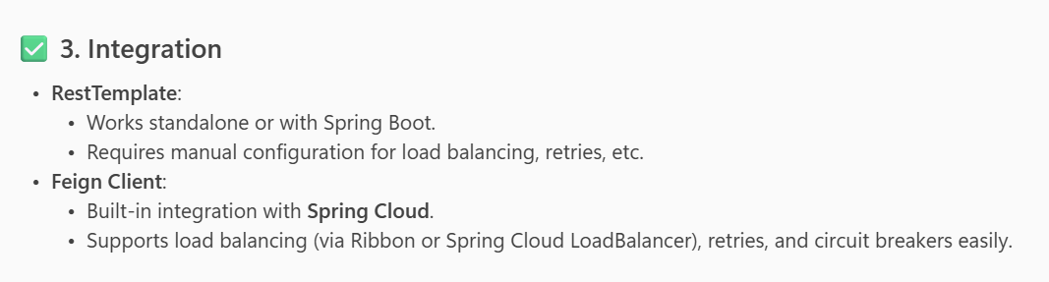  
  
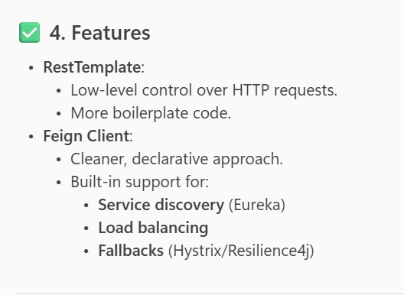  
  
RestTemplate Methods ::  
  
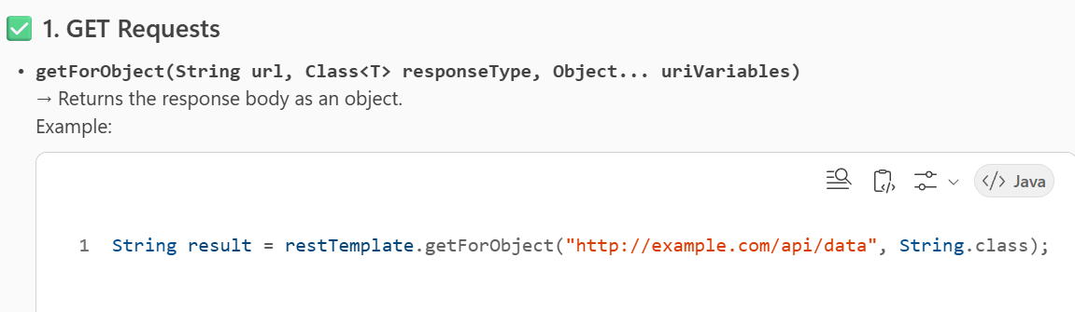  
[2]

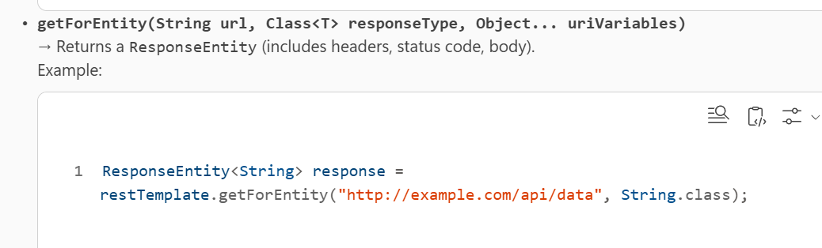  
  
[3]

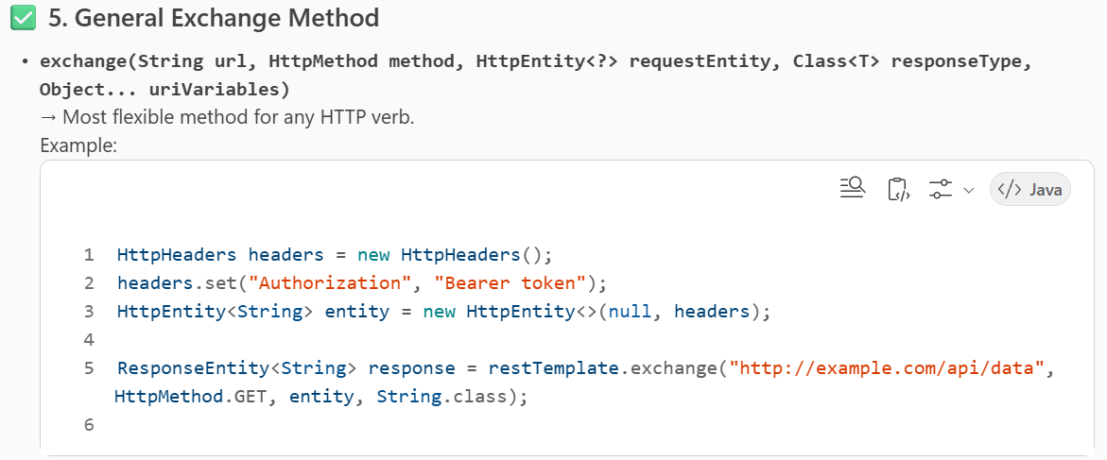  
  
What is difference between Future and Completable Future ?

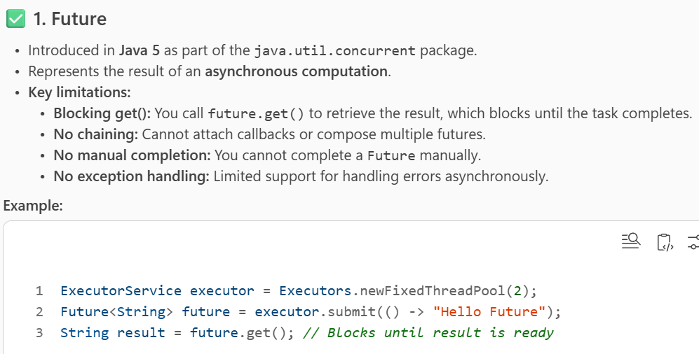  
  
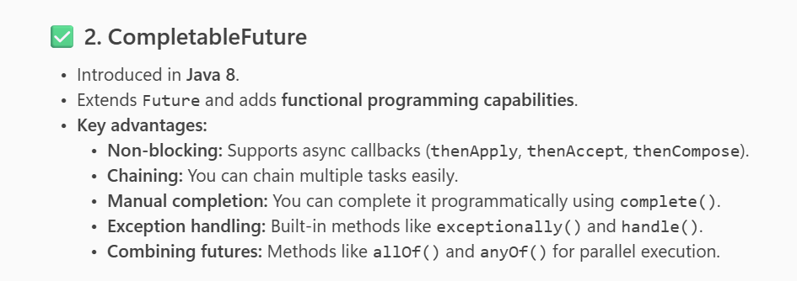  
  
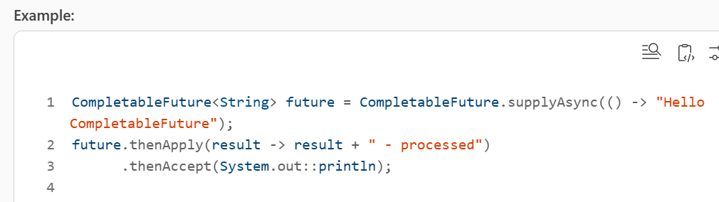  
  
  
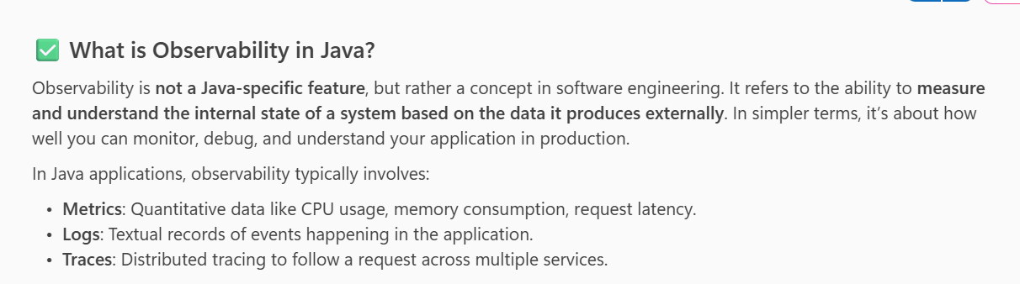  
  
  
  
  
  
  
**1. What is API Versioning and How is it Implemented?**

**API Versioning** is the practice of managing changes to an API without breaking existing clients. When APIs evolve (e.g., adding new features, changing response formats), versioning ensures backward compatibility.

**Common Implementation Strategies:**

* **URI Path Versioning:**  
  Example:
* https://api.example.com/v1/users
* https://api.example.com/v2/users

Each version is a separate endpoint.

* **Query Parameter Versioning:**  
  Example:
* https://api.example.com/users?version=1
* **Header-Based Versioning:**  
  Example:
* GET /users
* Header: Accept-Version: v1
* **Content Negotiation (Media Type):**  
  Example:
* Accept: application/vnd.example.v1+json

**Best Practices:**

* Use semantic versioning (e.g., v1, v2).
* Deprecate old versions gradually.
* Document changes clearly.

**2. What is API Caching?**

**API Caching** improves performance by storing responses temporarily so repeated requests don’t hit the server every time.

**How It Works:**

* When a client requests data, the API can return a cached response if available.
* Reduces latency and server load.

**Techniques:**

* **HTTP Caching Headers:**
  + Cache-Control, ETag, Expires
* **Reverse Proxy Caching:**
  + Tools like **Varnish**, **NGINX**
* **In-Memory Caching:**
  + Redis, Memcached for frequently accessed data.

**3. What is Rate Limiting?**

**Rate Limiting** controls how many requests a client can make to an API in a given time frame. It prevents abuse and ensures fair usage.

**Common Strategies:**

* **Fixed Window:**  
  Example: 100 requests per minute.
* **Sliding Window / Rolling Window:**  
  More accurate distribution.
* **Token Bucket / Leaky Bucket:**  
  Allows bursts but enforces average rate.

**Implementation Tools:**

* API Gateways (e.g., **Kong**, **Apigee**)
* Reverse proxies (NGINX)
* Custom middleware in your backend.  
  ---------------------------------------------------------------------  
  What are types of Thread in Java ?

**1. User Threads**

* These are the threads created by the programmer for performing tasks in the application.
* They run in the foreground and keep the JVM alive until all user threads finish execution.
* Example: Any thread you create using Thread class or Runnable interface.

**2. Daemon Threads**

* These are background threads that provide services to user threads (like garbage collection).
* JVM does **not** wait for daemon threads to finish; it exits when all user threads are done.
* You can make a thread daemon by calling thread.setDaemon(true) before starting it.

**3. Main Thread**

* The thread that starts when a Java program begins execution.
* It is created by the JVM and is responsible for running the main() method.

**4. Worker Threads (in Thread Pools)**

* Used in concurrent programming for executing tasks from a queue.
* Managed by ExecutorService or ForkJoinPool for efficient resource utilization.

**5. Specialized Threads**

* **Timer Threads**: Created by java.util.Timer for scheduling tasks.
* **ForkJoin Threads**: Used in parallelism for divide-and-conquer algorithms.’

---------------------------------------------------------------  
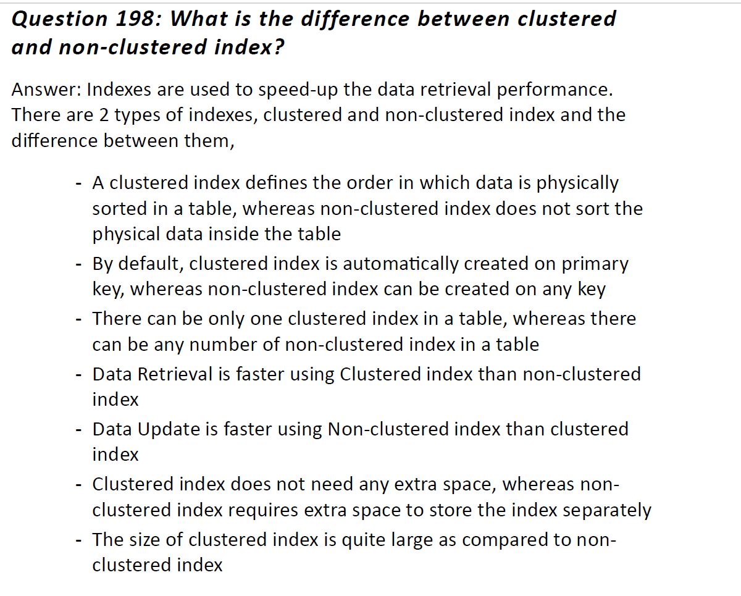  
  
-------------------------------------------------------------------  
  
  
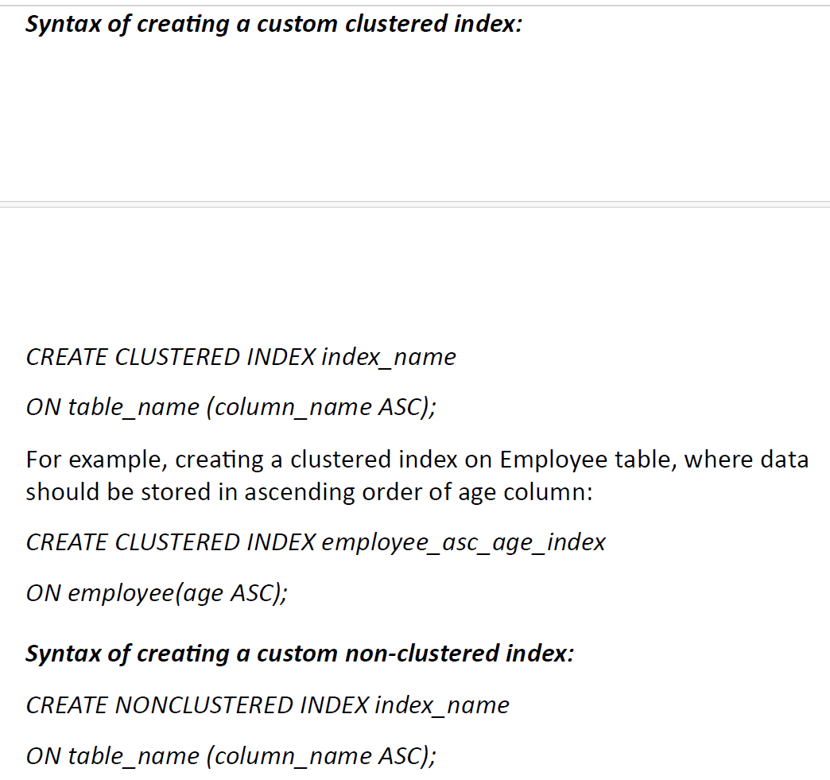

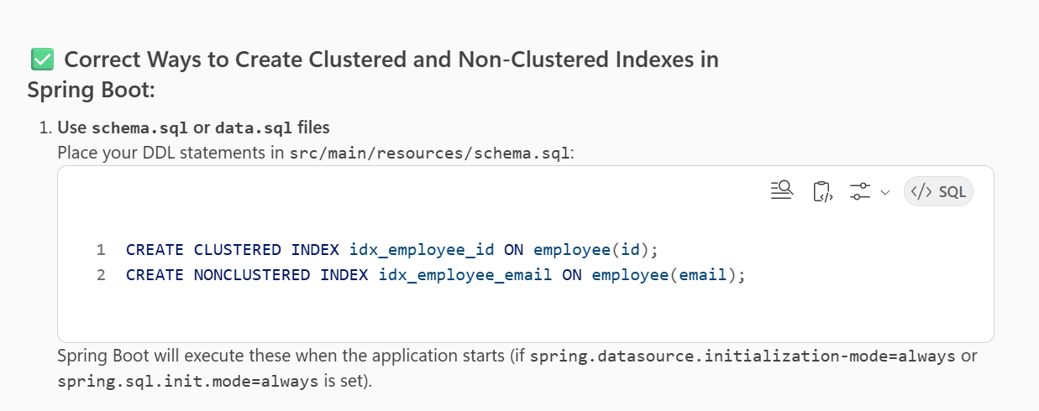  
  
------------------------------------------------------------------------  
What is HashSet and treeSet in java and which one is faster?

**HashSet**

* **Implementation**: Based on a **hash table**.
* **Ordering**: Does **not** maintain any order of elements.
* **Performance**: Very fast for basic operations like add, remove, and contains because these are **O(1)** on average (due to hashing).
* **Nulls**: Allows one null element.

**TreeSet**

* **Implementation**: Based on a **Red-Black Tree** (a type of self-balancing binary search tree).
* **Ordering**: Maintains elements in **sorted order** (natural or custom comparator).
* **Performance**: Operations like add, remove, and contains are **O(log n)** because of tree traversal.
* **Nulls**: Does **not** allow null if using natural ordering.

**Which is faster?**

* **HashSet** is generally faster than **TreeSet** because:
  + HashSet uses hashing → average **O(1)** time complexity.
  + TreeSet uses tree structure → **O(log n)** time complexity.
* However, if you need **sorted data**, TreeSet is the right choice despite being slower.

Code :  
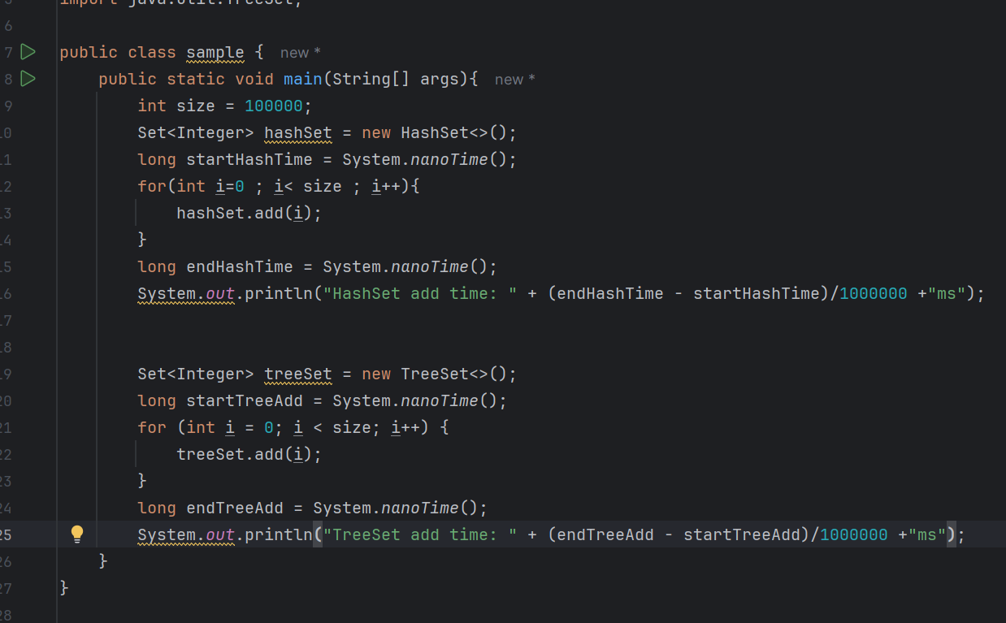

**HashSet add time: 8ms**

**TreeSet add time: 23ms  
------------------------------------------------------------------------  
What is @Transient keyword in jpa?**

In JPA, the **@Transient annotation is used to indicate that a particular field of an entity should not be persisted in the database**  
  
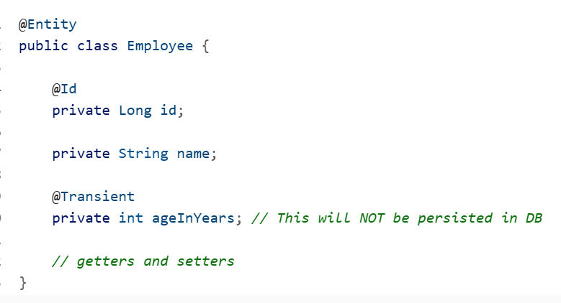  
  
-----------------------------------------------------------------------  
**What does persist mean in JPA?**

In **Java Persistence API (JPA)**, persist() is a method provided by the EntityManager interface. It is used to **make a transient entity instance managed and persistent**. In simpler terms:

When you call entityManager.persist(entity), JPA:

* + Associates the entity with the current persistence context.
  + Marks it for insertion into the database when the transaction is committed.
* The actual SQL INSERT happens **later**, typically at **flush** or **commit** time, not immediately.  
    
  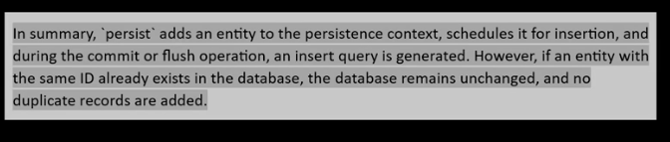

**Key points about persist() in JPA:**

* It **does not return anything** (void).
* It only works on **new (transient) entities**.
* If the entity already exists in the database, persist() will throw an exception (use merge() for updates).  
    
  --------------------------------------------------------------  
  Understanding of Term : **make a transient entity instance managed and persistent**.  
  **Transient → Managed → Persistent**
* In JPA, an entity can be in different states:

**Transient**

* A new Java object that is **not associated with any persistence context** and **not stored in the database**.  
    
  Employee emp = new Employee();

emp.setName("Ankur");

At this point, emp is just a normal object in memory.

2 **Managed (Persistent Context)**

When you call entityManager.persist(emp), JPA **attaches** this object to the persistence context.

* Now JPA tracks changes to this object. If you modify its fields, JPA will update the database automatically when the transaction commits.

3 .**Persistent (in Database)**

* After the transaction is committed (or flush() is called), JPA executes the SQL INSERT and the object’s data is stored in the database.  
    
  ----------------------------------------------------------------  
  How Persist is different from Jdbc ?  
  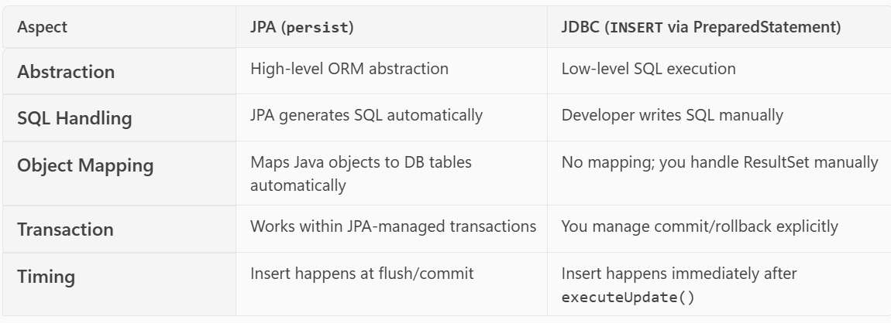  
  --------------------------------------------------------------------  
  How persist can be implemented in Spring Application?  
   <https://www.youtube.com/watch?v=gUwF3BHBEV8&list=PL5mjp3QjkuoJ6sy-> M1QrZ8osHVEFt0S2D&index=2 🡪 Refer Video

[1] Dependency required :  
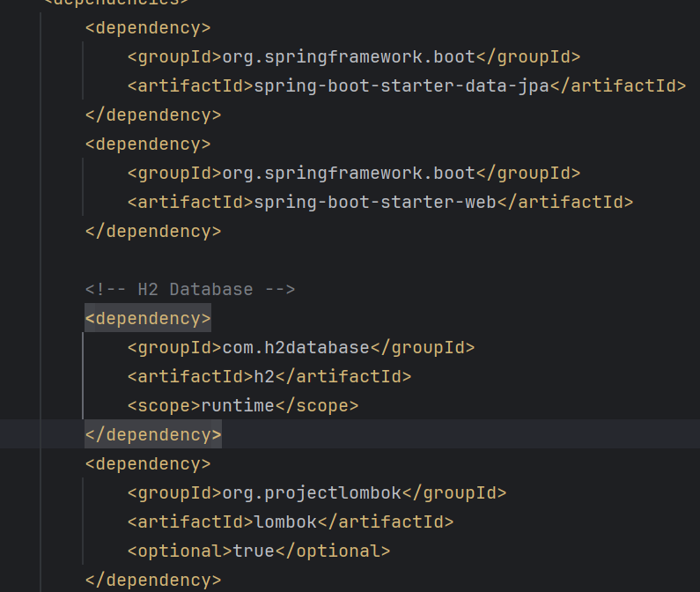  
  
{2] Create a Entity   
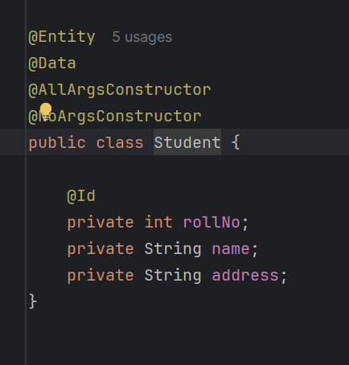  
  
[3]   
  
Create a class which will implement PersistenceUnitInfo   
  
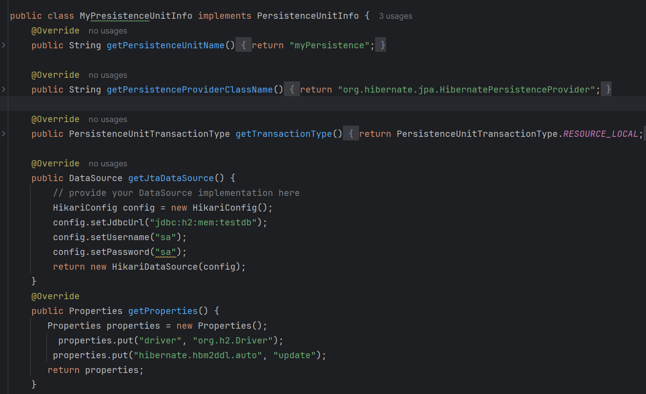  
  
[4] Execute the transient -> managed -> persist state changes of Jpa in main class  
In this emf.createEntityManager creates an empty context for Persistence context.

Persist method is used to adding an entity to context   
commit() method is used to execute statmentinto Db jpa   
------------------------------------------------------  
  
  
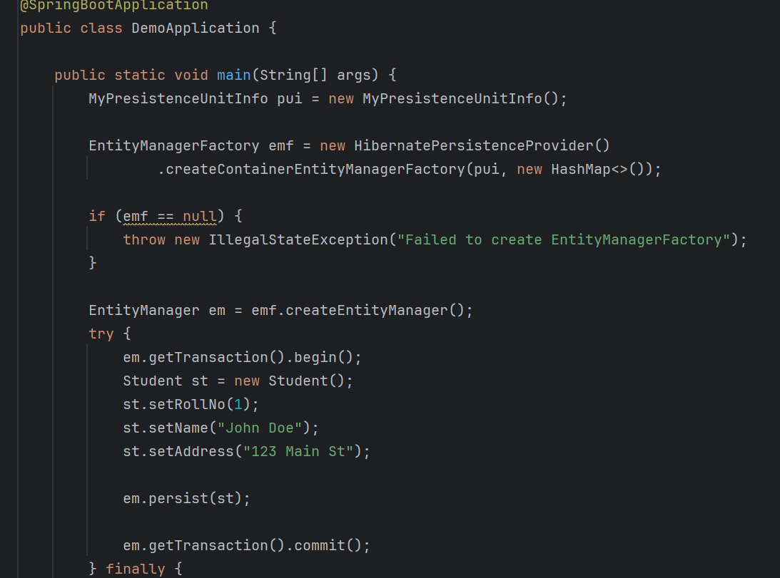  
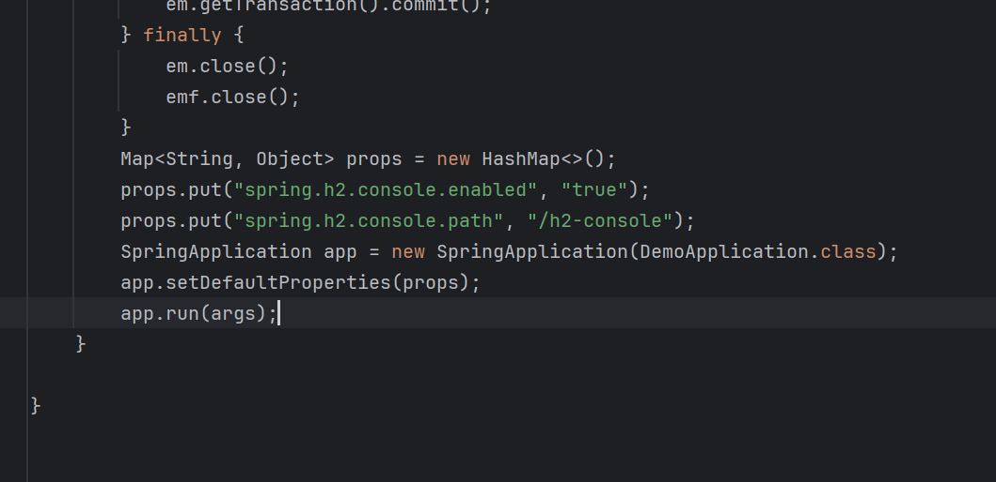  
  
---------------------------------------------------------  
Merge 🡪 method is used to update detached entity to context   
Where as detached entity means record already present into context .  
it will execute a select statement to check and commit will decide whether to insert and update   
  
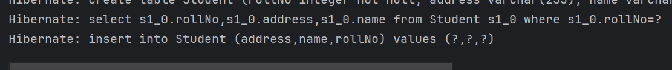  
  
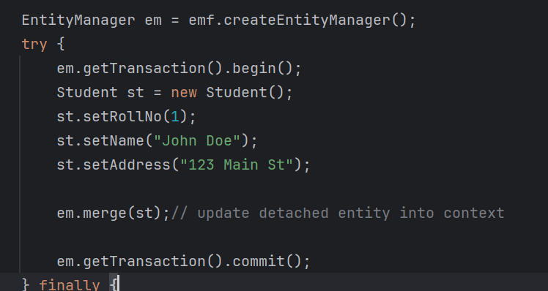  
  
To understand 🡪 we will add properties show sql 🡪 true   
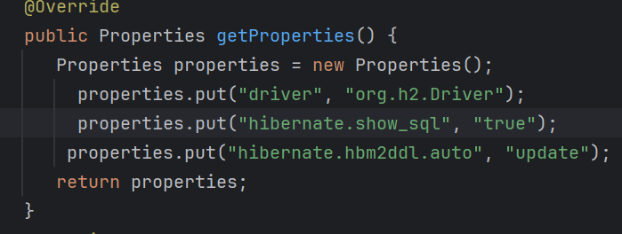  
---------------------------------------------------------  
  
  
How does ssl security is enabled in spring application and how it is used with https Url ?   
  
**What is SSL / HTTPS (Very Simple)**

* **SSL/TLS** encrypts data between **client ↔ server**
* **HTTPS = HTTP + SSL**
* Prevents:
  + Data theft
  + Man-in-the-middle attacks
  + Password/token leakage

👉 If your URL starts with  
https:// → SSL is enabled  
http:// → NOT secure

**2️⃣ How SSL works (High-level Flow)**

1. Client calls https://api.example.com
2. Server sends **SSL certificate**
3. Client verifies certificate
4. Secure encrypted connection is established
5. Data flows securely 🔐

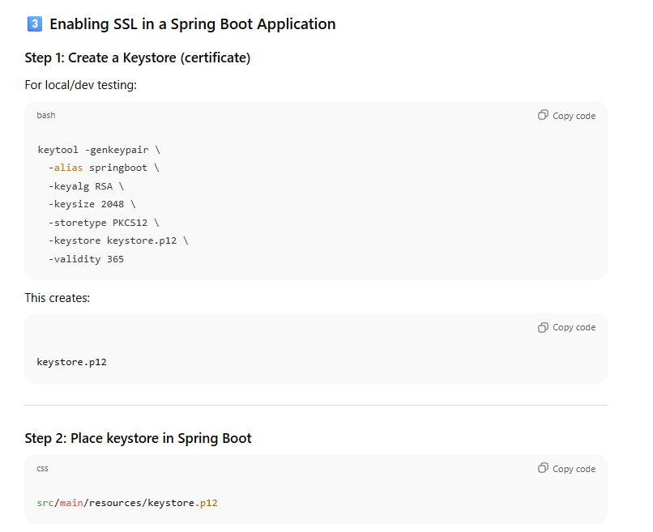  
  
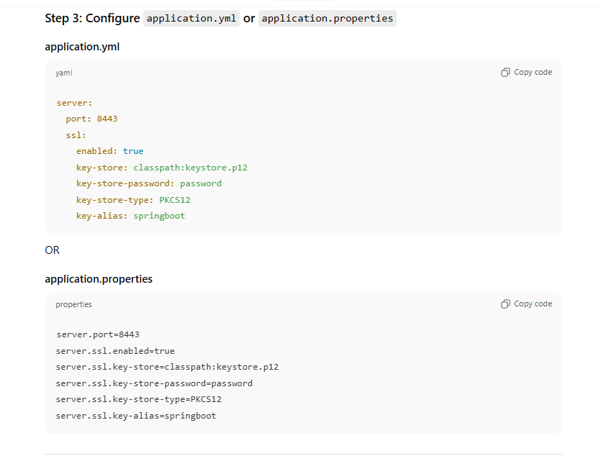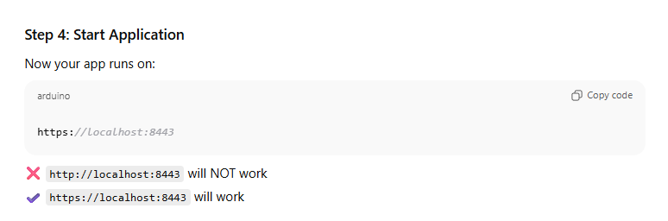  
  
If you are using with spring cloud gateway use it in this way :  
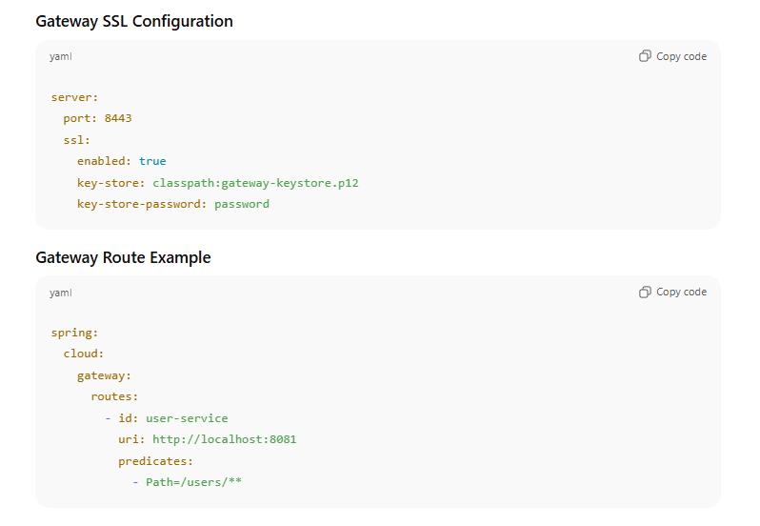  
---------------------------------------------------------  
**Explain solid principal with real word examples ?**  
  
**1️⃣ S – Single Responsibility Principle (SRP)**

**Definition**  
👉 *A class should have only one reason to change* (one responsibility).

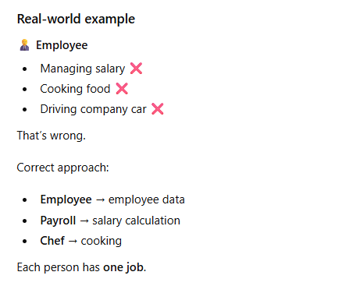  
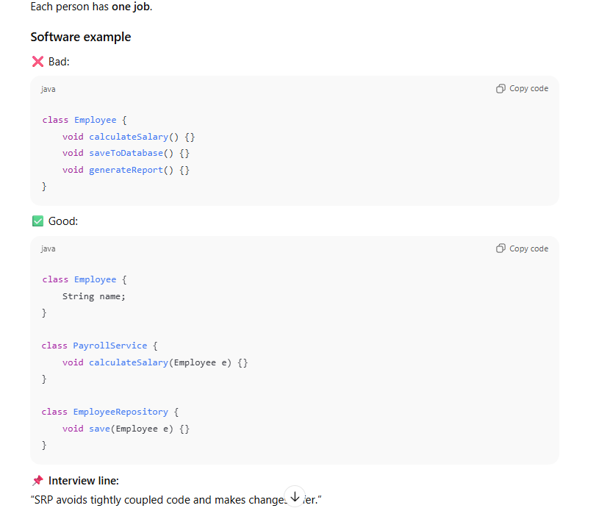  
  
  
[2] 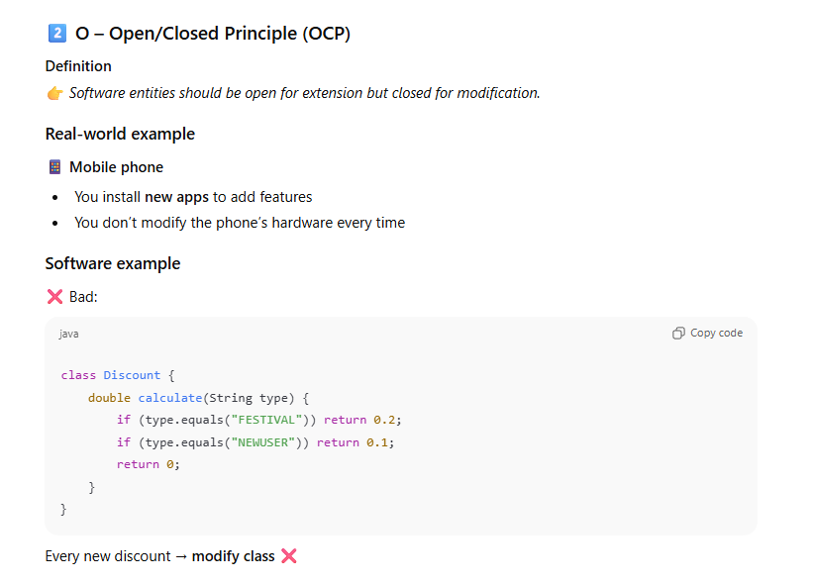  
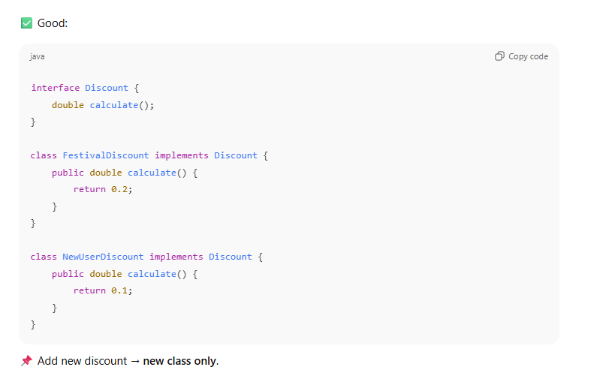

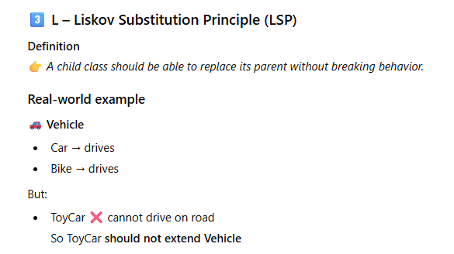  
  
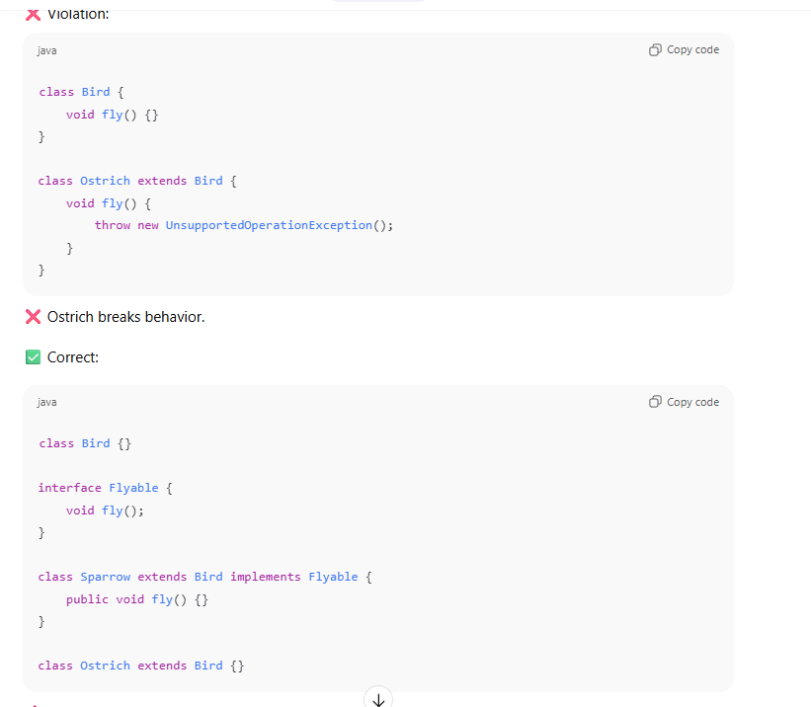  
  
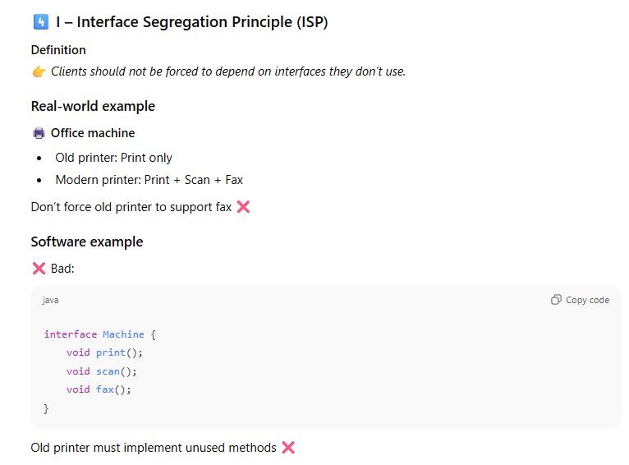  
  
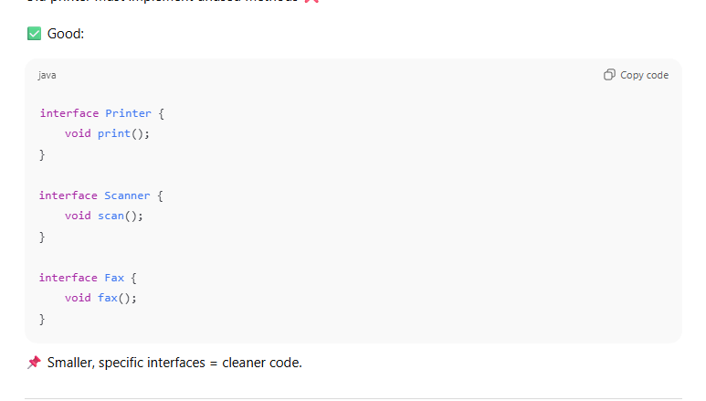  
  
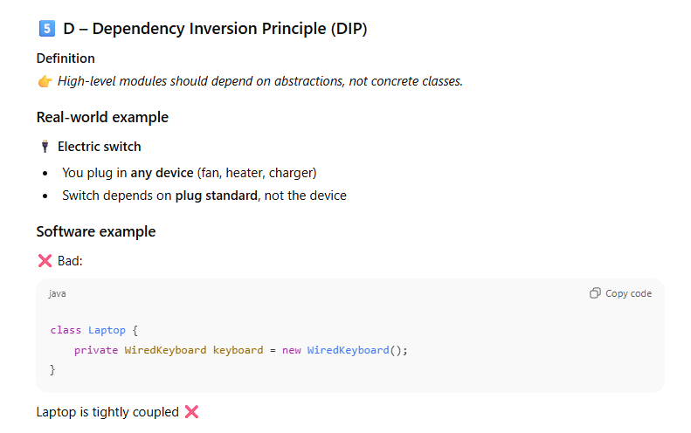  
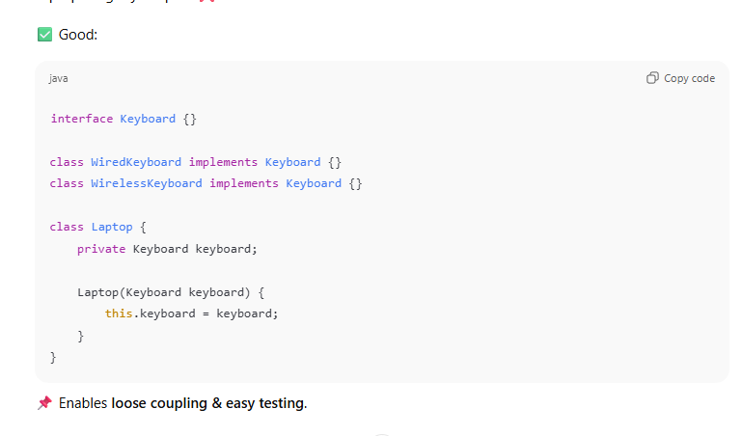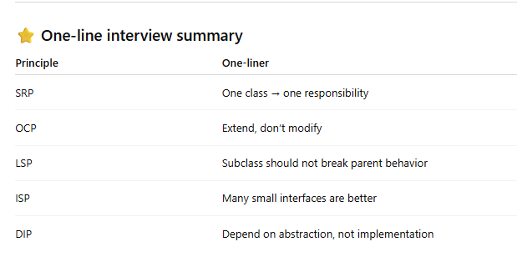

Q. **Equals and hashcode code method ( list has duplicate values how to get distinct values )**

**Why equals() and hashCode() matter**

* Used by **HashSet**, **HashMap**, **distinct()**
* To identify **duplicate objects**
* **Contract**:
  + If equals() is true → hashCode() **must be same**
  + Same hashCode() does **not** mean equals() is true  
      
    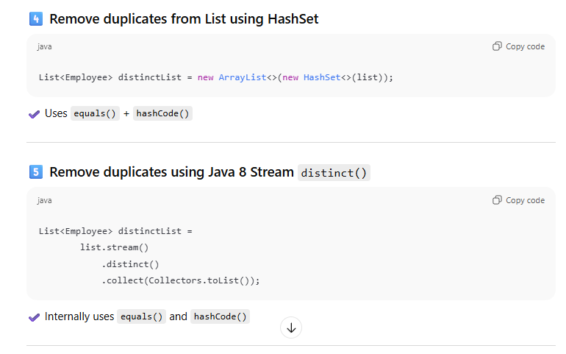

**Can we make a constructor final in java ?**

**No, constructors cannot be final because they are not inherited and cannot be overridden.**

**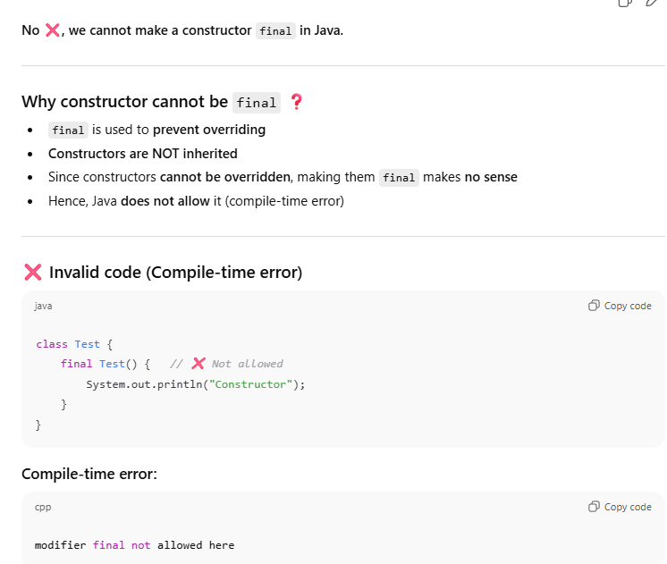  
  
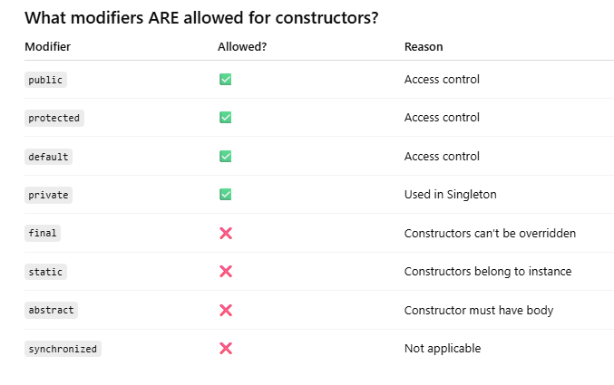  
Q. Predicate supplier consumer predicate function difference related to stream functions ?  
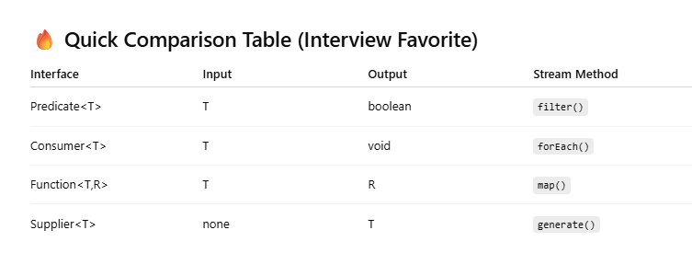  
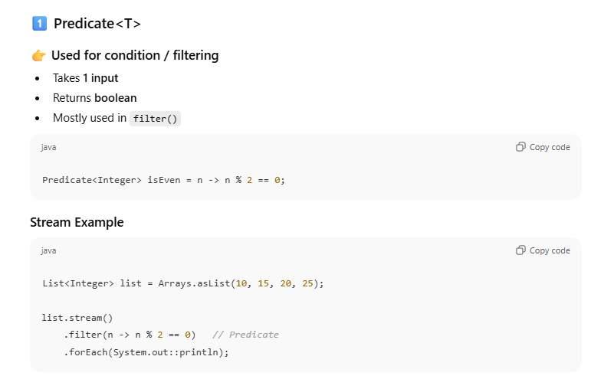  
[2]**

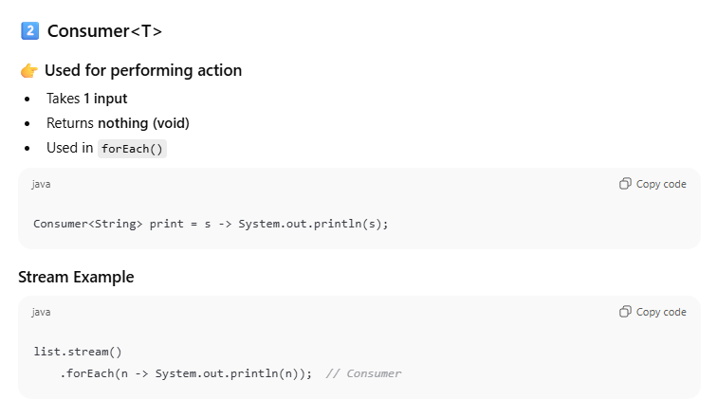

**[3]**

**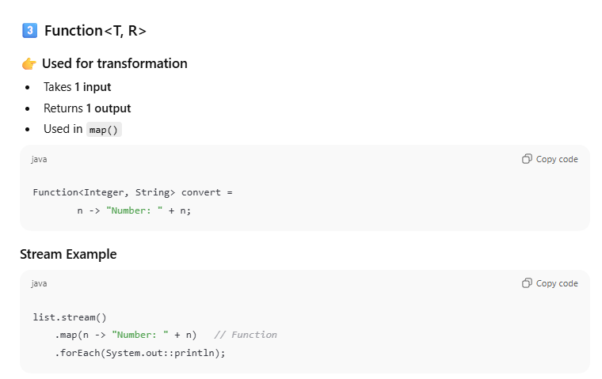  
[4]**

**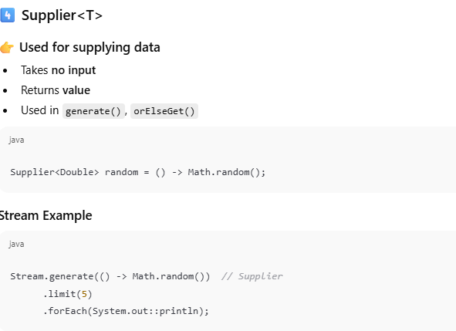  
  
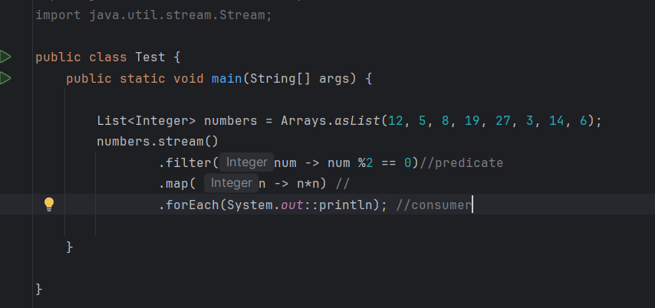  
  
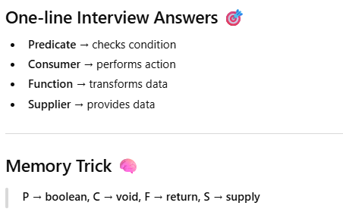  
  
Q. MultiThreading concepts used in spring ?**

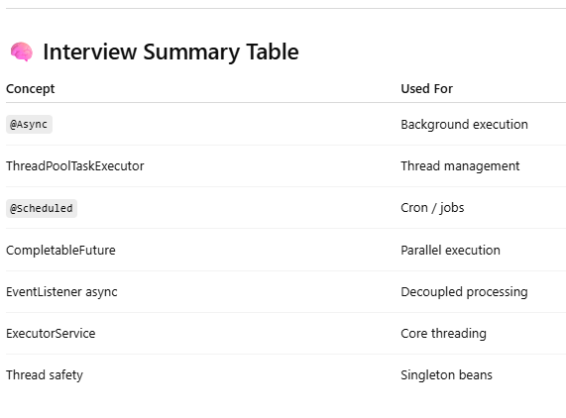 **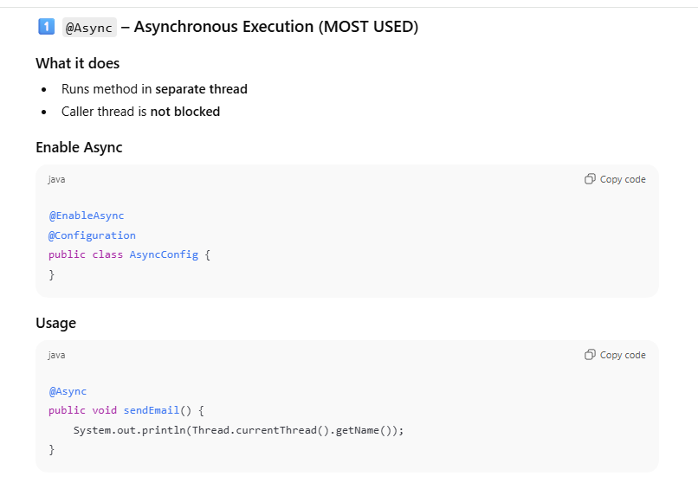  
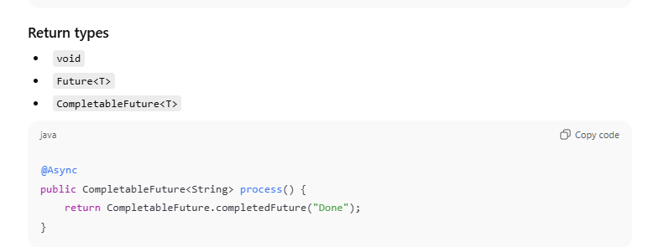  
  
[2]  
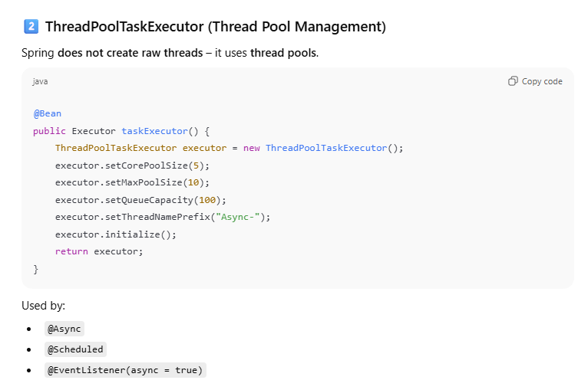  
[3]  
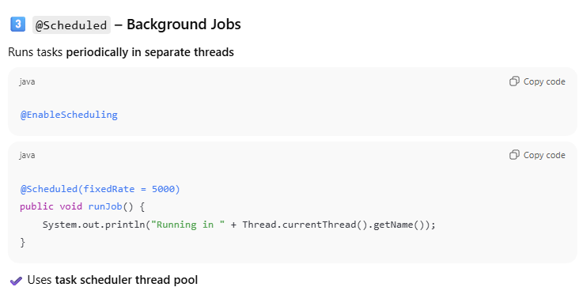  
[4]  
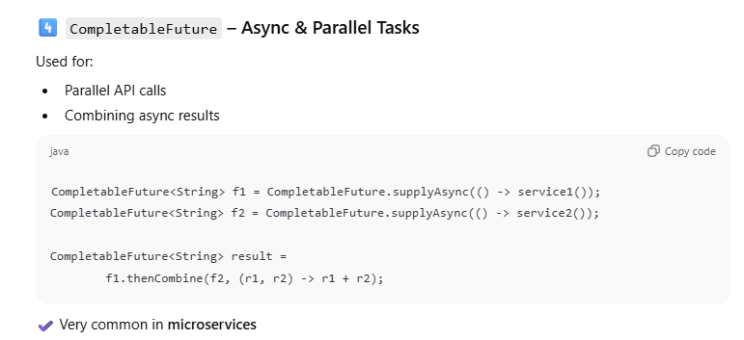**

**How to add custom dependency in spring boot application?**

A custom Spring Boot starter is a reusable module that provides **auto-configuration + dependencies so that users can enable a feature just by adding one dependency.  
  
Steps to Create a Custom Spring Boot Starter**

**Step 1️⃣ Create Two Maven Projects (Best Practice)**

**1. my-feature-spring-boot-starter**

👉 **Starter module**

* Contains only dependencies
* No configuration logic

**2. my-feature-spring-boot-autoconfigure**

👉 **Auto-configuration module**

* Contains configuration classes
* Uses conditional annotations

📌 This separation avoids circular dependencies.

Step 2️⃣ Create Auto-Configuration Class

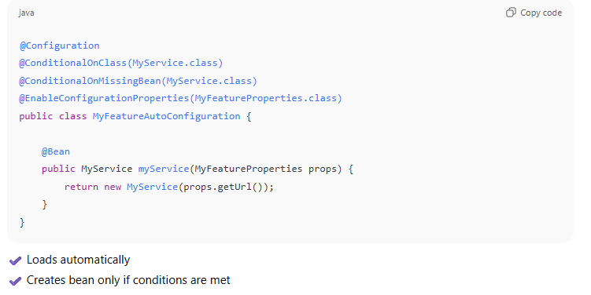  
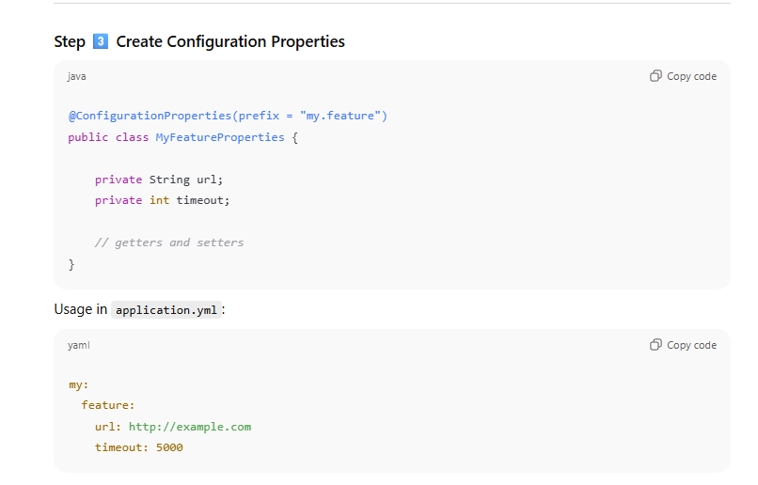  
[4] 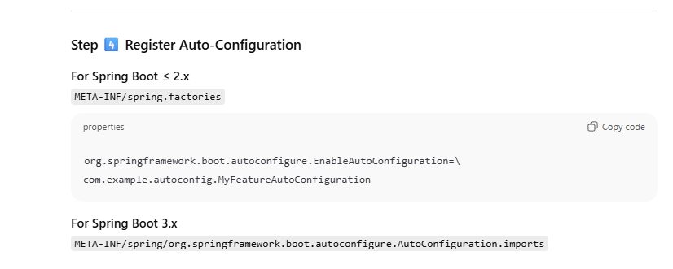

Understanding purpose :  
This property is not defined in application.properties or in yml file .  
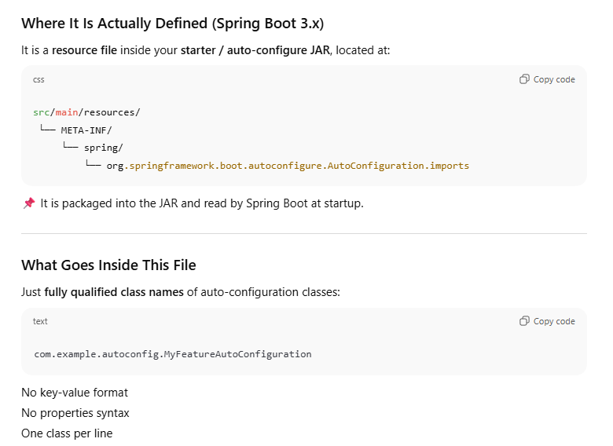  
  
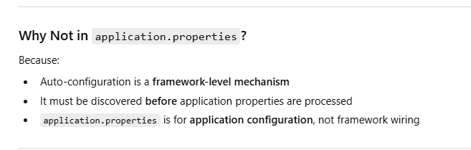  
  
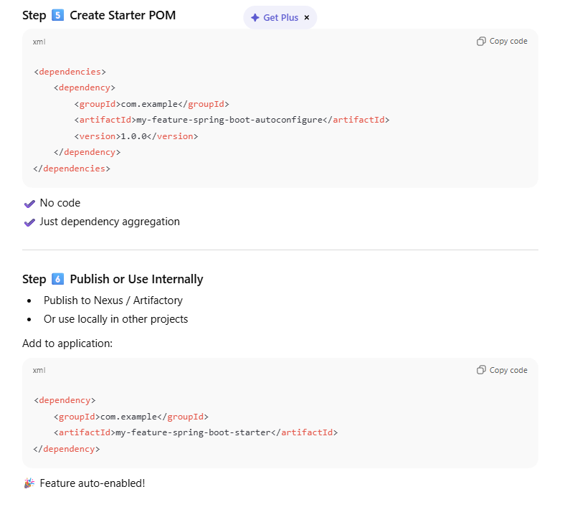  
Properties used :  
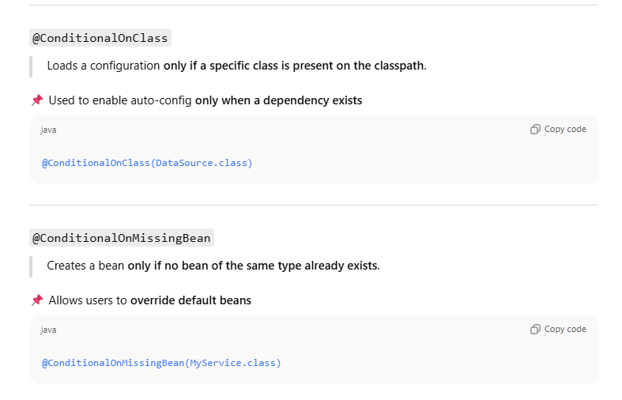

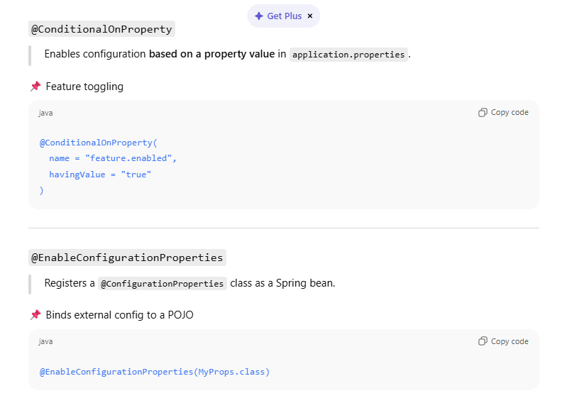  
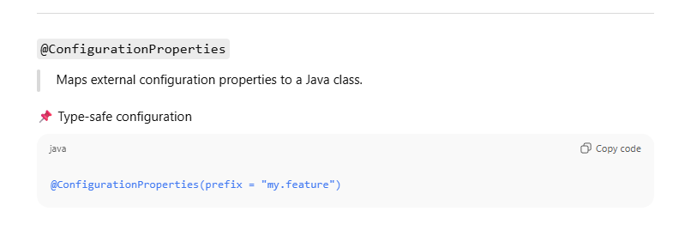

**how to create custom annotation in spring application?**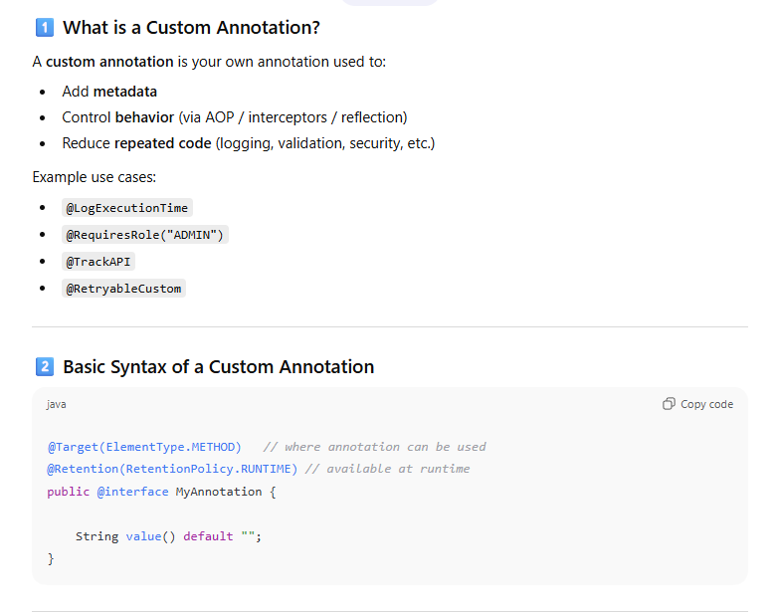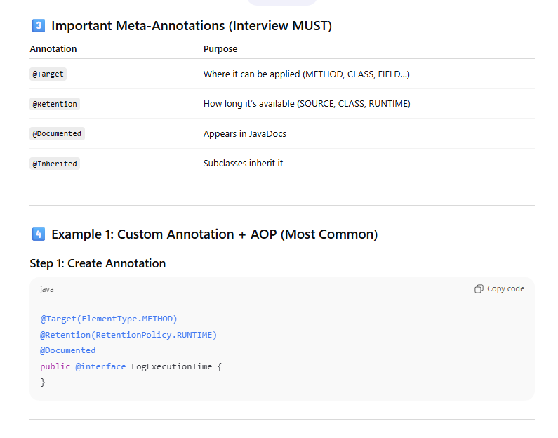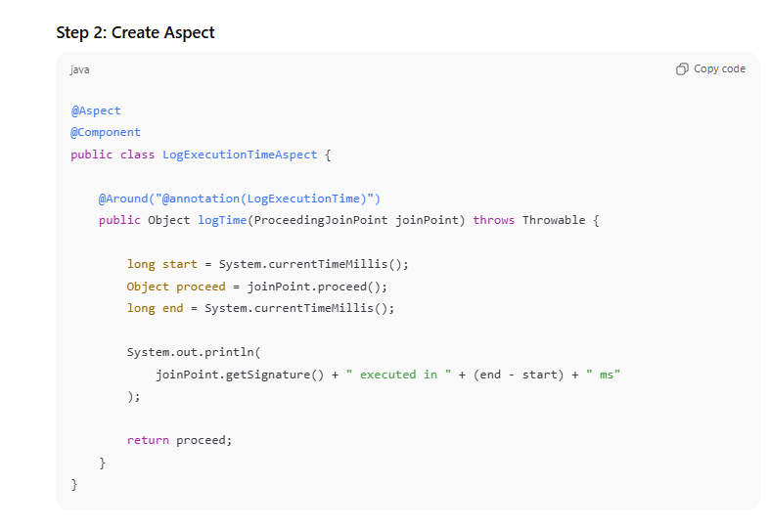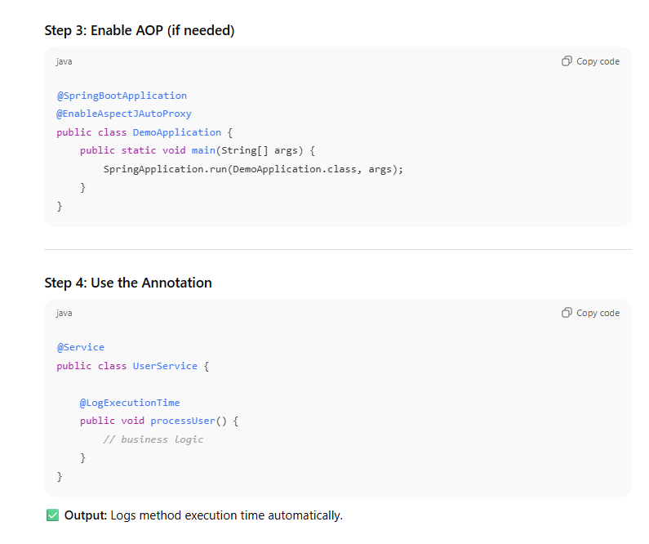

**Executor service vs fork join pool ?**

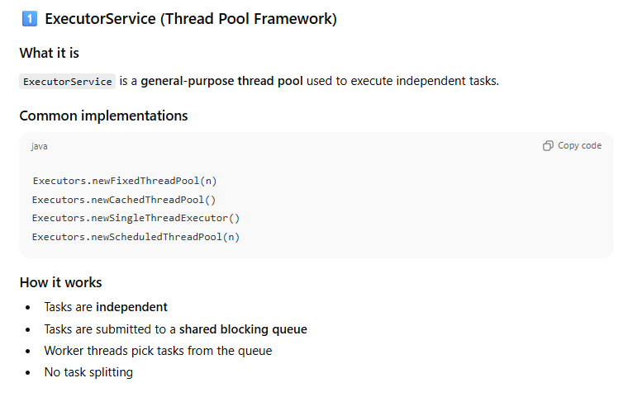  
  
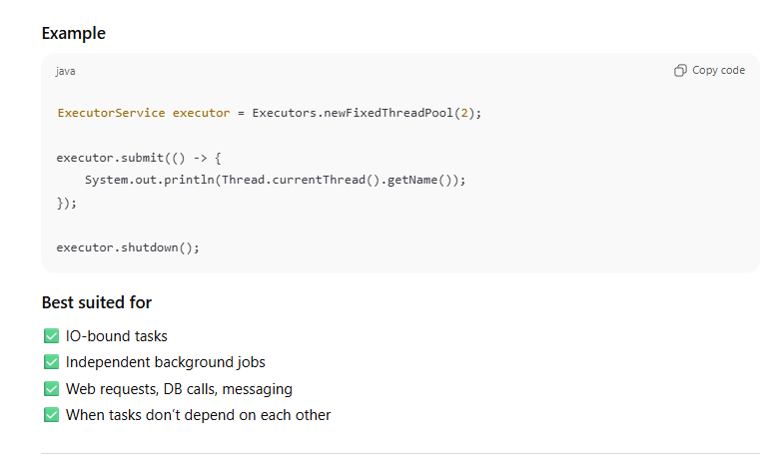  
  
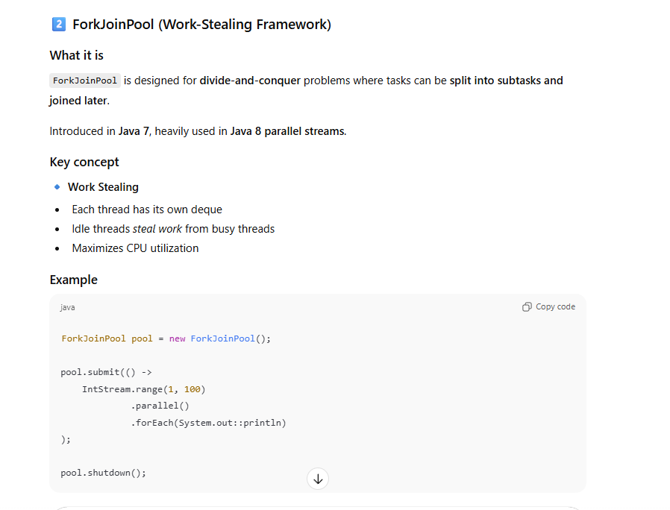  
  
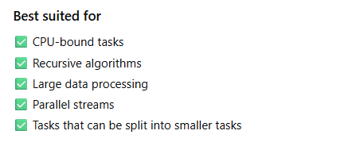  
---------------------------------------------------------------------  
Bean Factory vs application context ?

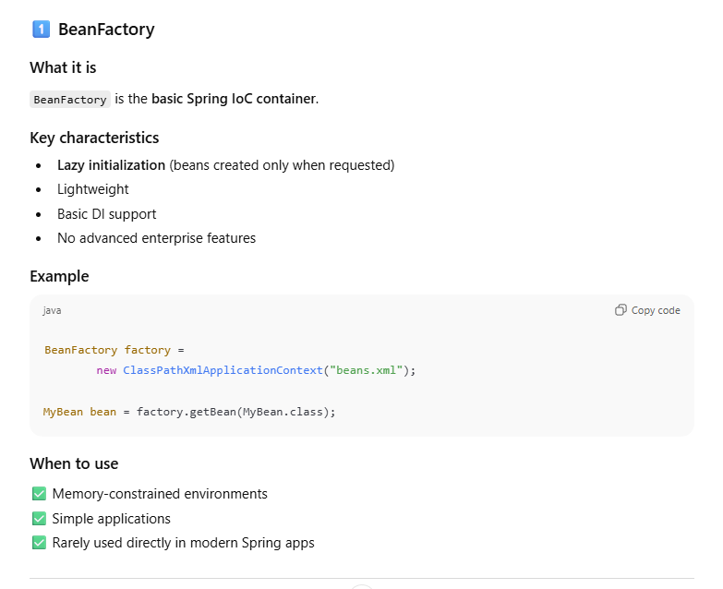  
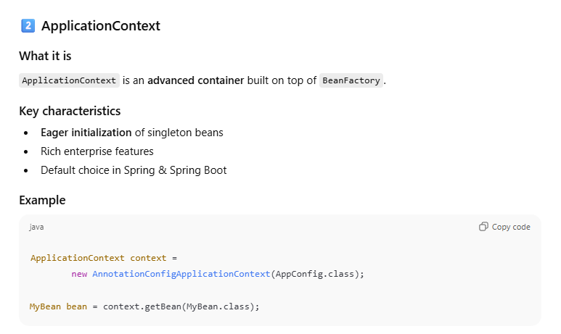

**How to make HashMap Thread-safe?**“HashMap itself is not thread-safe. To make it thread-safe, we can use **synchronization or use ConcurrentHashMap**.”

Ways to Make HashMap Thread-Safe

* 1. Collections.synchronizedMap (Legacy but valid)

**Map<Integer, String> map =**

**Collections.synchronizedMap(new HashMap<>());**

Points to mention:

* Uses single lock on the entire map
* Thread-safe but poor performance  
    
  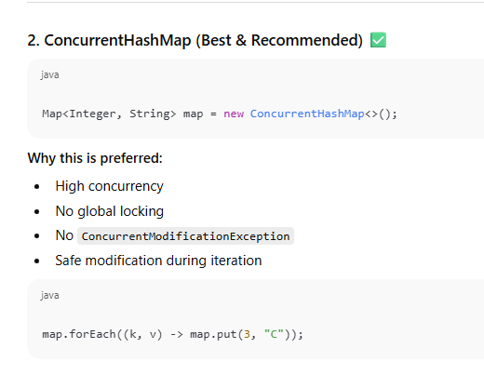

-------------------------------------------------------------  
**Removing Ambiguity without Qualifier annotation ?**

**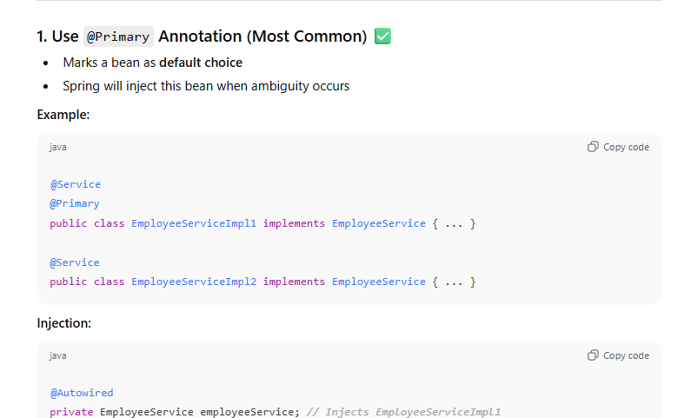  
  
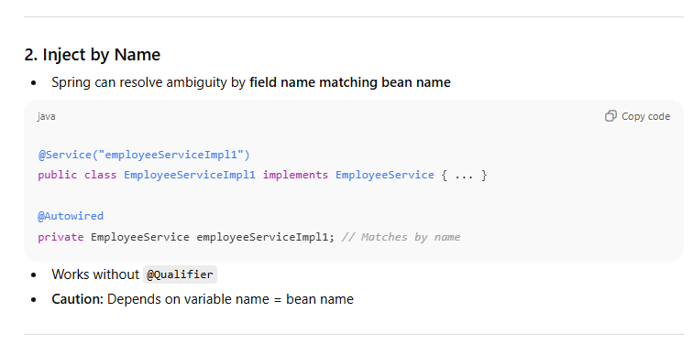  
  
What is the annotation used for Composite Primary Key ?**

**“For a composite primary key, we use either @EmbeddedId or @IdClass.”**

**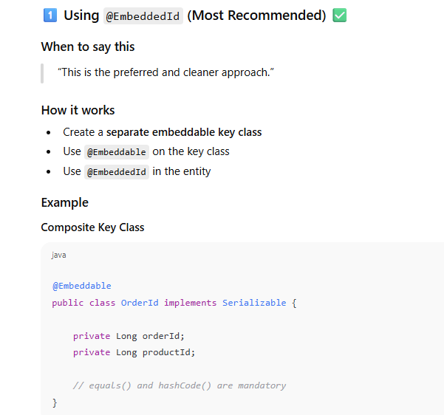  
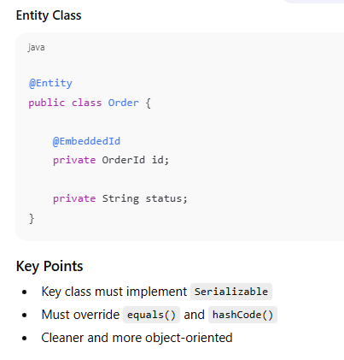**

**[2]**

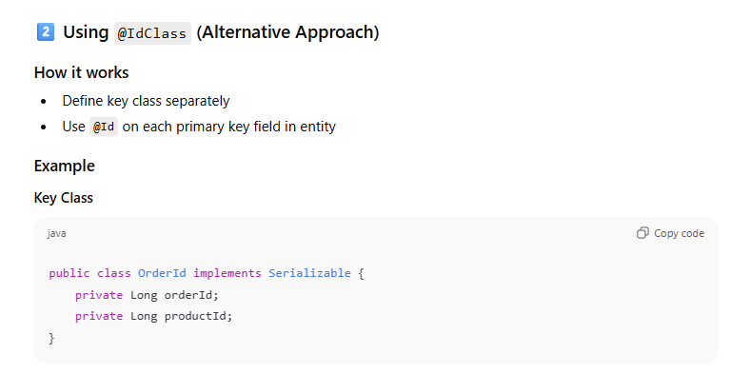

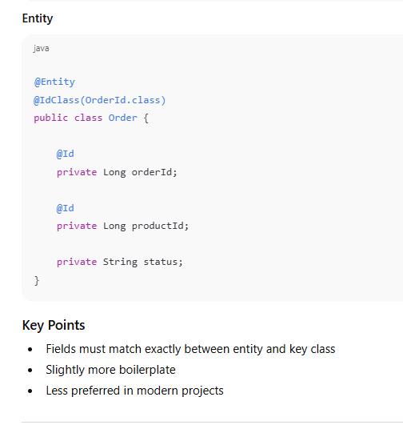

**“@EmbeddedId is generally preferred over @IdClass because it encapsulates the composite key as a value object and results in cleaner code.”**

**How to optimize fetching of data from multiple tables when using joins ?**

**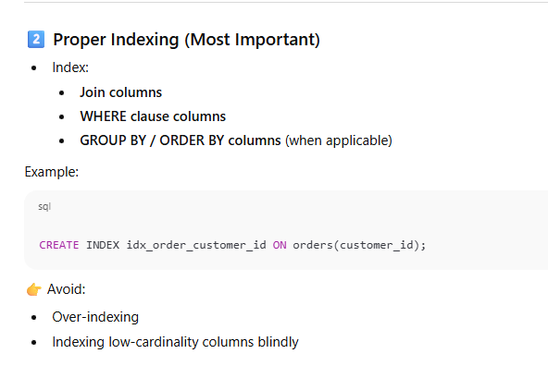  
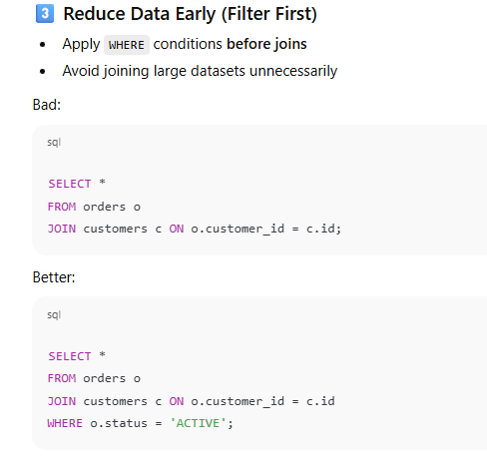**

**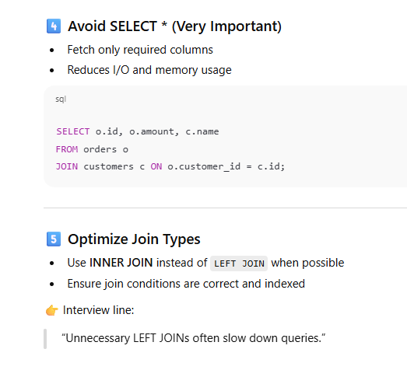  
  
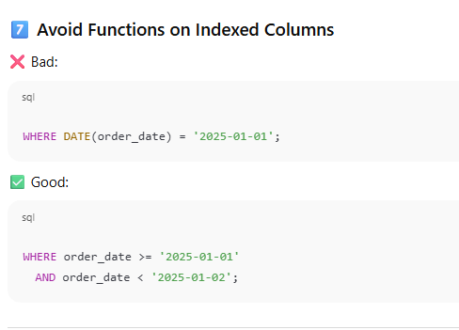  
  
------------------------------------------------------------------  
How to improve code quality like from sonar cube suggestion ?**

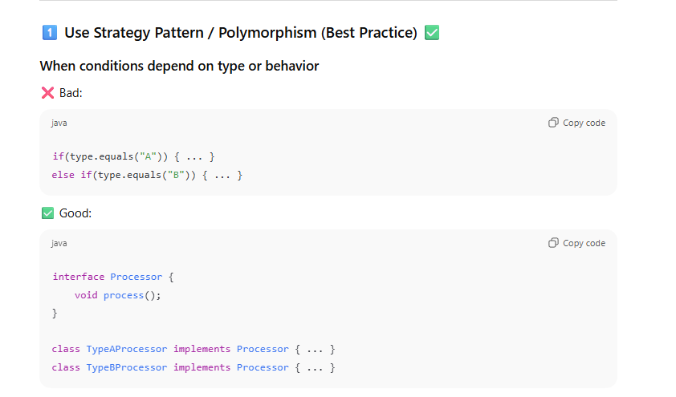

**[2]**

**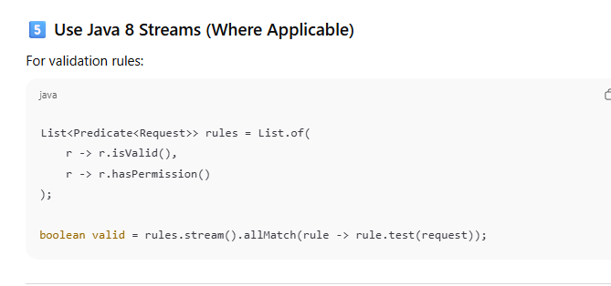  
  
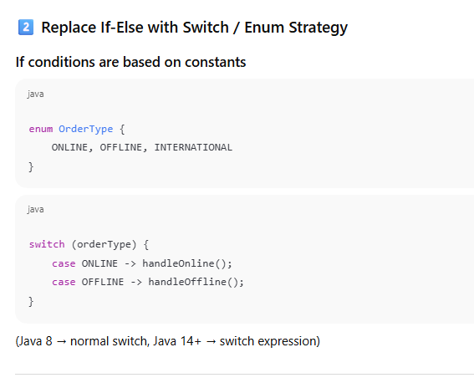**

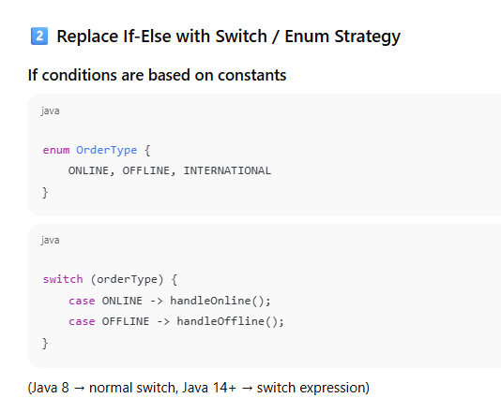

**How does the spring boot decides which bean to create?**

**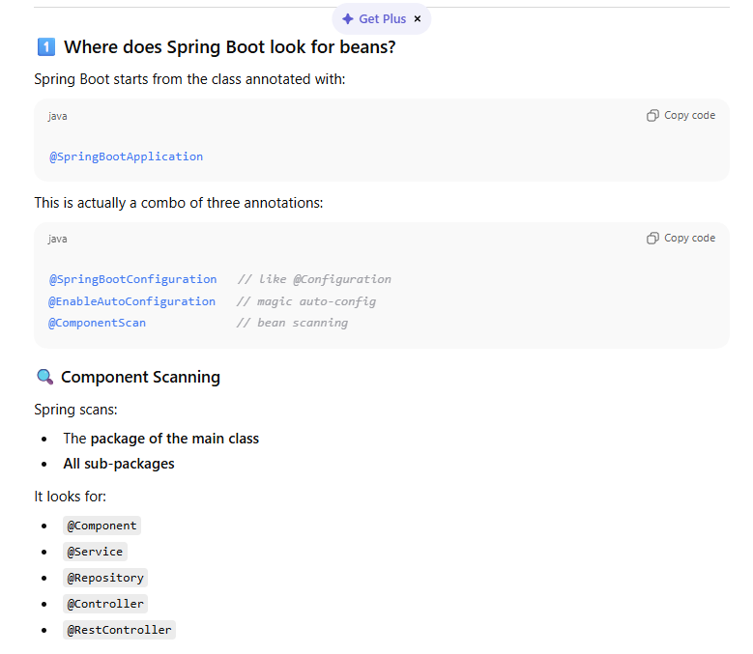  
  
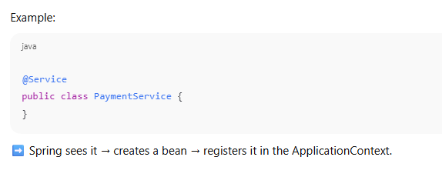  
  
[2]**

**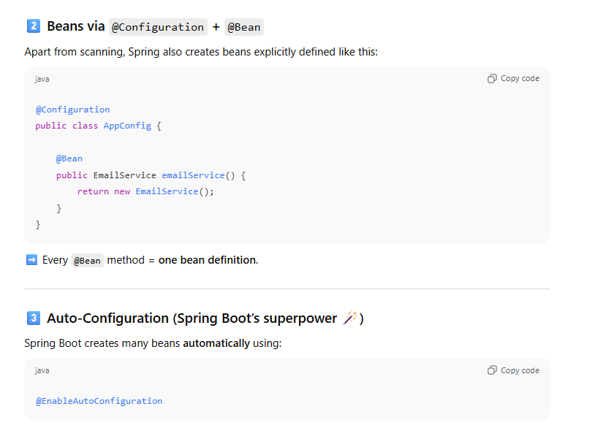  
  
What is spring factories?**

**spring.factories is a configuration file used by Spring Boot to load classes automatically at startup** — *without you explicitly referencing them*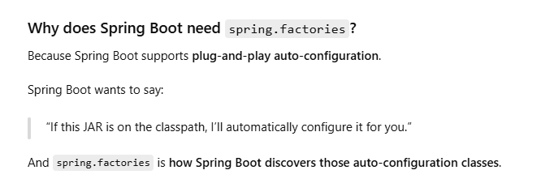

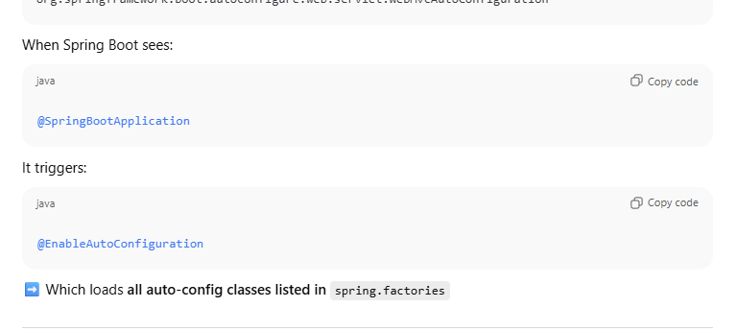

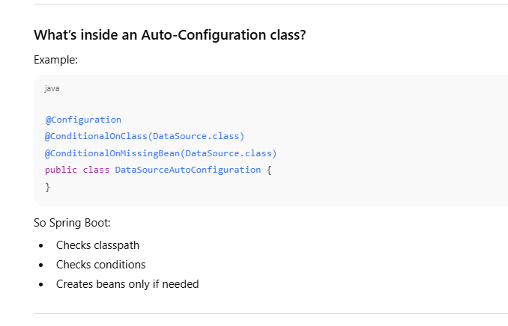  
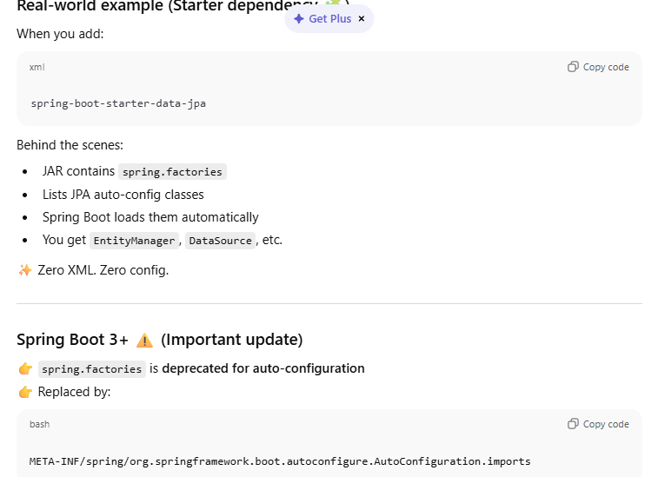

**How to override auto configure beans?  
  
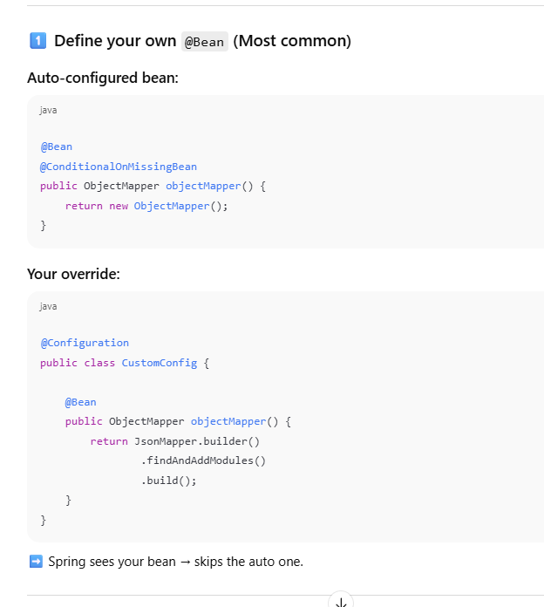  
[2]  
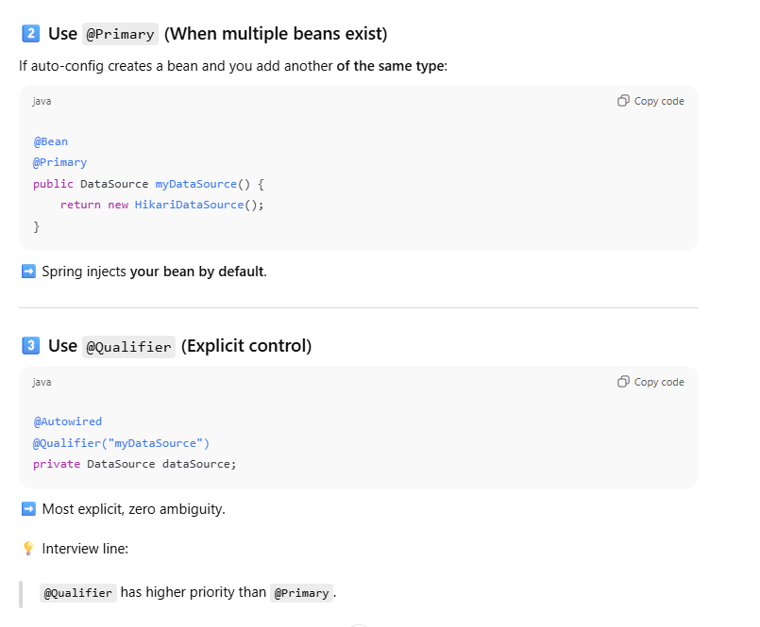  
  
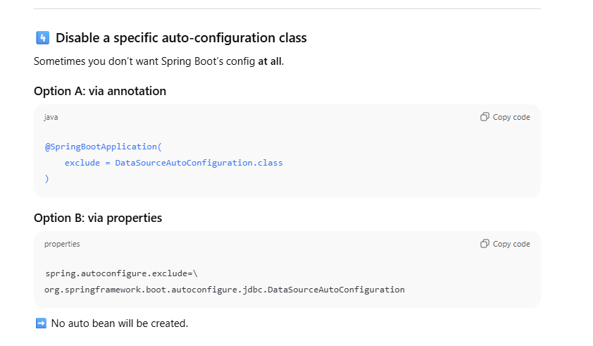**

**What is externalized configuration ?**

**Externalized configuration means keeping application configuration outside the code**, so the same application binary can run in different environments without changing or recompiling the code.

**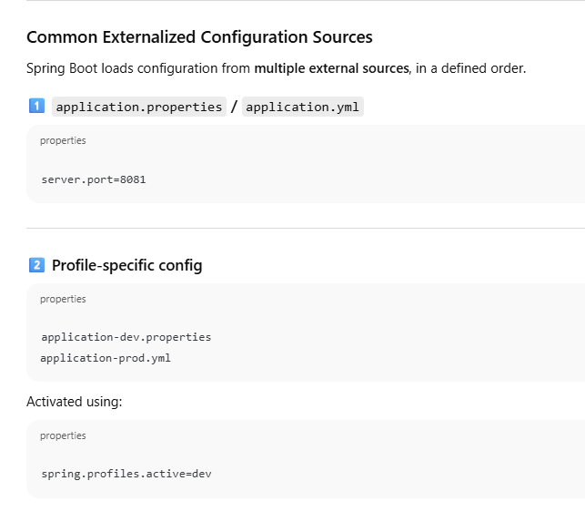  
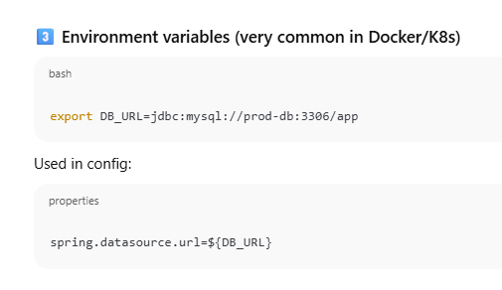**

What is the role of Jackson in spring boot application ? **Jackson plays the role of converting Java objects to JSON and JSON to Java in Spring Boot applications.  
It is automatically configured by Spring Boot and used internally by Spring MVC through HTTP message converters to handle REST request and response bodies.**

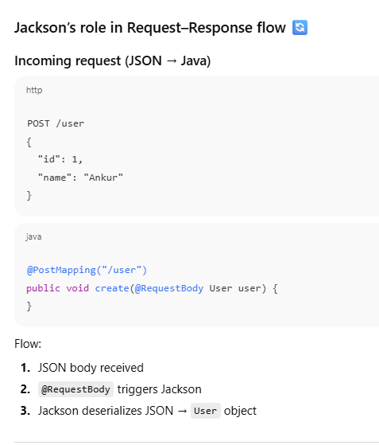  
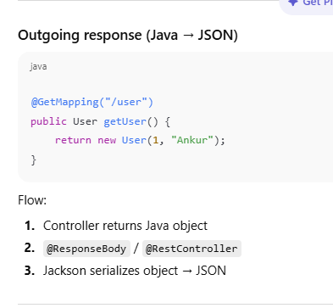

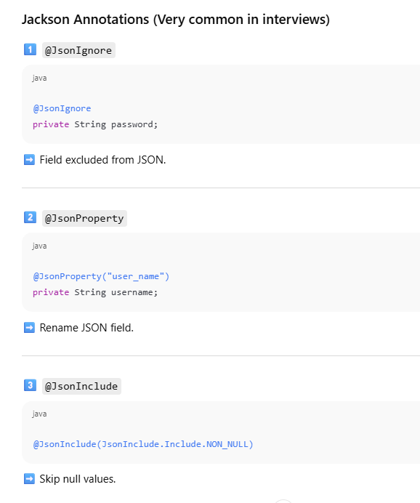

What is http message convertor in java spring applications?  
  
HTTP Message Converter in Spring is **responsible for converting HTTP request and response bodies into Java objects and vice versa, based on content type and media type.**

In simple terms:

* **Request side**:  
  HTTP body (JSON/XML/etc) ➜ Java object
* **Response side**:  
  Java object ➜ HTTP body (JSON/XML/etc)

Spring uses these converters **automatically** in REST API

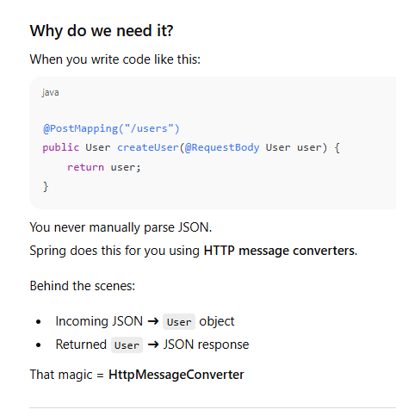  
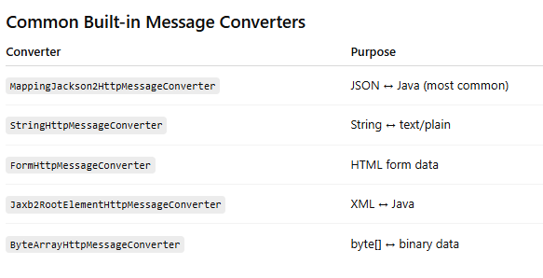  
  
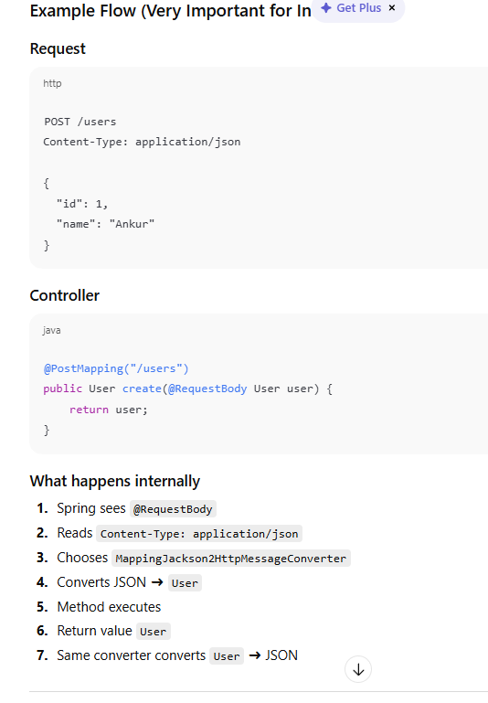

What is difference between @Valid and @Validated in spring application ?

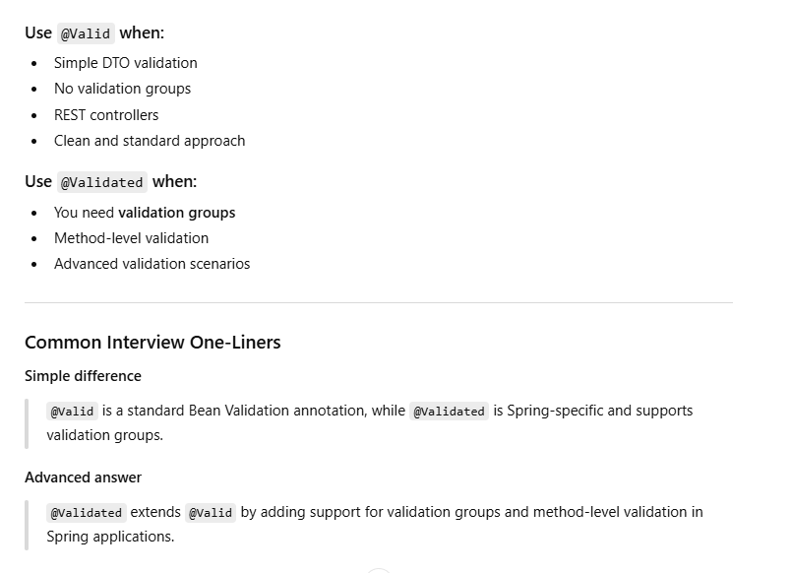  
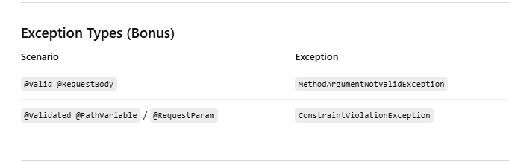  
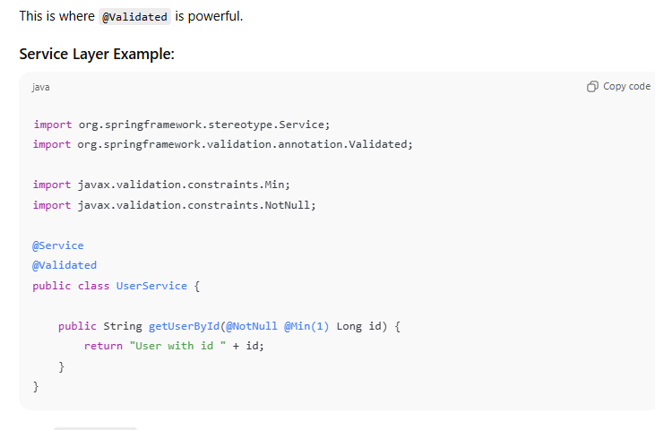  
 **what is hash map collison and how it can be rectify in java?**  
  
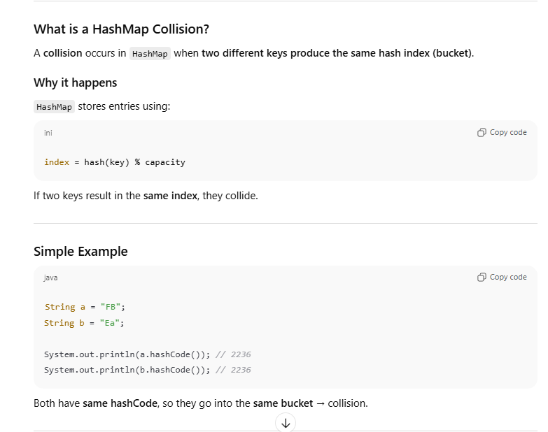  
  
What is hash map collison and how it can be rectify in java?  
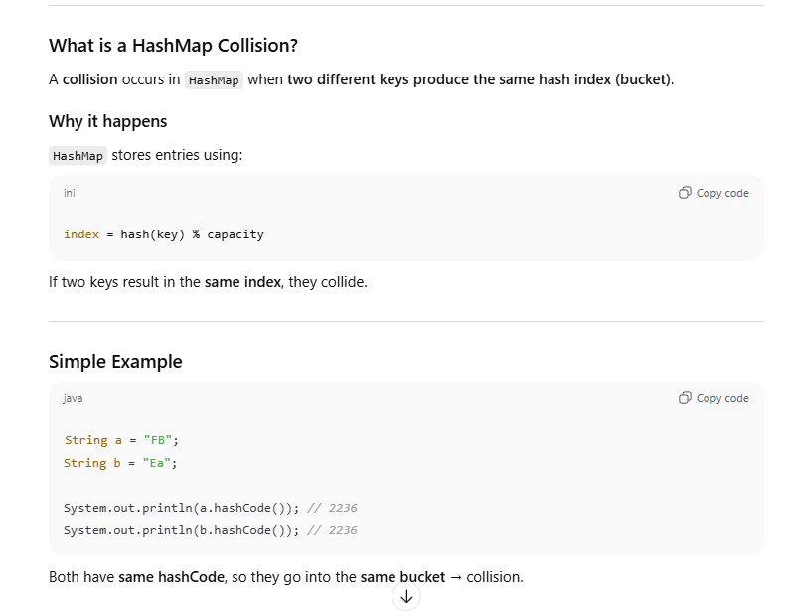  
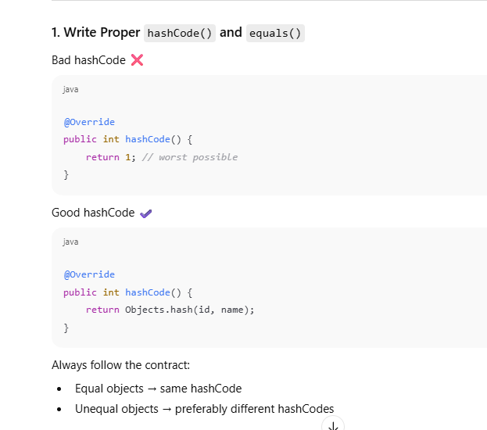  
  
  
  
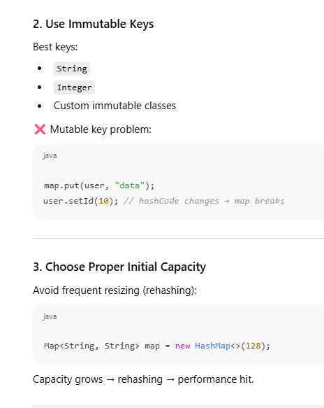  
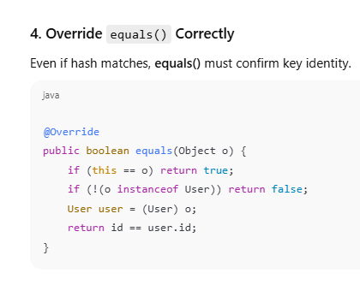  
**if we want to store class object as a key in hash map how can we do it** ?  
  
**It is possible by override equals and hashcode method**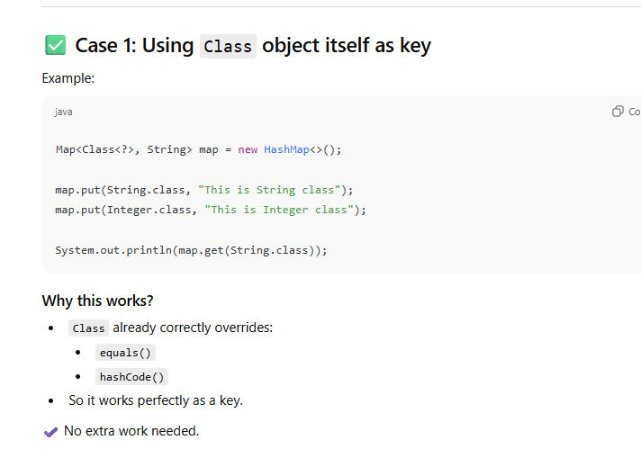Case 2: Using Custom Class Object as Key  
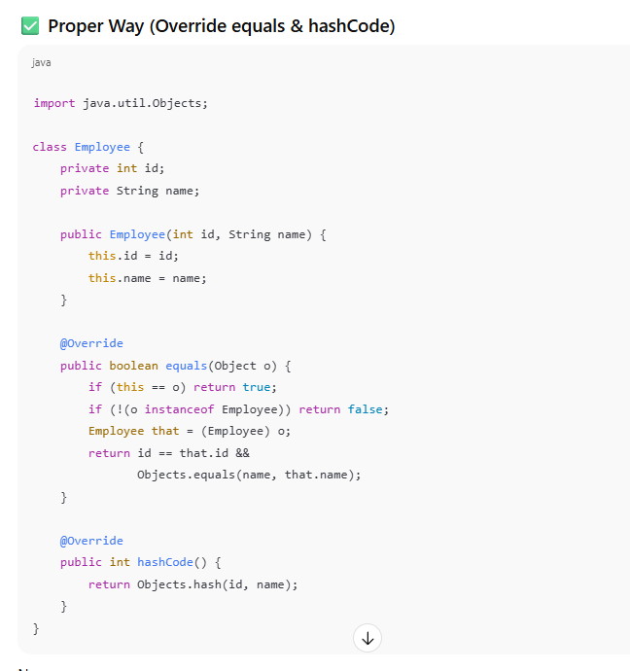

**What is difference between volatile and synchronized ?  
  
volatile ensures visibility of a variable across threads but does not provide atomicity.  
synchronized ensures both visibility and atomicity by allowing only one thread to access a block or method at a time.**volatile is lightweight, while synchronized involves locking and has more overhead.  
  
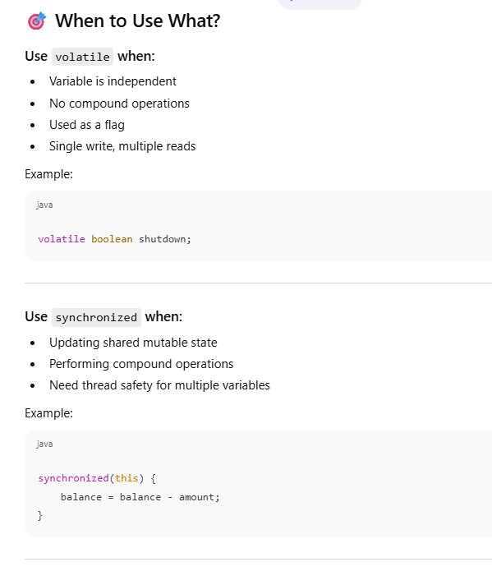  
What are the different ways to ensure thready safety in Java?  
  
Thread safety in Java can be ensured using synchronized blocks or methods, volatile variables for visibility , concurrent collections like ConcurrentHashMap, Immutable Classes and using Thread Pool Executor like Executor Service.  
**What is Thread Local and how it is used ?**  
ThreadLocal is a class in Java that **provides thread-confined variables**. Each **thread has its own independent copy of the variable, so changes made by one thread do not affect others**.  
  
**ThreadLocal provides thread-level isolation by giving each thread its own copy of a variable.**  
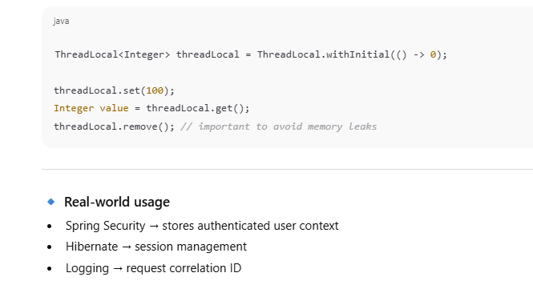 **What is BlockingQueue?**

BlockingQueue is a thread-safe queue from java.util.concurrent **that supports operations which wait (block) when the queue is empty while retrieving, or full while inserting. It is mainly used in producer-consumer scenarios.**  
  
